University of Seville  
 School of Computer Engineering

**Performance Report**



Software engineering  
Design and testing 2

2018 – 2019

06/04/2019

Group 26

**Index**

1. Observations 5

2. Package 5

Create 5

Edit LUIS 6

Delete 8

Conclusion 10

3. Evaluation 11

Create 11

Delete 13

Conclusion 14

4. Message 15

Send 15

Move 16

Copy 18

Delete 20

Conclusion 22

5. Message box 23

Create 23

Edit 24

Delete 26

Conclusion 28

6. Social profile 29

Create 29

Edit 31

Delete 32

Conclusion 34

7. Dashboard 35

Show dashboard and launch all process 35

Conclusion 37

8. Category 37

Create 37

Edit 39

Delete 41

Conclusion 43

9. Request 43

Create 43

Edit 45

Delete 47

Conclusion 49

10. TraverseTown 49

Create 49

Edit 51

Delete 53

Conclusion 55

11. Issue 56

Create 56

Delete 57

Conclusion 59

12. Town 60

Create 60

Edit 62

Delete 63

Conclusion 65

13. Comment 66

Create 66

Conclusion 68

14. Configuration 68

Display and edit 68

Conclusion 70

15. Finder 71

Search 71

Conclusion 73

16. Offer 73

Create/Edit 73

Delete 75

Conclusion 77

17. TODO DE AQUI PABAJO SE BORRA 77

18. Position 78

Create 78

Edit 80

Delete 82

Conclusion 84

19. Mess 85

Search by tags, list by that tag and display a mess 85

Send a message 86

Delete a message 88

Send a broadcast mess 90

Conclusion 91

20. Dashboard 92

Display the dashboard and set the spammers 92

Conclusion 93

21. Configuration 94

Display the configuration and edit it 94

Conclusion 96

22. Problem 96

Create 96

Edit 98

Delete 100

Conclusion 102

23. Finder 102

Search and clear 102

Conclusion 104

24. Curricula 104

Create a curriculum 104

Delete a curriculum 106

25. Datas (Personal, Education, Position and Miscellaneous data) 108

Create all datas 108

Edit a position data 110

Edit a education data 112

Edit a miscellaneous data 114

Delete a position data 115

Delete a education data 117

Delete a miscellaneous data 119

Conclusion 121

26. Social profile 121

Create 121

Edit 123

Delete 126

Conclusion 127

27. Actor 128

Create 128

Edit 130

Delete 132

Conclusion 134

28. Application 134

Create 134

Edit 136

Delete 138

Conclusion 140

29. Audit 140

Assign 140

Create 142

Edit 145

Delete 147

Conclusion 149

30. Sponsorship 150

Create 150

Edit 152

Delete 154

Conclusion 155

31. Item 156

Create 156

Edit 158

Delete 160

Conclusion 161

32. Conclusion of the performance 162

# Observations

We have considered that our performance tests were valid as long as they were lasting between 2’5 and 3 seconds and no error was showed.

# Package

## Create

Sequence:

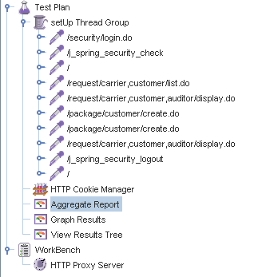

Aggregate Report:

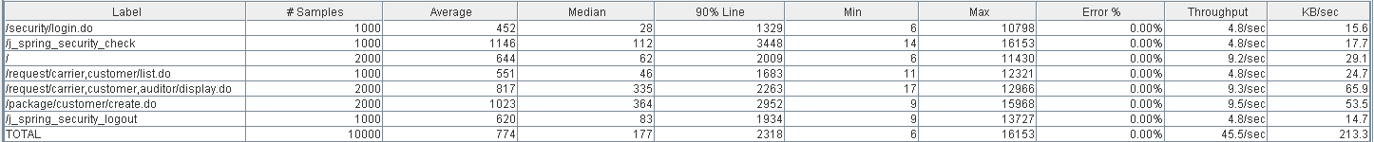



Thread properties:

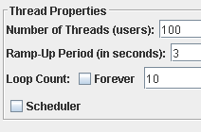

Graph Results:

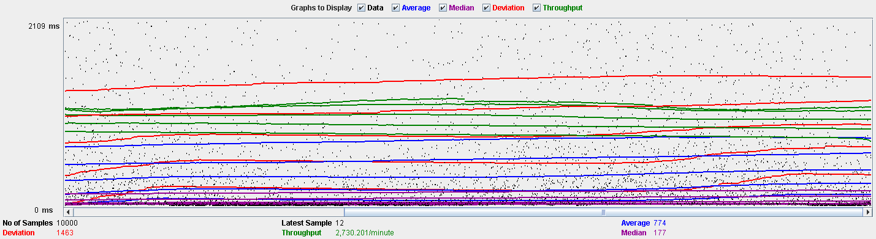

Performance Results:

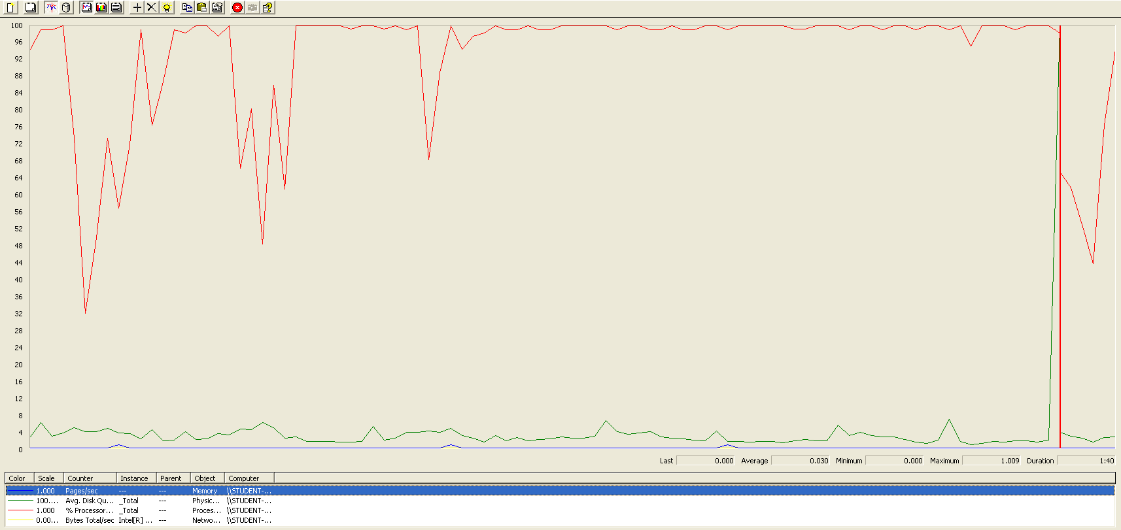

The CPU is always being used while the disk usage is barely noticeable..

## Edit LUIS

Sequence:

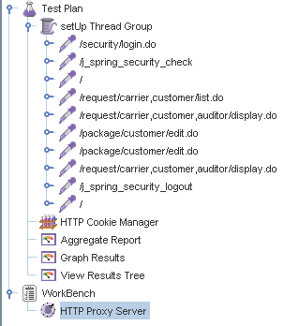

Aggregate Report:

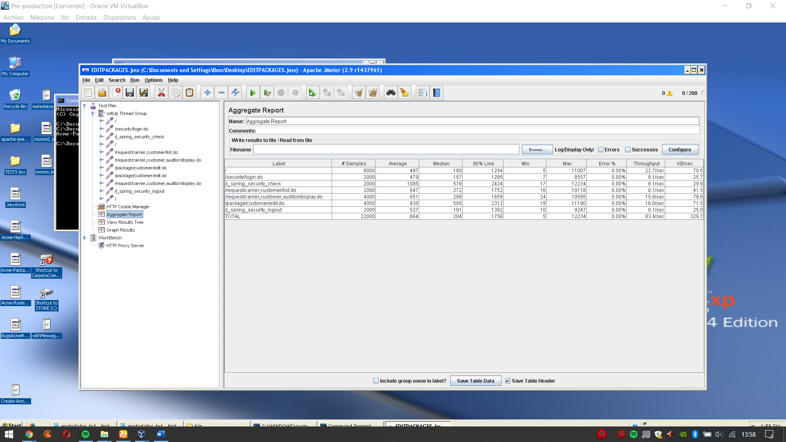

Thread properties:

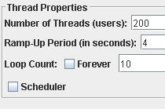

Graph Results:

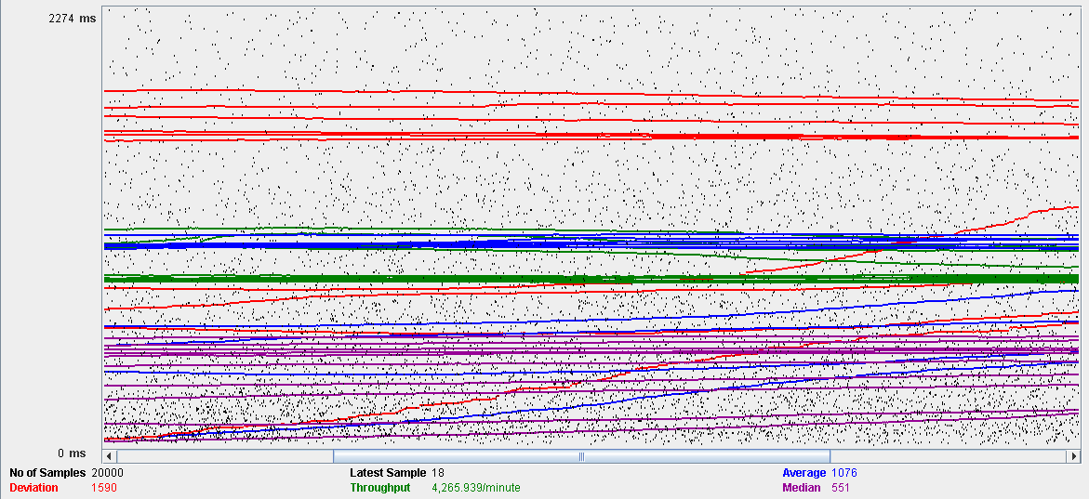

Performance Results:

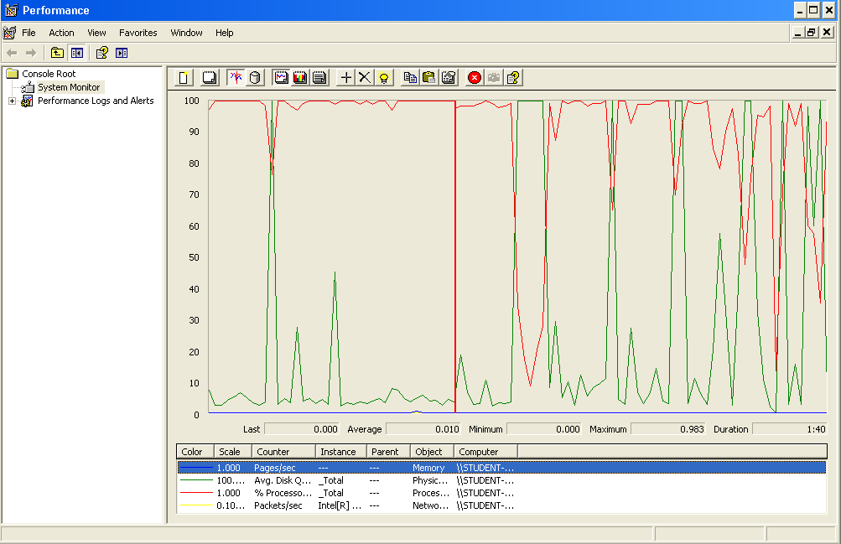

Again we can see that the CPU is always being used while the disk usage shows some periodic peaks.

## Delete

Sequence:

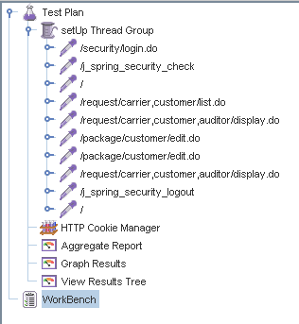

Aggregate Report:

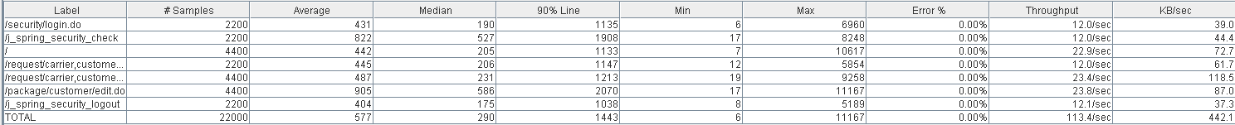



Thread properties:

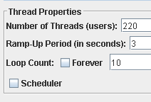.

Graph Results:

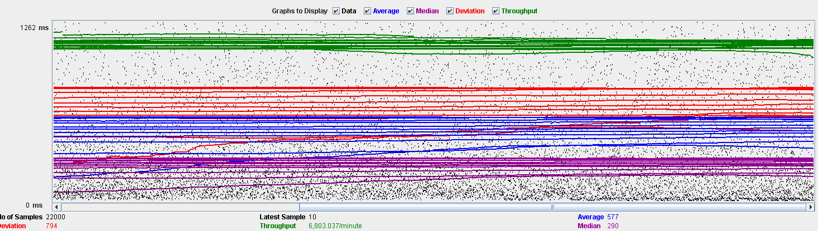

Performance Results:

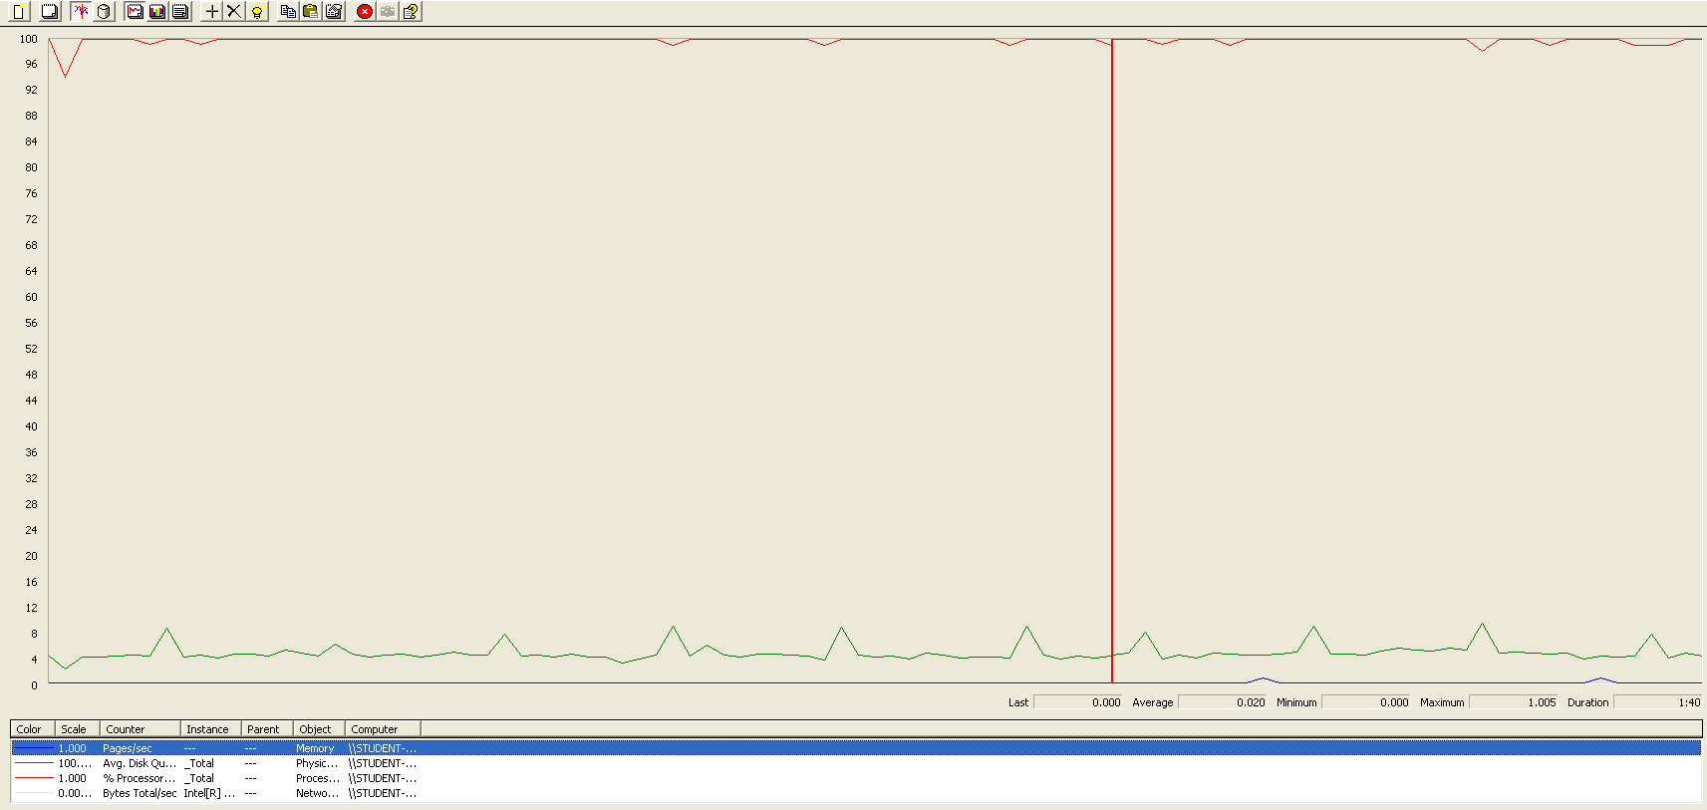

Again we can see that the CPU is always being used while the disk usage shows some peaks. The times are a little bit lower in order to avoid errors.

## Conclusion

The test was performed using:

CPU: i7 6700hq (2 cores in the virtual machine)

RAM: 4 GB (virtual machine)

For this use case we can say that the limitation occurs during the creation process, being the maximum of concurrent users 100. The times during the delete process did not reach the 3 seconds mark in order to avoid errors.

# Evaluation

## Create

Sequence:

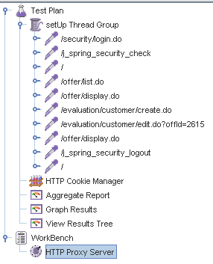

Aggregate Report:

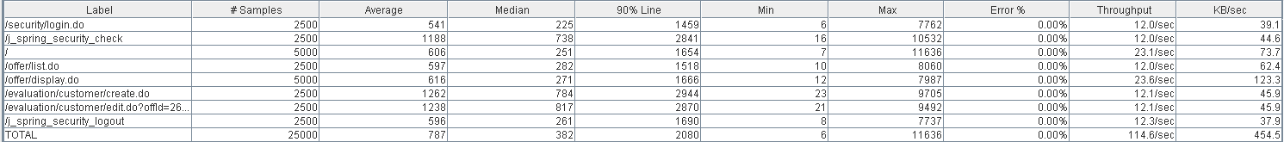



Thread properties:

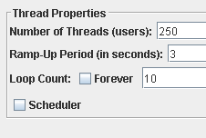

Graph Results:

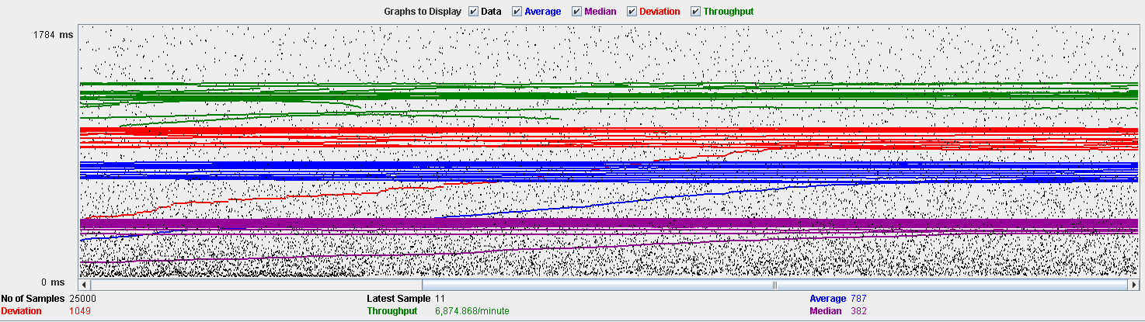

Performance Results:

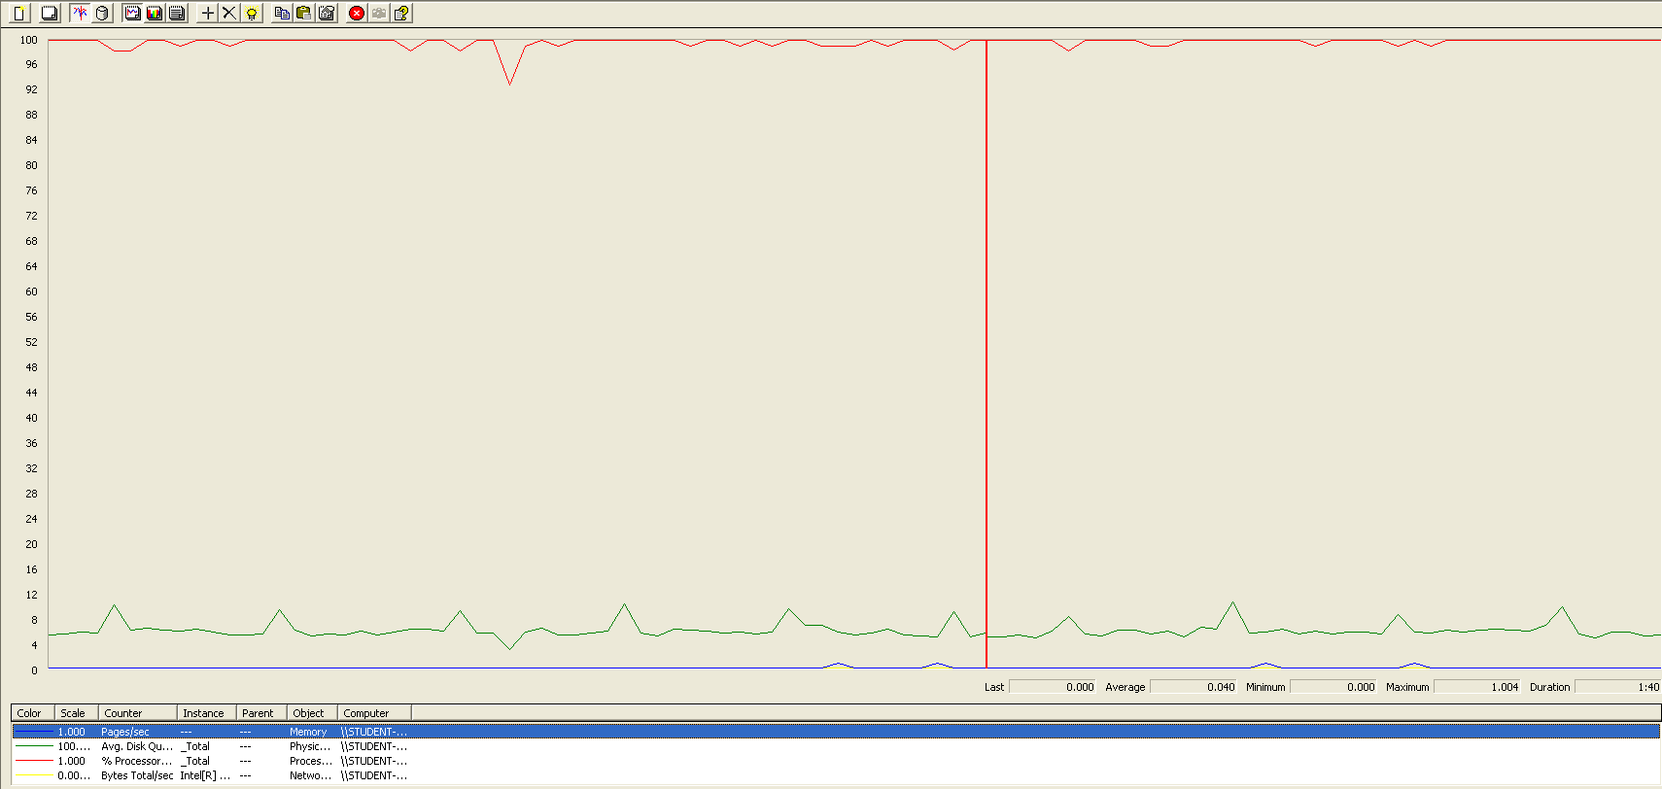

The CPU is always being used while the disk usage is barely noticeable.

## Delete

Sequence:

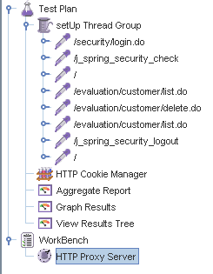

Aggregate Report:





Thread properties:

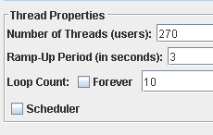

Graph Results:

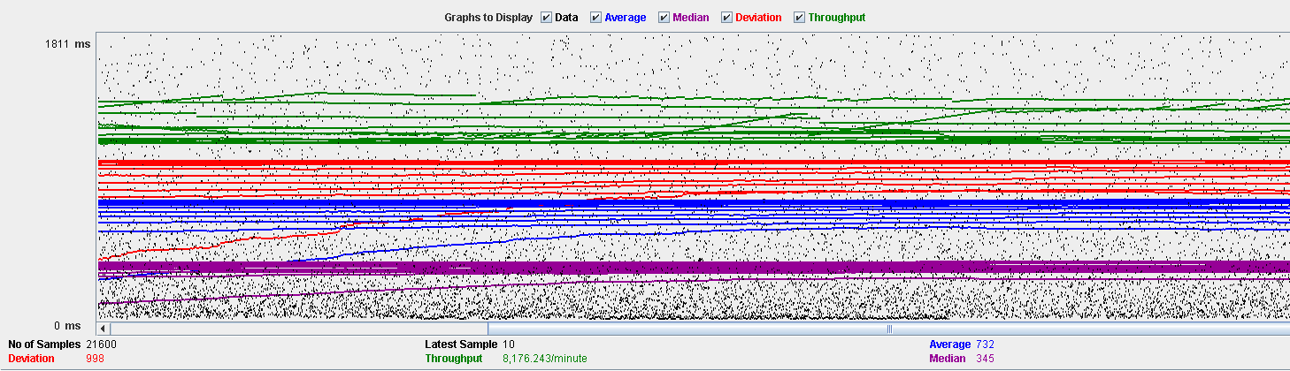

Performance Results:

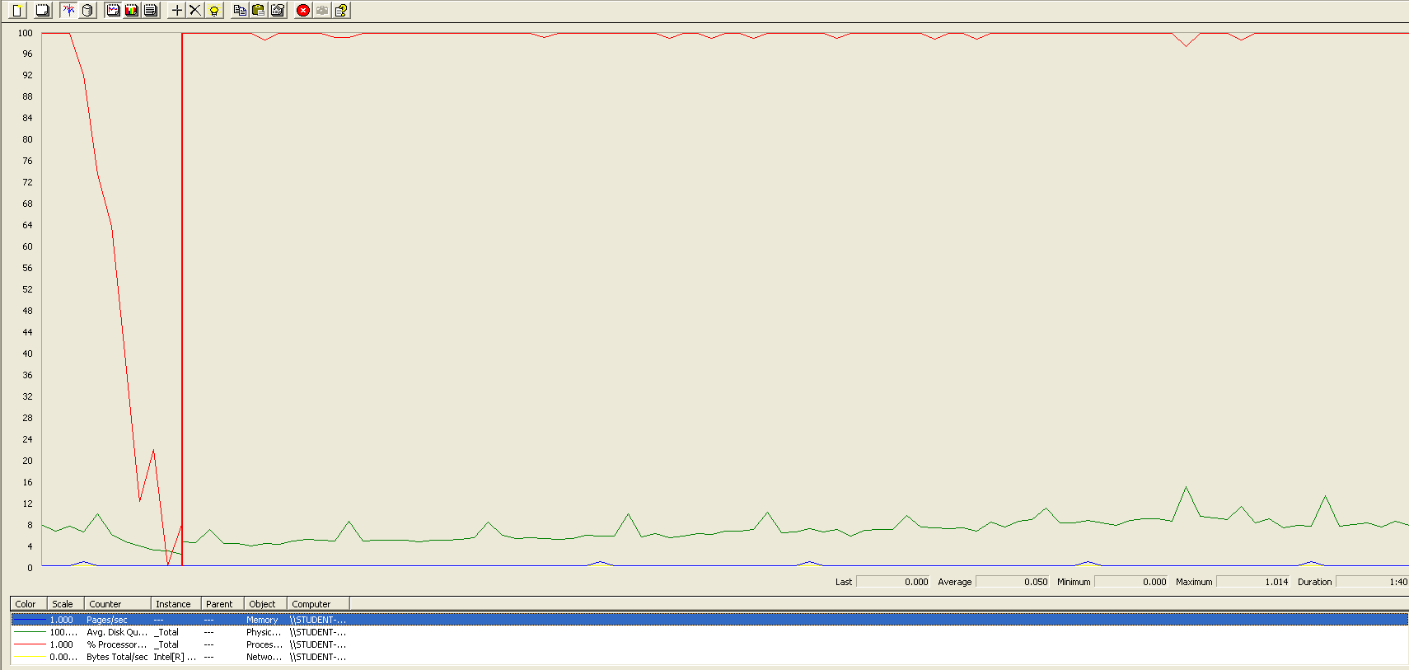

The CPU is always being used while the disk usage is barely noticeable.

## Conclusion

The test was performed using:

CPU: i7 7700hq (2 cores in the virtual machine)

RAM: 4 GB (virtual machine)

For this use case we can say that the limitation occurs during the creation process, being the maximum of concurrent users 250.

# Message

## Send

Sequence:

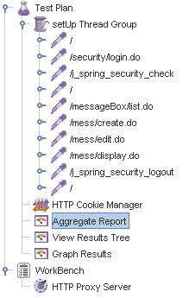

Aggregate Report:

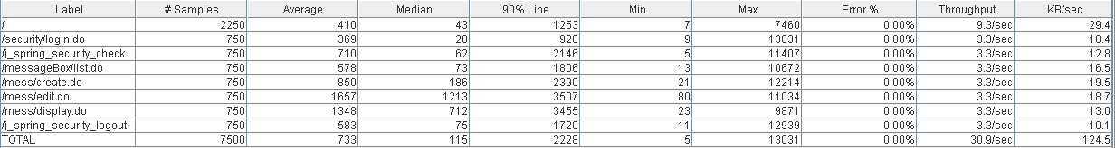

Thread properties:

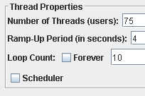

Graph Results:

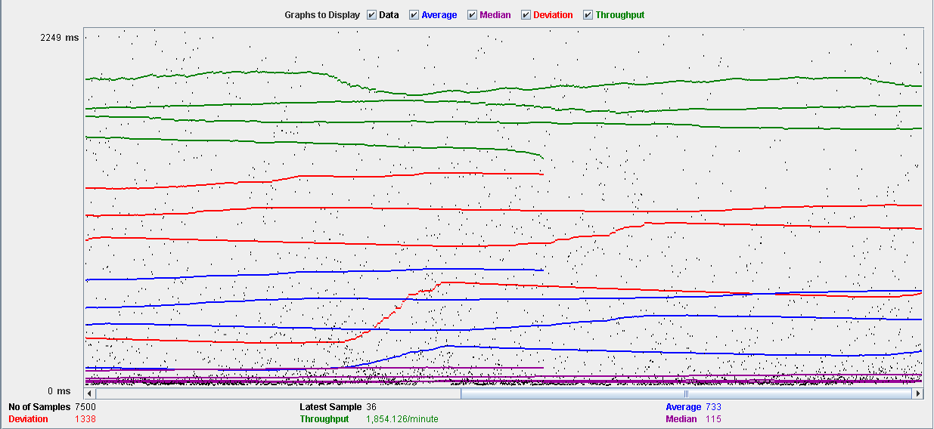

Performance Results:

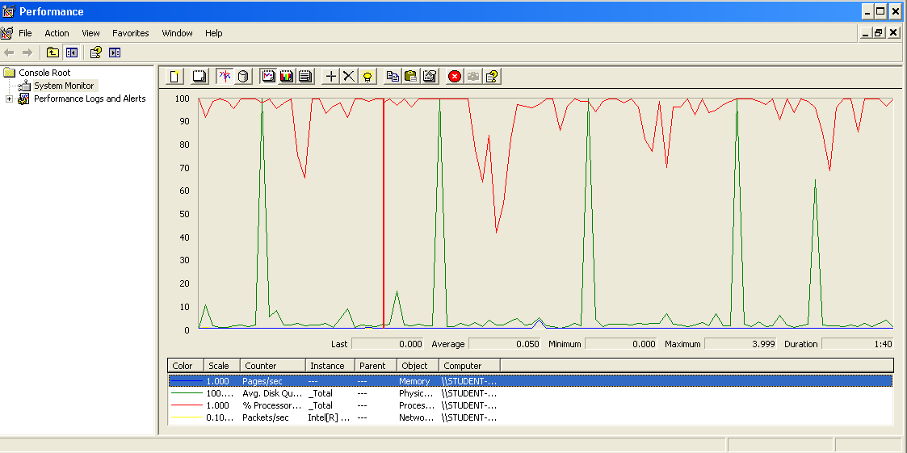

The CPU is always being used and some picks of physical disk.

## Move

Sequence:

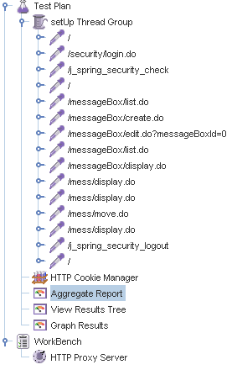

Aggregate Report:

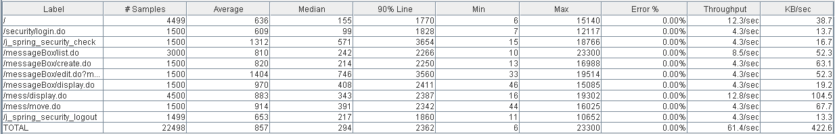

Thread properties:

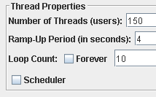

Graph Results:

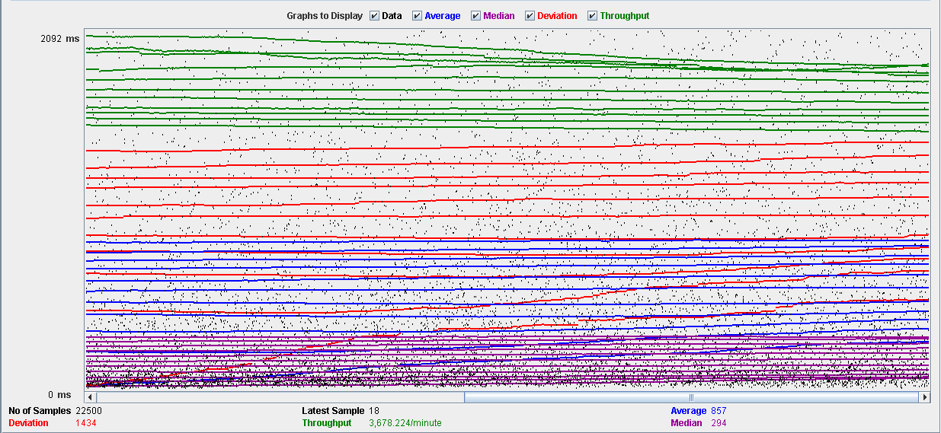

Performance Results:

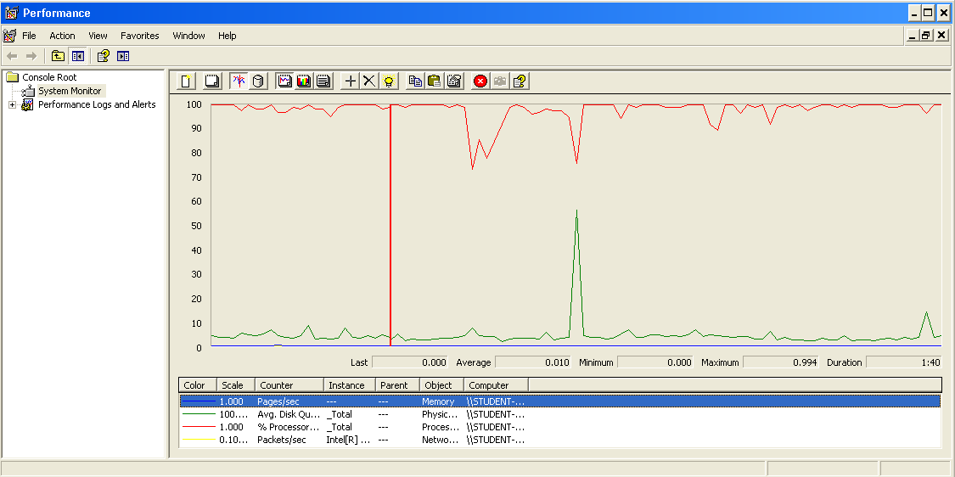

The CPU is always being used and some picks of physical disk.

## Copy

Sequence:

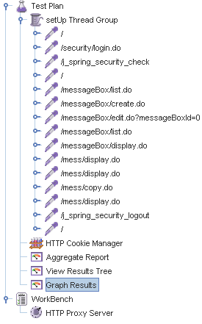

Aggregate Report:

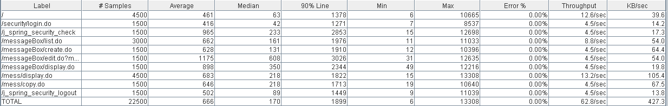

Thread properties:



Graph Results:

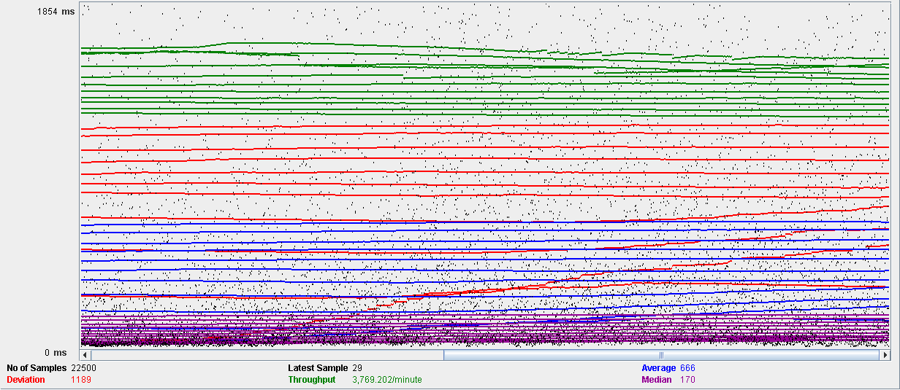

Performance Results:

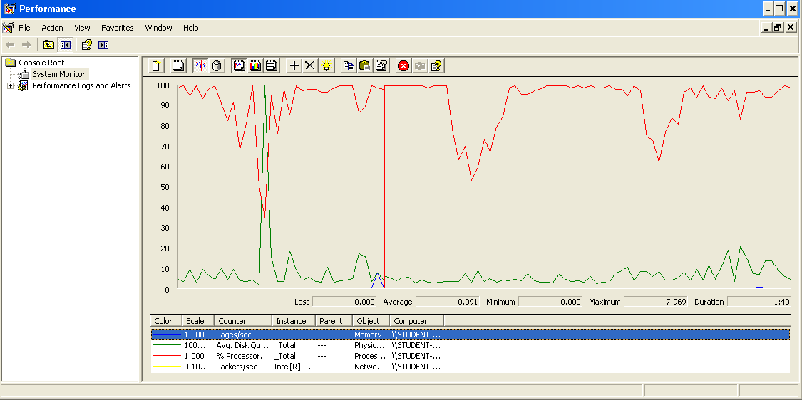

The CPU is always being used and a pick of physical disk.

## Delete

Sequence:

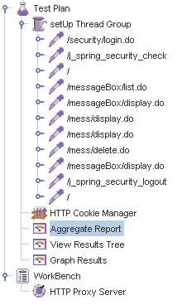

Aggregate Report:

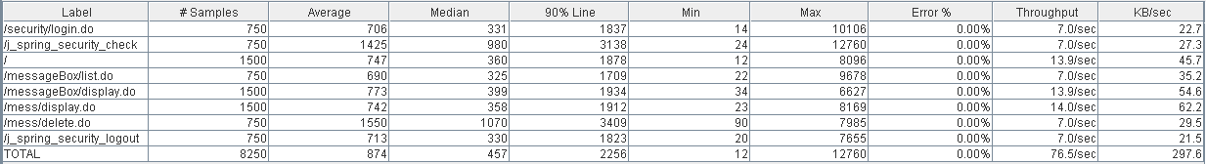

Thread properties:



Graph Results:

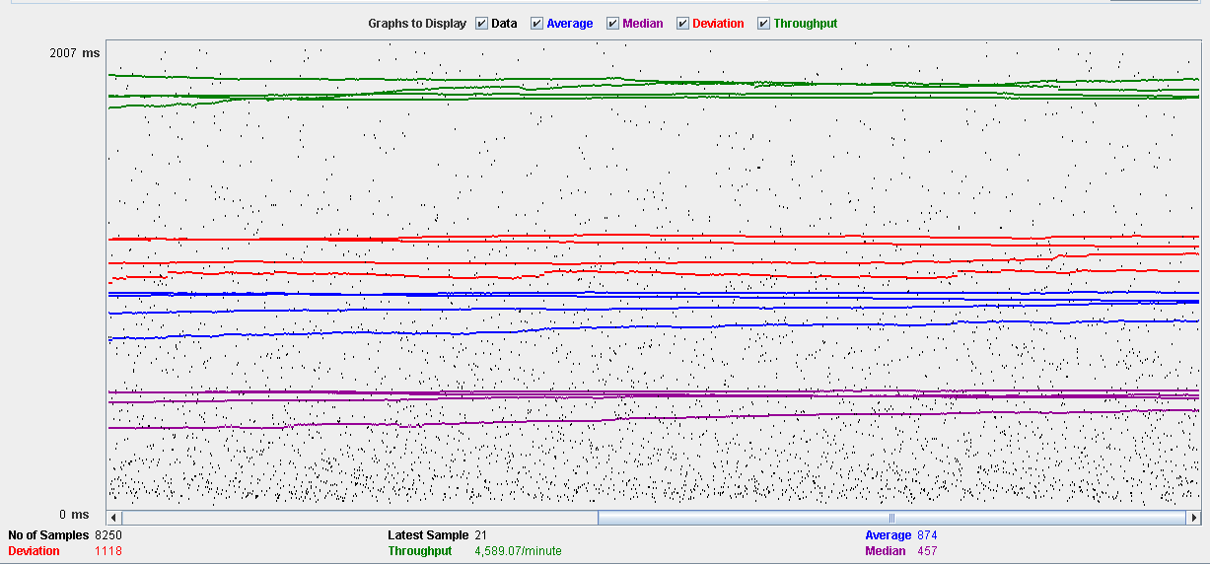

Performance Results:

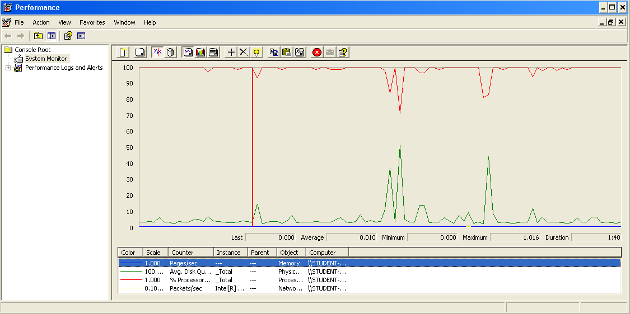

The CPU is always being used while the physical disk has some picks.

## Conclusion

The test was performed using:

CPU: i7 7700hq (2 cores in the virtual machine)

RAM: 2 GB (virtual machine)

For this use case we can say that the limitation occurs during the send and delete process, being the maximum of concurrent users 75.

# Message box

## Create

Sequence:

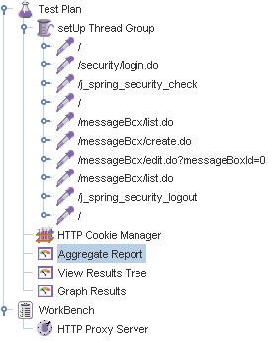

Aggregate Report:

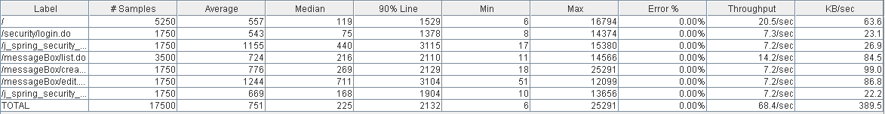

Thread properties:

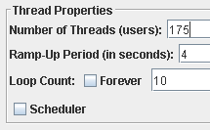

Graph Results:

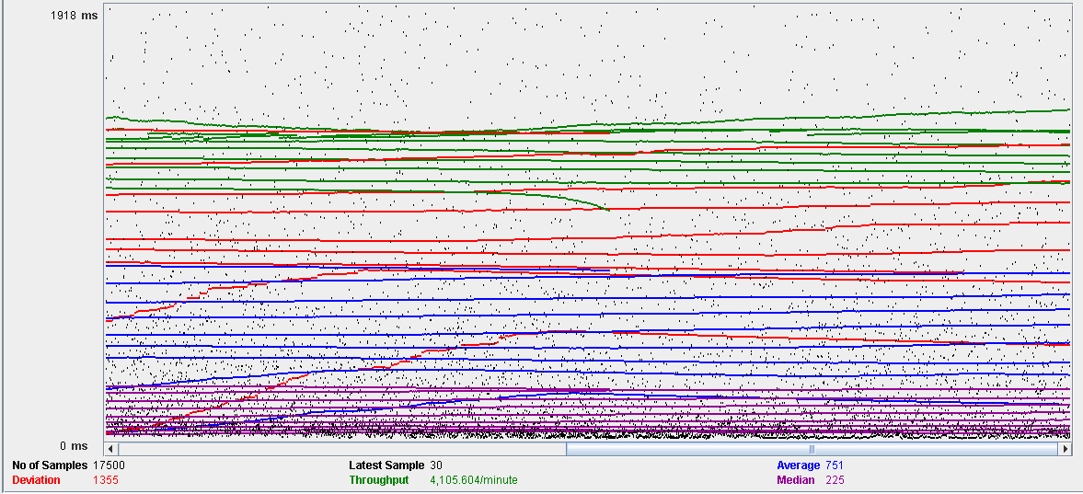

Performance Results:

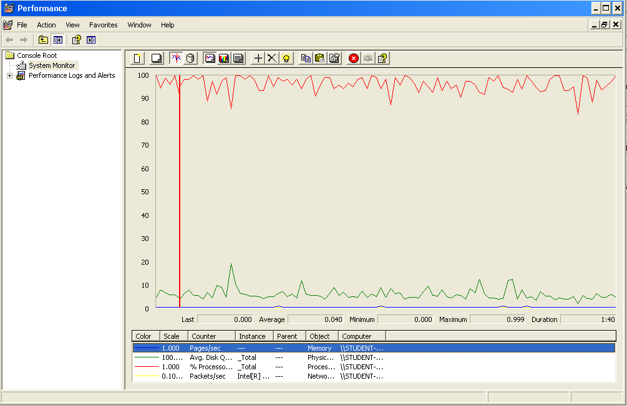

The CPU is always being used and physical disk usage is barely noticeable.

## Edit

Sequence:

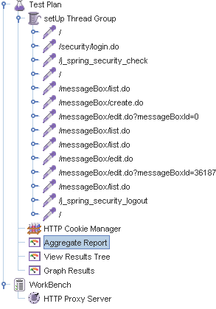

Aggregate Report:

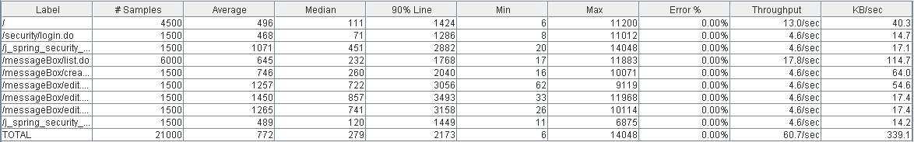

Thread properties:



Graph Results:

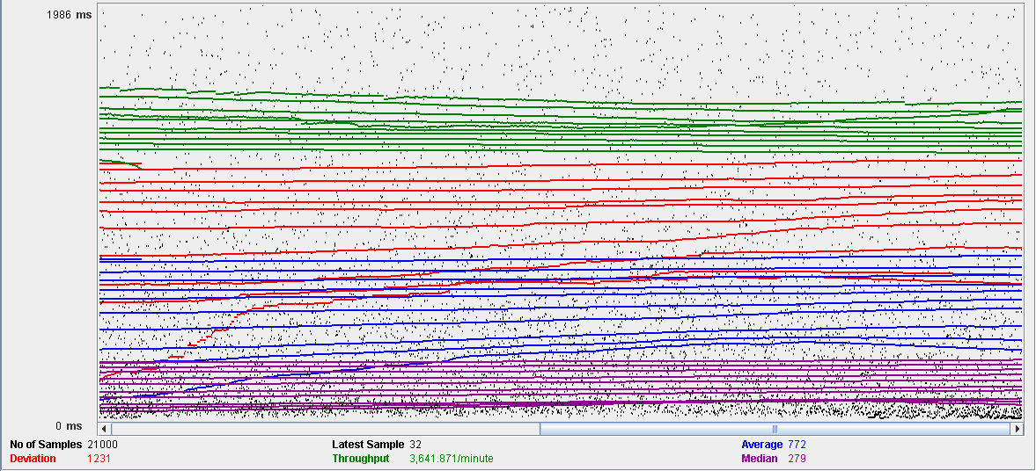

Performance Results:

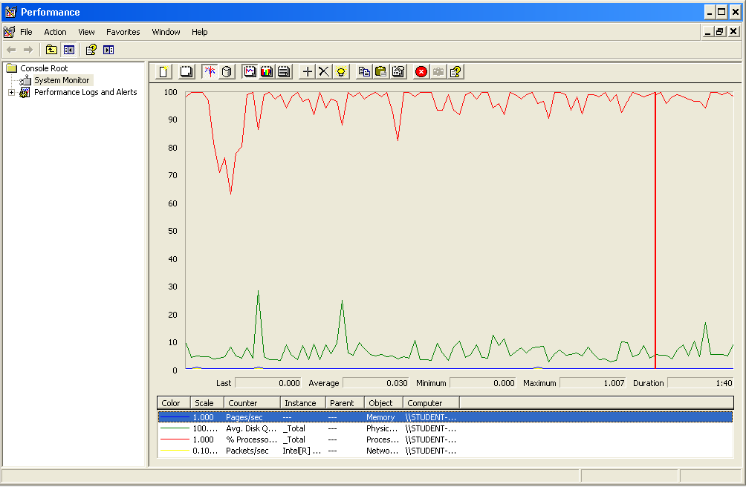

The CPU is always being used and small picks of physical disk

## Delete

Sequence:

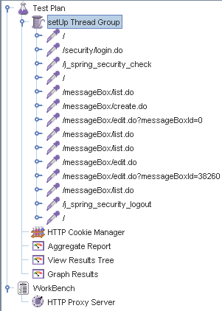

Aggregate Report:

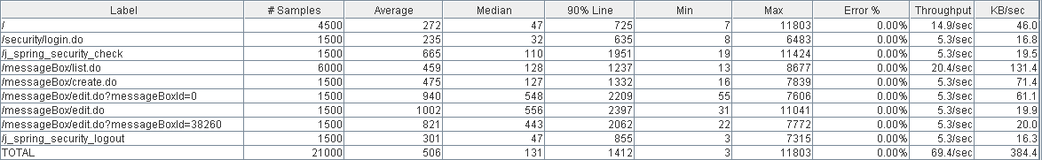

Thread properties:



Graph Results:

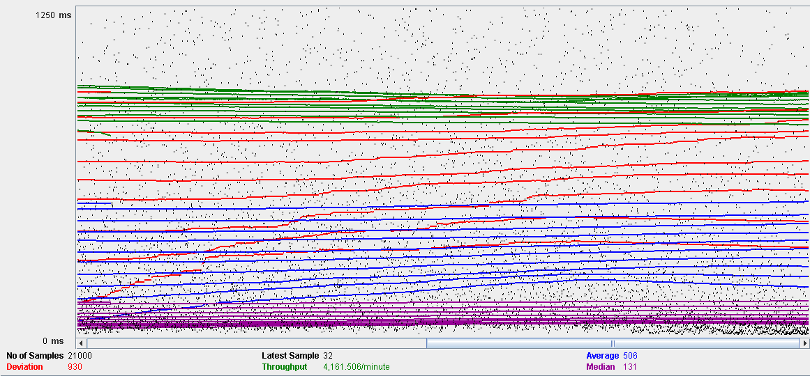

Performance Results:

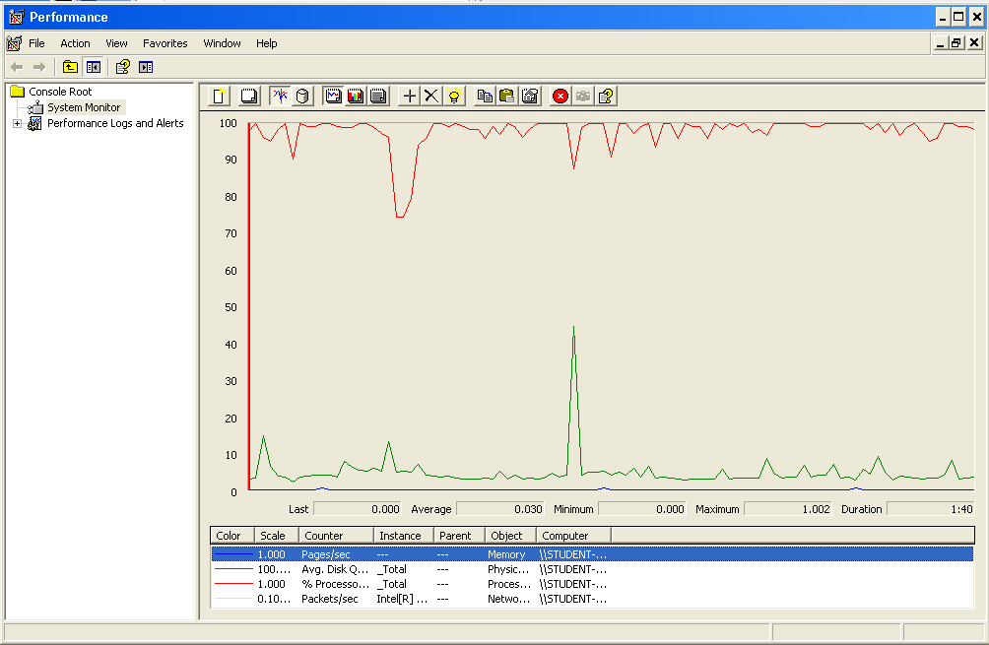

The CPU is always being used while the memory has some picks.

## Conclusion

The test was performed using:

CPU: i7 7700hq (2 cores in the virtual machine)

RAM: 2 GB (virtual machine)

For this use case we can say that the limitation occurs during the edition process, being the maximum of concurrent users 150.

# Social profile

## Create

Sequence:

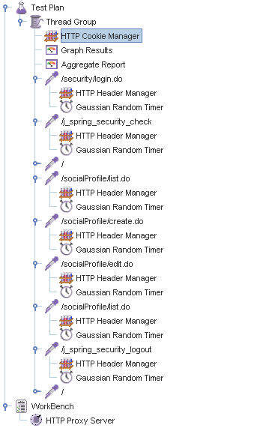

Aggregate Report:

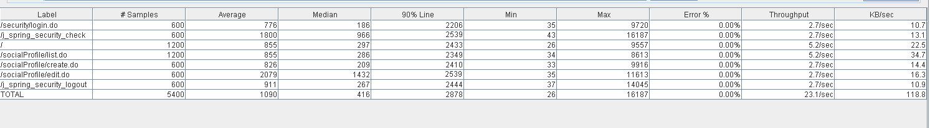

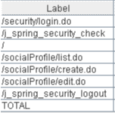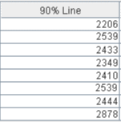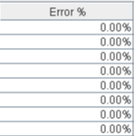

Thread properties:

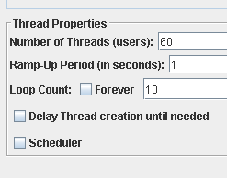

Graph Results:

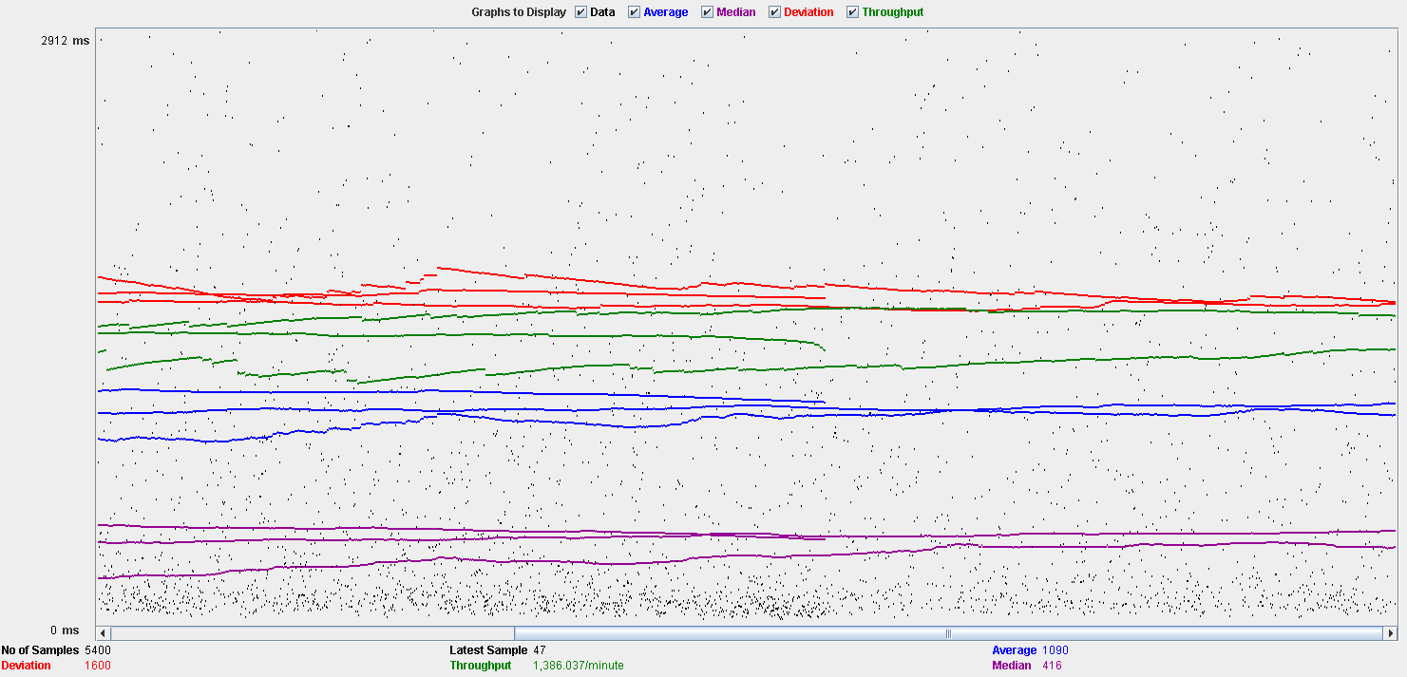

Performance Results:

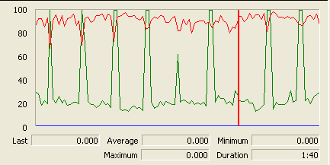

The CPU is always being used while the disk show many peaks.

## Edit

Sequence:

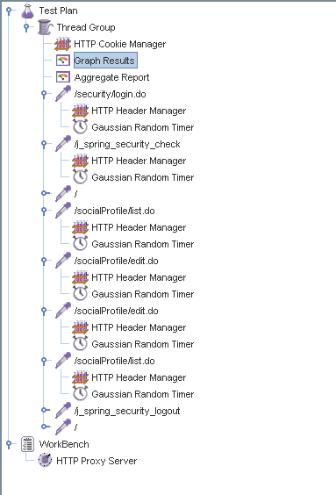

Aggregate Report:

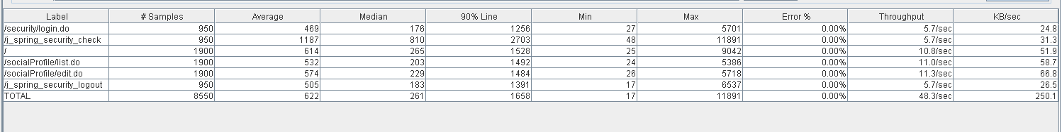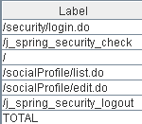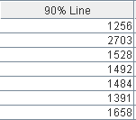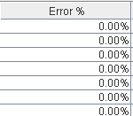

Thread properties:

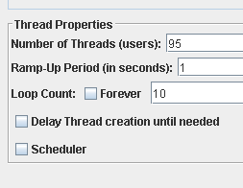

Graph Results:

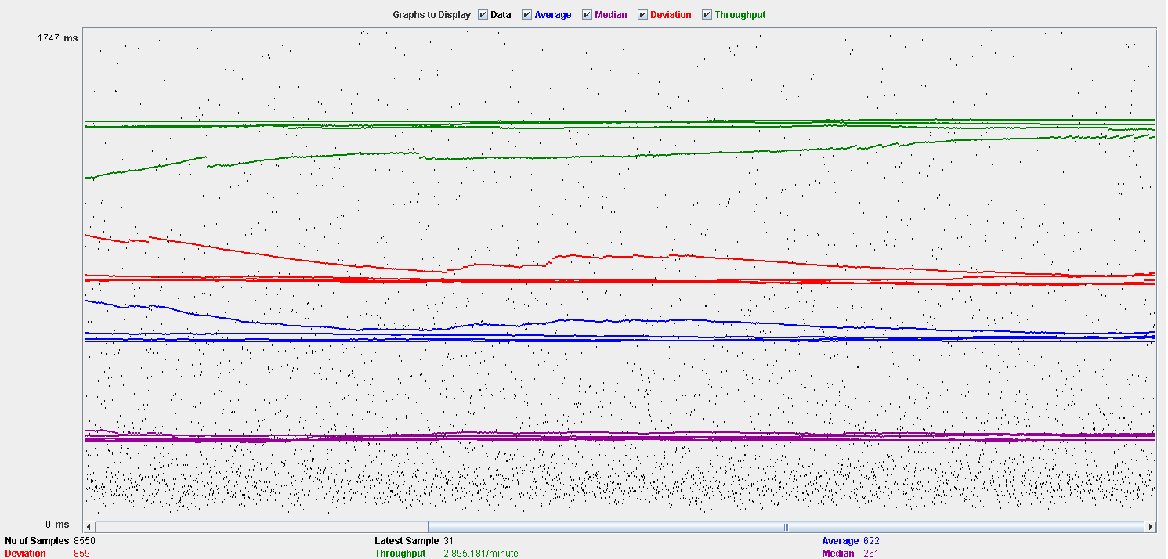

Performance Results:

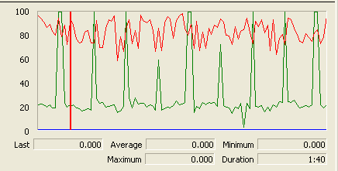

Again we can see that the CPU is always being used while the disk usage shows some periodic peaks.

## Delete

Sequence:

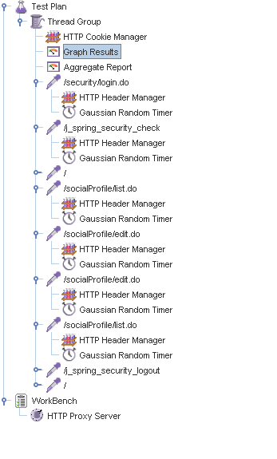

Aggregate Report:

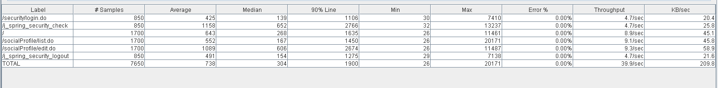

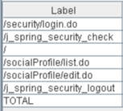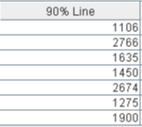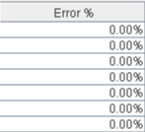

Thread properties:

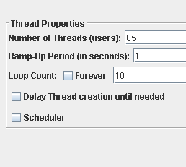.

Graph Results:

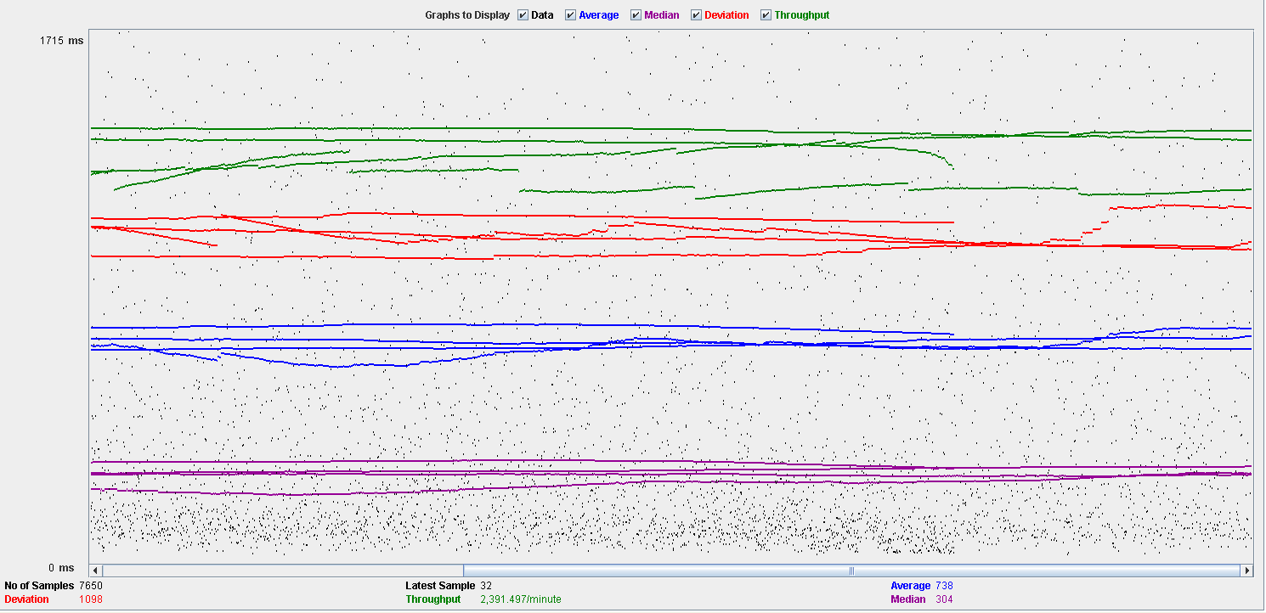

Performance Results:

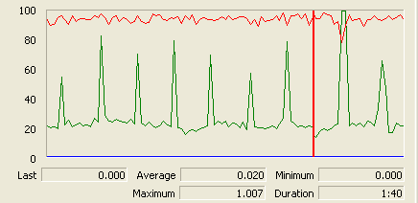

Again we can see that the CPU is always being used while the disk usage shows some peaks.

## Conclusion

The test was performed using:

CPU: i5 2500k (2 cores in the virtual machine)

RAM: 2 GB (virtual machine)

For this use case we can say that the limitation occurs during the creation process, being the maximum of concurrent users 60.

# Dashboard

## Show dashboard and launch all process

Sequence:

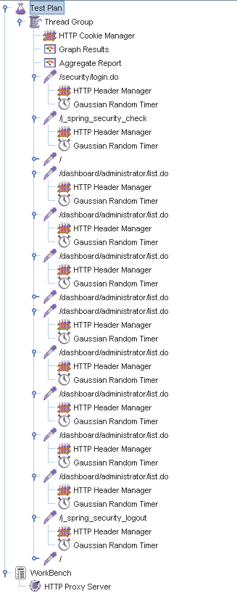

Aggregate Report:

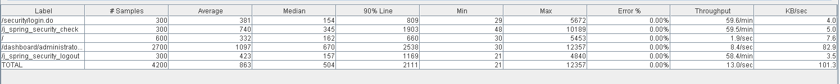

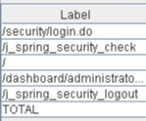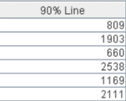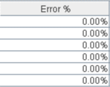

Thread properties:

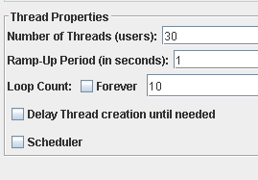

Graph Results:

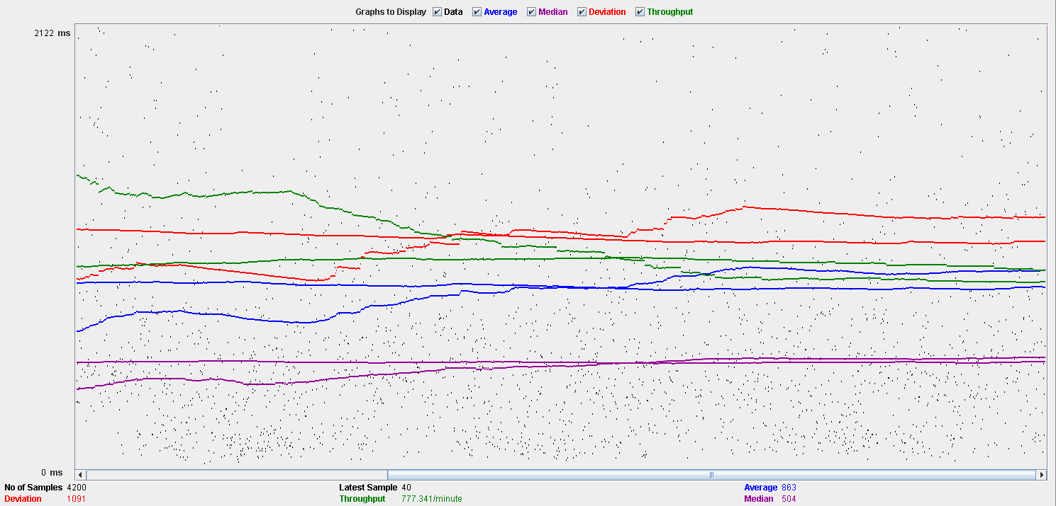

Performance Results:

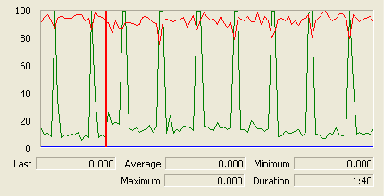

The CPU is always being used while the disk show some peaks.

## Conclusion

The test was performed using:

CPU: i5 2500k (2 cores in the virtual machine)

RAM: 2 GB (virtual machine)

For this use case we can say that the limitation around 30 users.

# Category

## Create

Sequence:

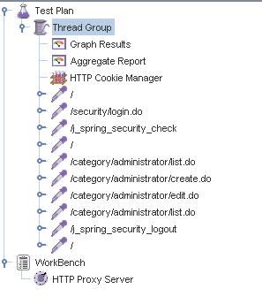

Aggregate Report:

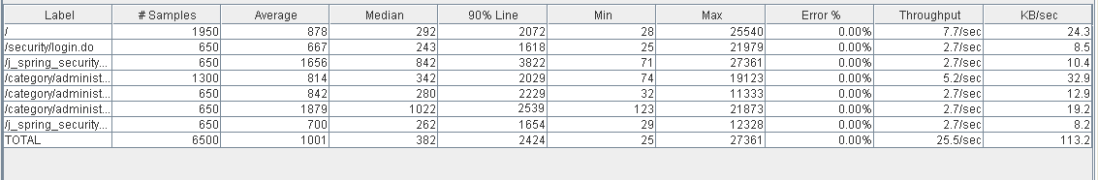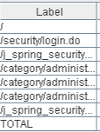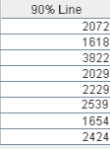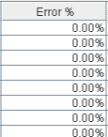

Thread properties:

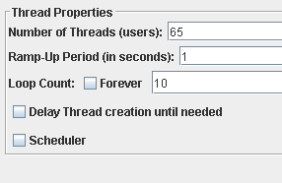

Graph Results:

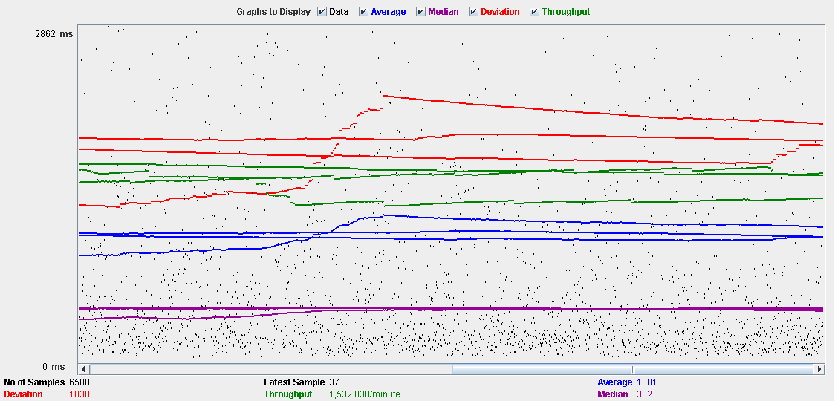

Performance Results:

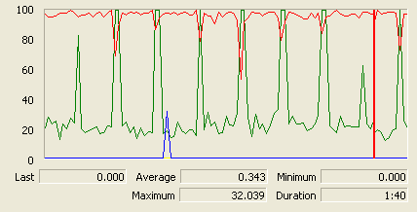

The CPU is always being used and disk show some peaks.

## Edit

Sequence:

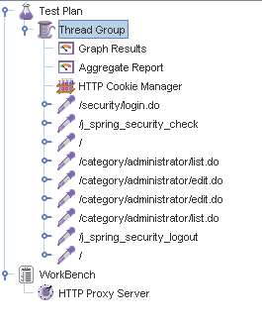

Aggregate Report:

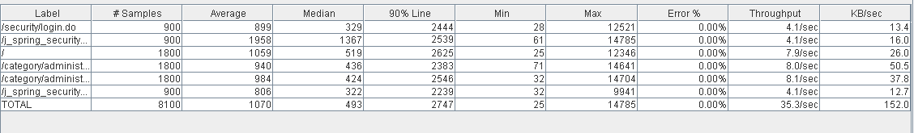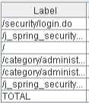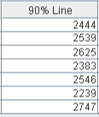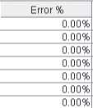

Thread properties:

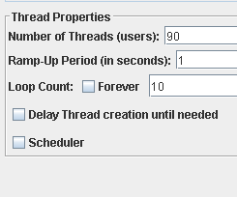

Graph Results:

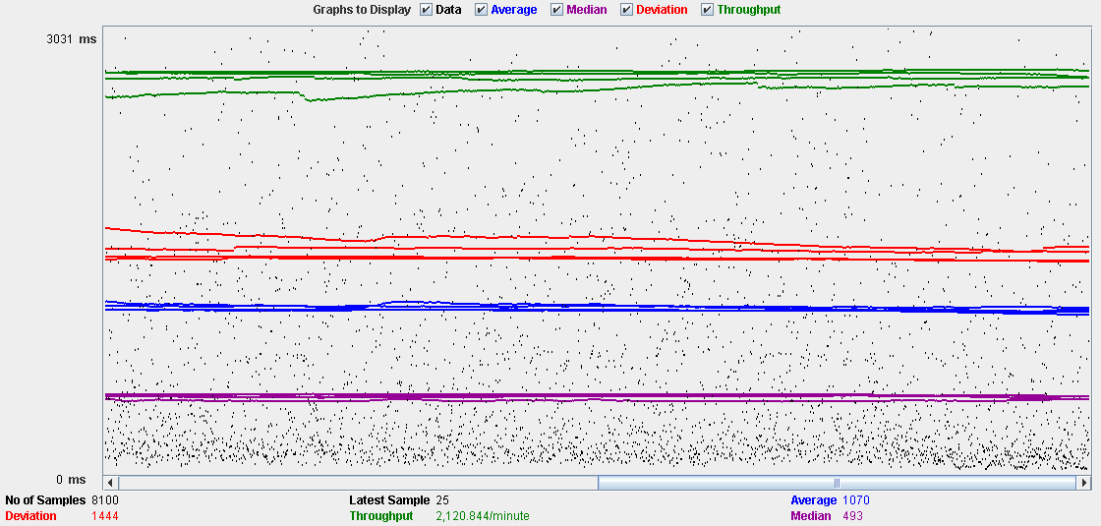

Performance Results:

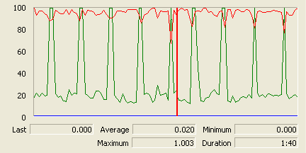

The CPU is always being used and the disk show som peaks.

## Delete

Sequence:

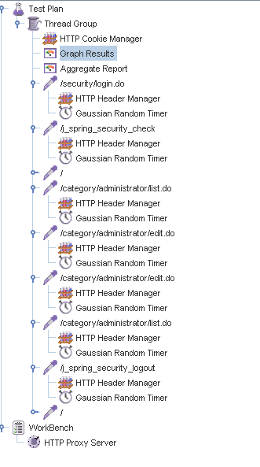

Aggregate Report:

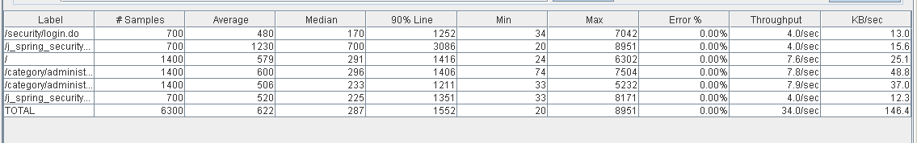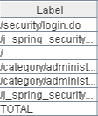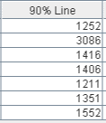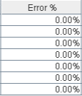

Thread properties:

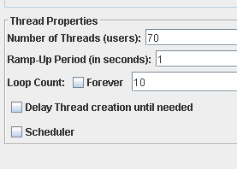

Graph Results:

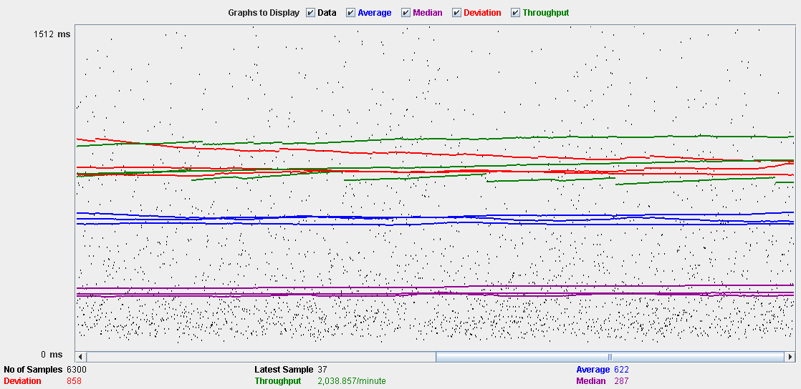

Performance Results:

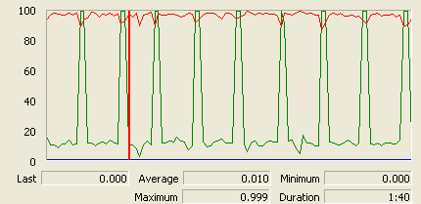

The CPU is always being used and disk show some peaks.

## Conclusion

The test was performed using:

CPU: i5 2500k (2 cores in the virtual machine)

RAM: 2 GB (virtual machine)

For this use case we can say that the limitation occurs during the create process, being the maximum of concurrent users 65.

# Request

## Create

Sequence:

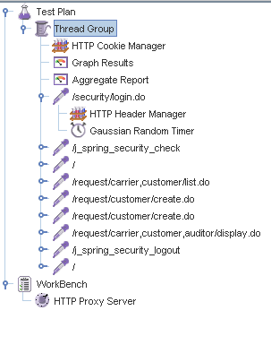

Aggregate Report:

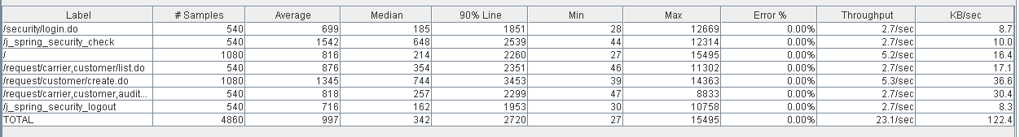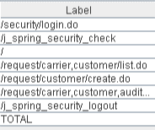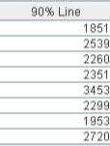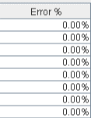

Thread properties:

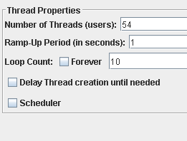

Graph Results:

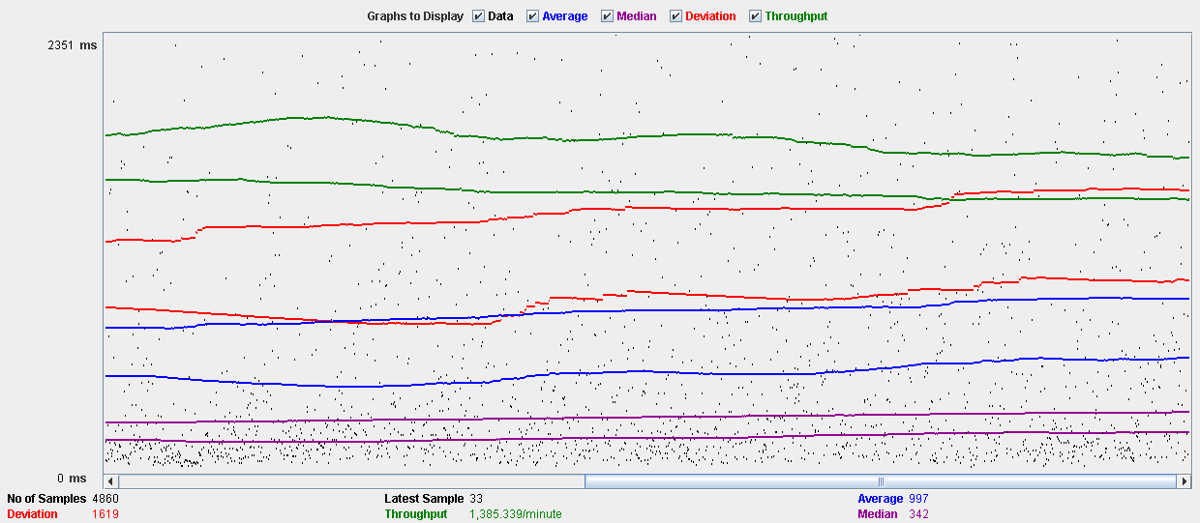

Performance Results:

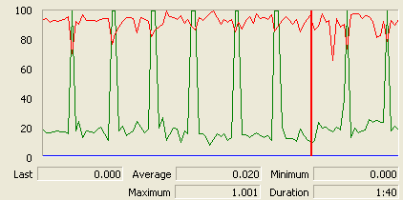

The CPU is always being used and physical disk show some peaks.

## Edit

Sequence:

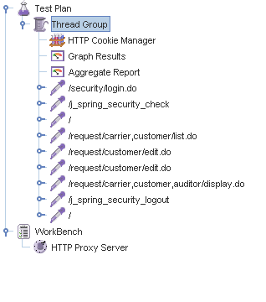

Aggregate Report:

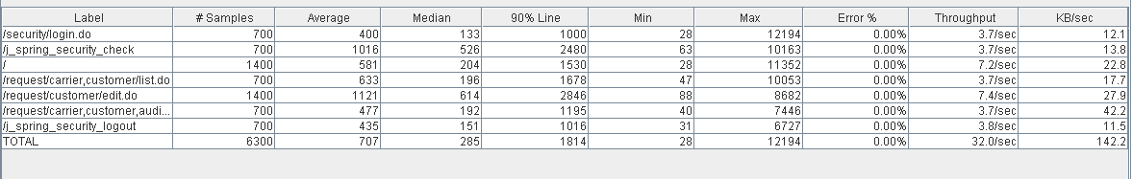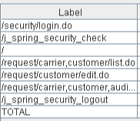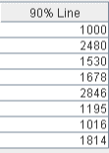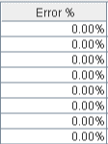

Thread properties:

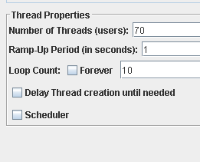

Graph Results:

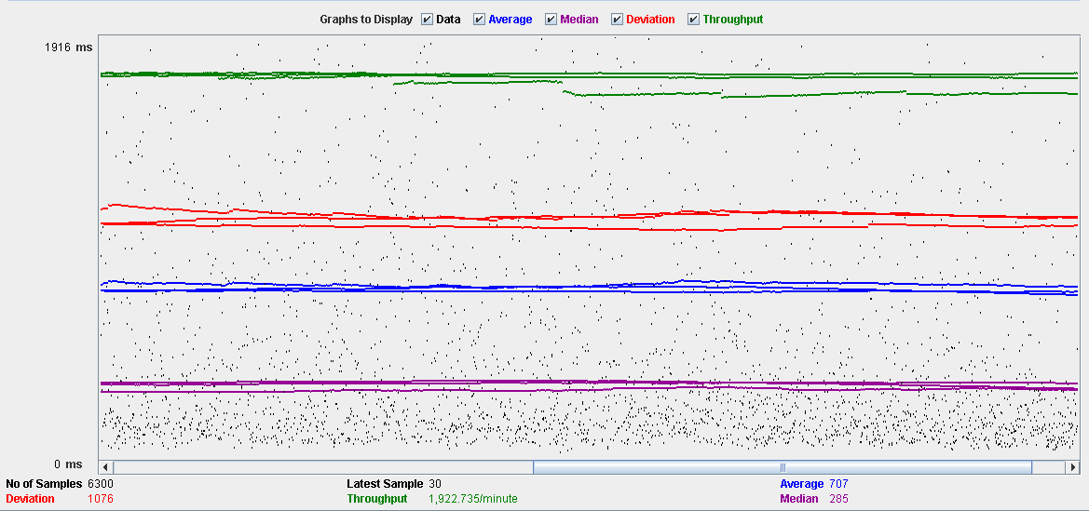

Performance Results:

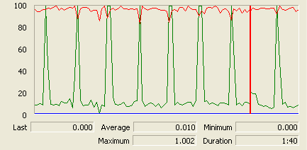

The CPU is always being used and disk show some peaks.

## Delete

Sequence:

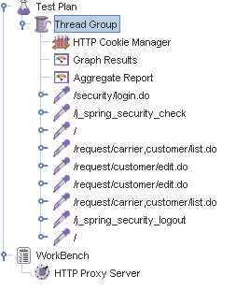

Aggregate Report:

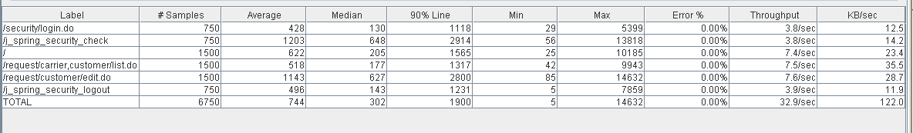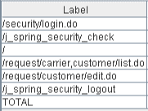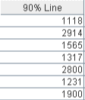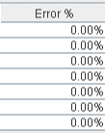

Thread properties:

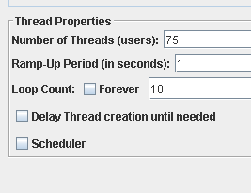

Graph Results:

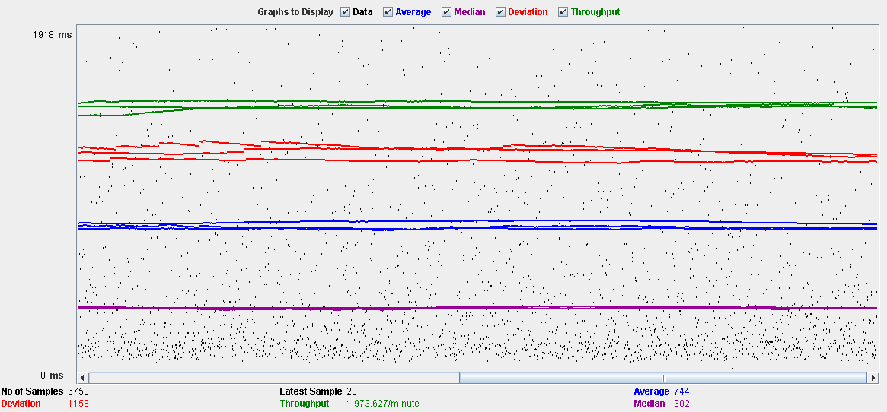

Performance Results:

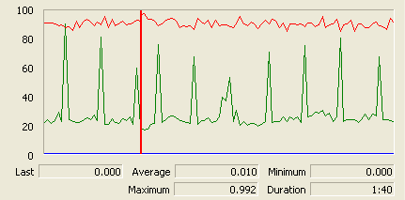

The CPU is always being used while the memory has some peaks.

## Conclusion

The test was performed using:

CPU: i5 2500kk (2 cores in the virtual machine)

RAM: 2 GB (virtual machine)

For this use case we can say that the limitation occurs during the creation process, being the maximum of concurrent users 54.

# TraverseTown

## Create

Sequence:

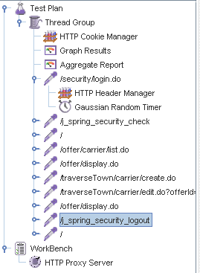

Aggregate Report:

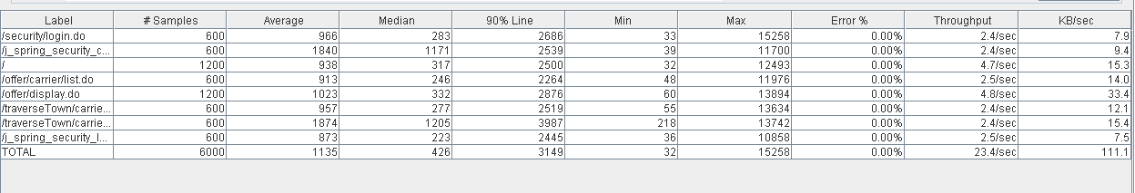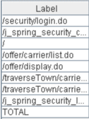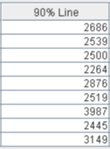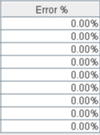

Thread properties:

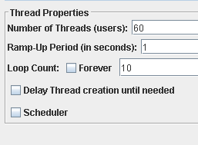

Graph Results:

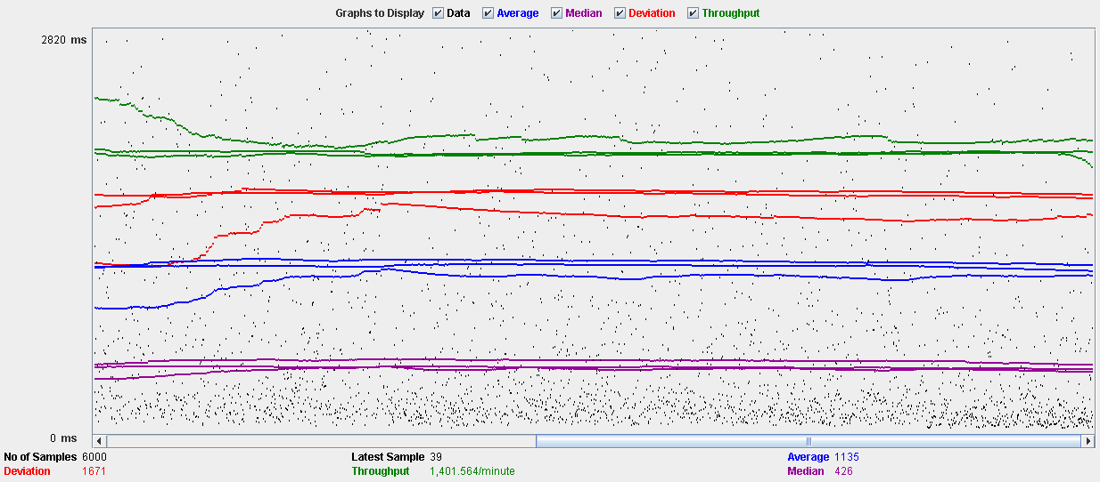

Performance Results:

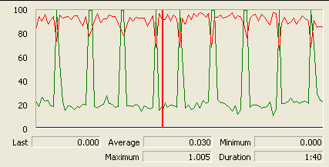

The CPU is always being used and physical disk show some peaks.

## Edit

Sequence:

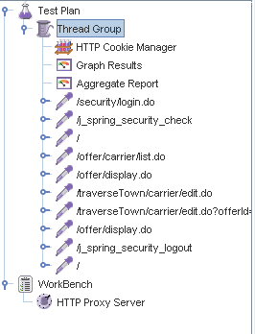

Aggregate Report:

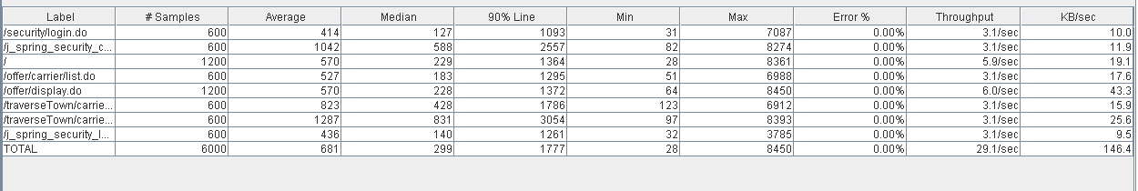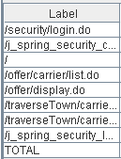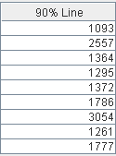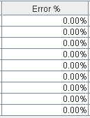

Thread properties:

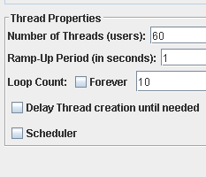

Graph Results:

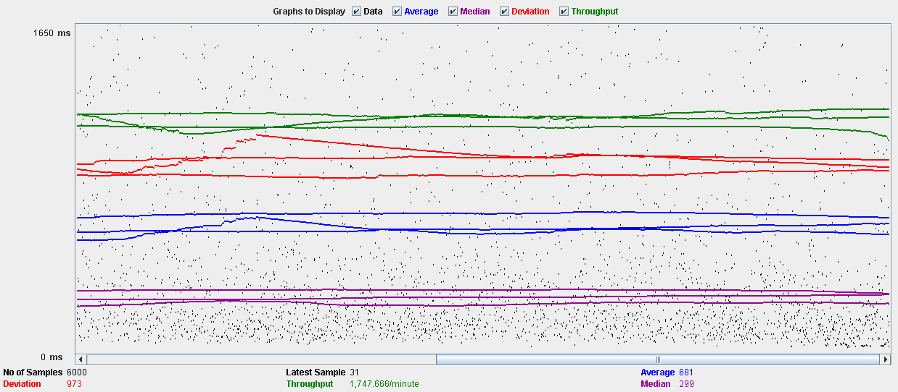

Performance Results:

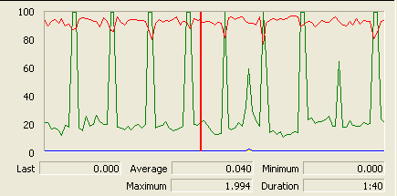

The CPU is always being used and disk show some peaks

## Delete

Sequence:

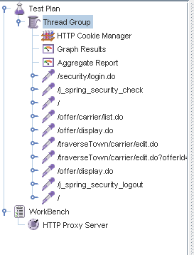

Aggregate Report:

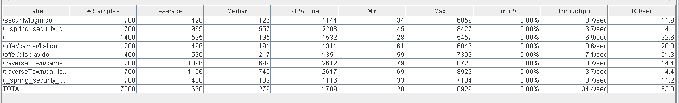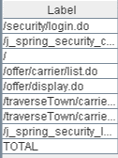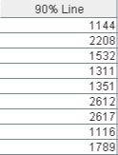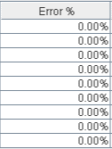

Thread properties:

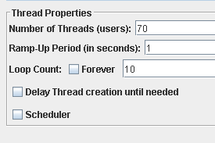

Graph Results:

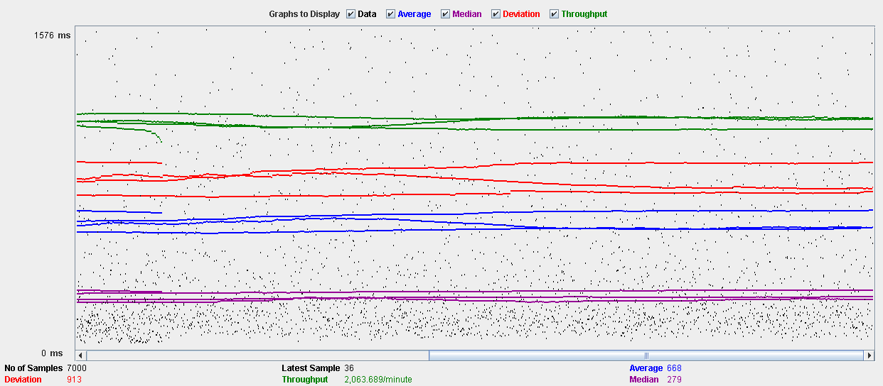

Performance Results:

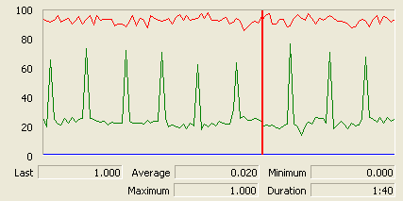

The CPU is always being used while the memory has some peaks.

## Conclusion

The test was performed using:

CPU: i5 2500k (2 cores in the virtual machine)

RAM: 2 GB (virtual machine)

For this use case we can say that the limitation occurs during the creation and edition process, being the maximum of concurrent users 60.

# Issue

## Create

Sequence:

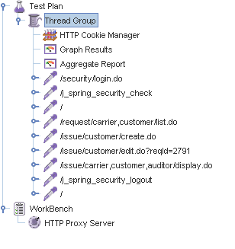

Aggregate Report:

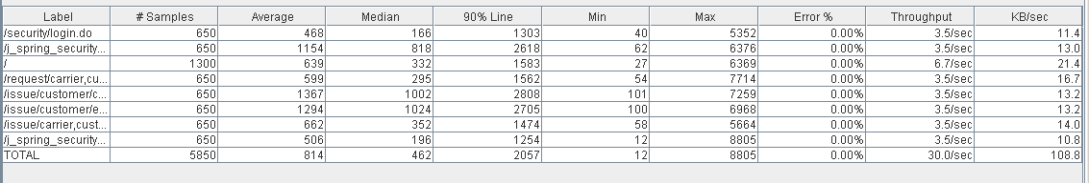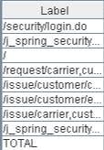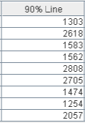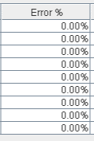

Thread properties:

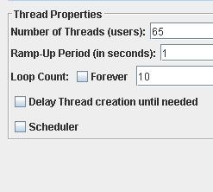

Graph Results:

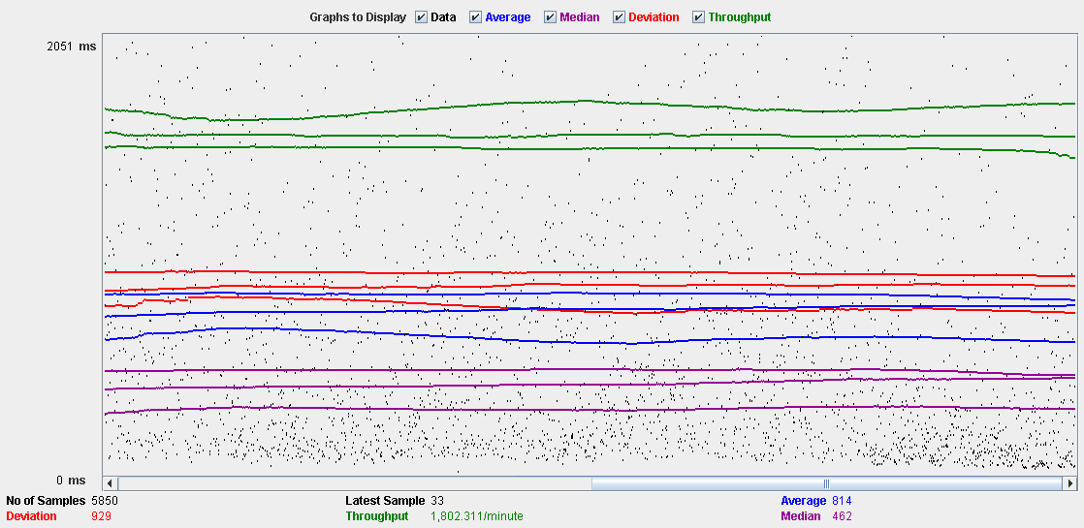

Performance Results:

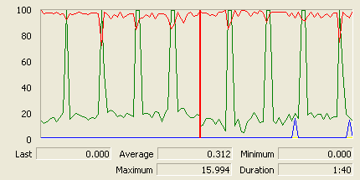

The CPU is always being used and physical disk usage show some peaks.

## Delete

Sequence:

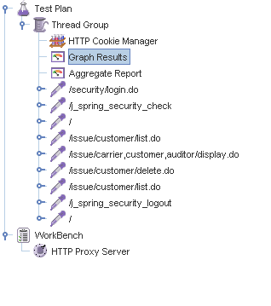

Aggregate Report:

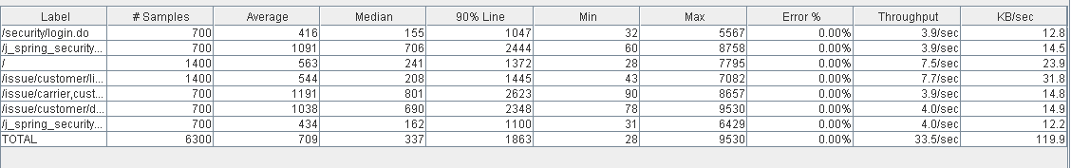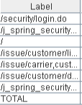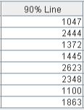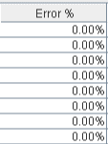

Thread properties:

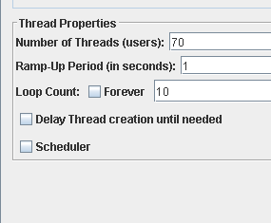

Graph Results:

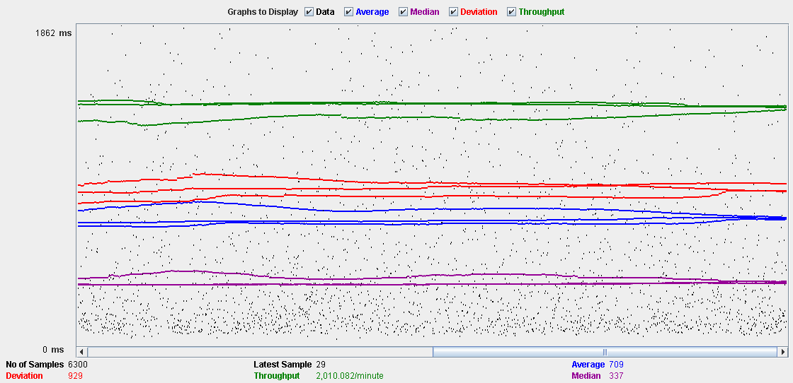

Performance Results:

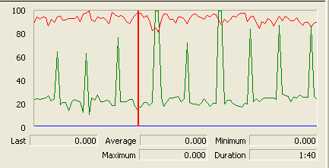

The CPU is always being used and disk show some peaks-

## Conclusion

The test was performed using:

CPU: i5 2500k (2 cores in the virtual machine)

RAM: 2 GB (virtual machine)

For this use case we can say that the limitation occurs during the create process, being the maximum of concurrent users 65.

# Town

## Create

Sequence:

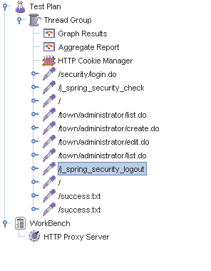

Aggregate Report:

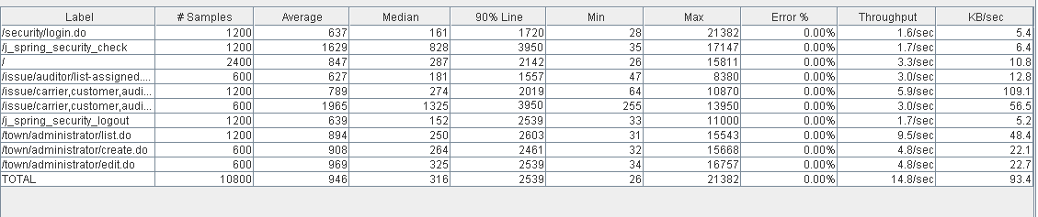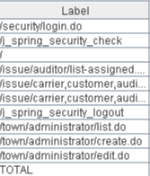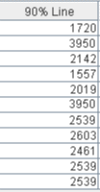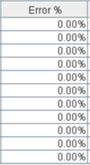

Thread properties:

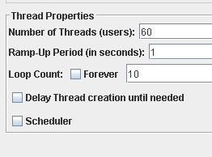

Graph Results:

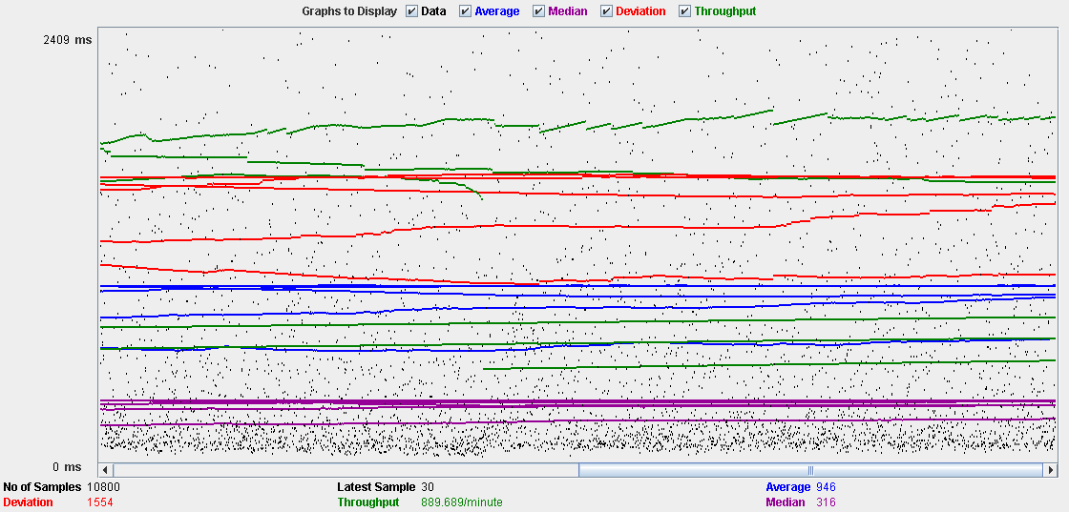

Performance Results:

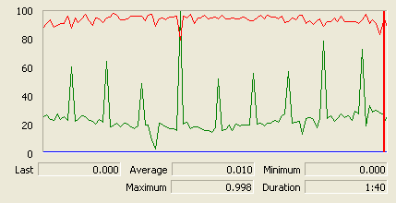

The CPU is always being used and physical disk usage show some peaks.

## Edit

Sequence:

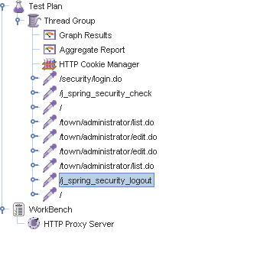

Aggregate Report:

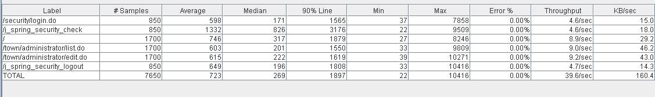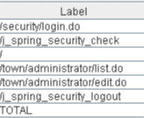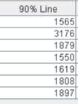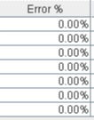

Thread properties:

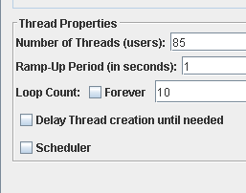

Graph Results:

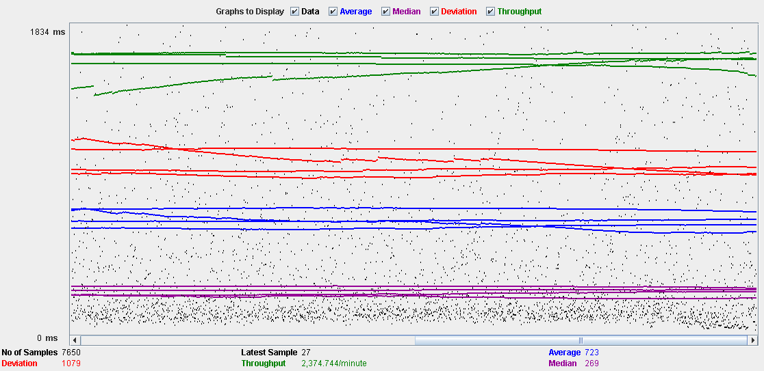

Performance Results:

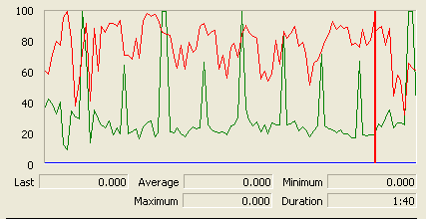

The CPU is always being used and small picks of physical disk

## Delete

Sequence:

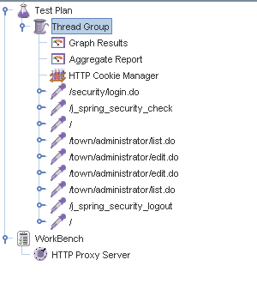

Aggregate Report:

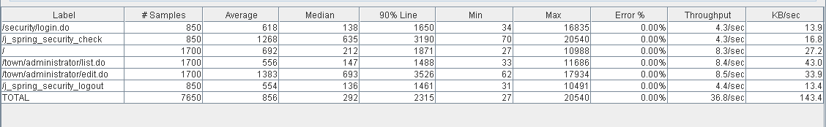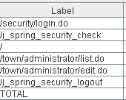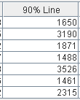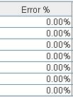

Thread properties:

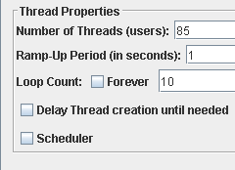

Graph Results:

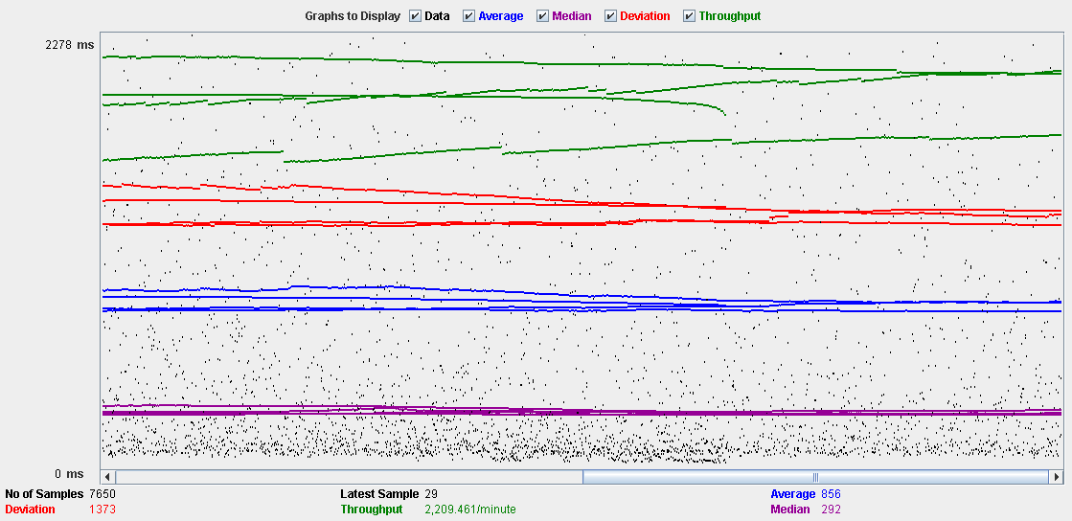

Performance Results:

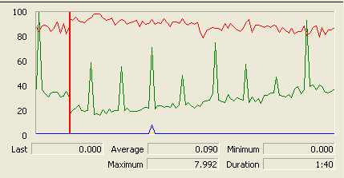

The CPU is always being used while the memory has some peaks.

## Conclusion

The test was performed using:

CPU: i5 2500k (2 cores in the virtual machine)

RAM: 2 GB (virtual machine)

For this use case we can say that the limitation occurs during the create process, being the maximum of concurrent users 60.

# Comment

## Create

Sequence:

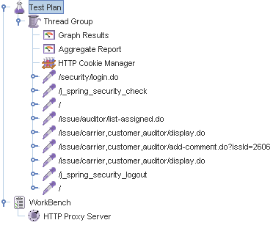

Aggregate Report:

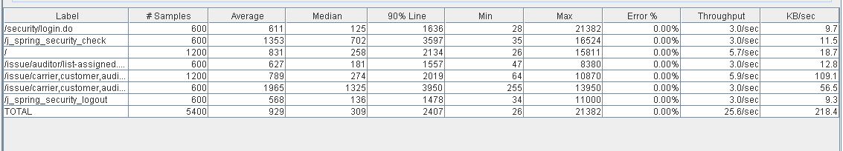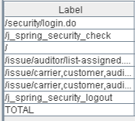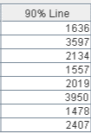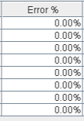

Thread properties:

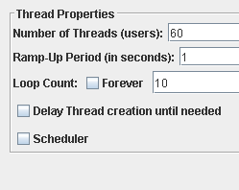

Graph Results:

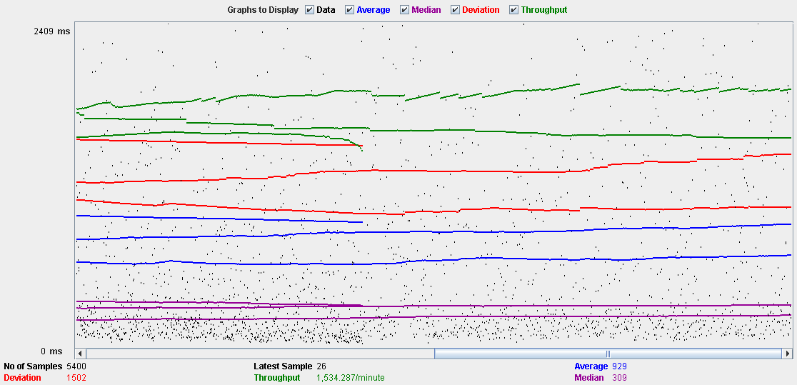

Performance Results:

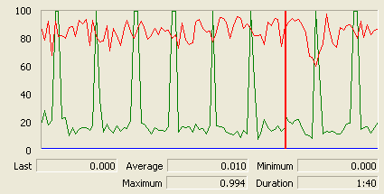

The CPU is always being used and physical disk usage is barely noticeable.

## Conclusion

The test was performed using:

CPU: i5 2500k (2 cores in the virtual machine)

RAM: 2 GB (virtual machine)

For this use case we can say that the limitation occurs with 60 users.

# Configuration

## Display and edit

Sequence:

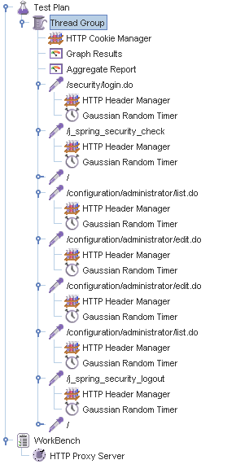

Aggregate Report:

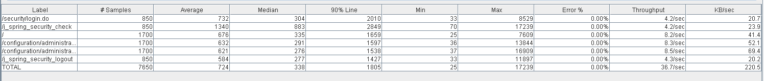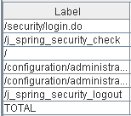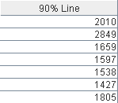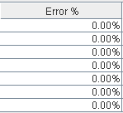

Thread properties:

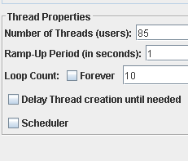

Graph Results:

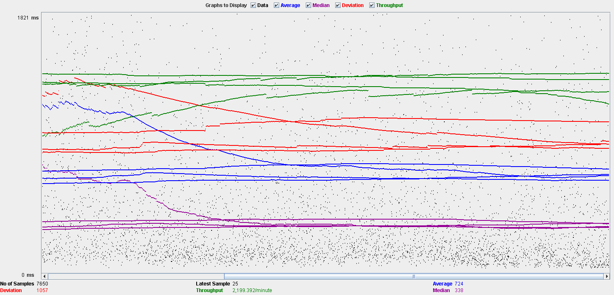

Performance Results:

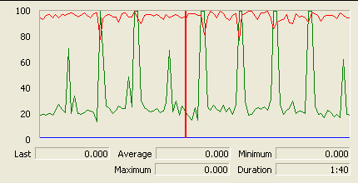

The CPU is always being used and physical disk usage show some peaks.

## Conclusion

The test was performed using:

CPU: i5 2500k (2 cores in the virtual machine)

RAM: 2 GB (virtual machine)

For this use case we can say that the limitation occurs during the edition process, being the maximum of concurrent users 85.

# Finder

## Search

Sequence:

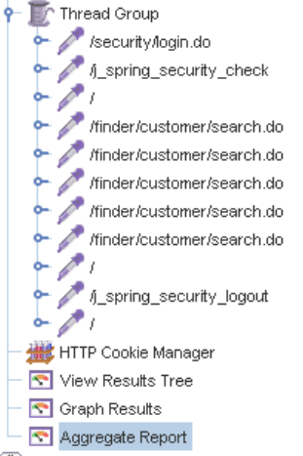

Aggregate Report:

 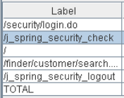 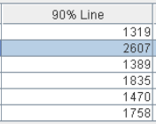 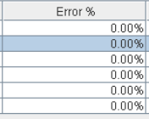

Thread properties:

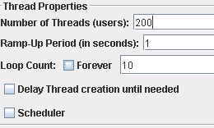

Graph Results:

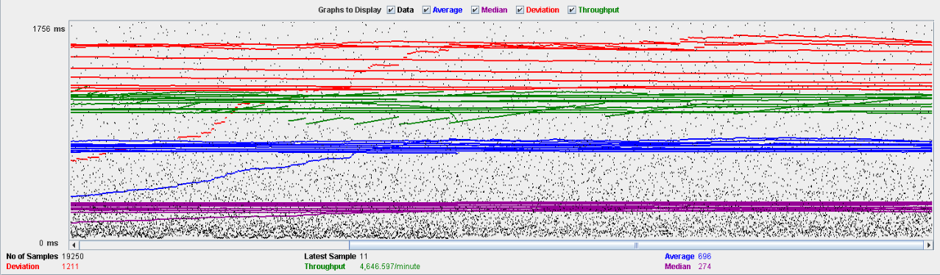

Performance Results:

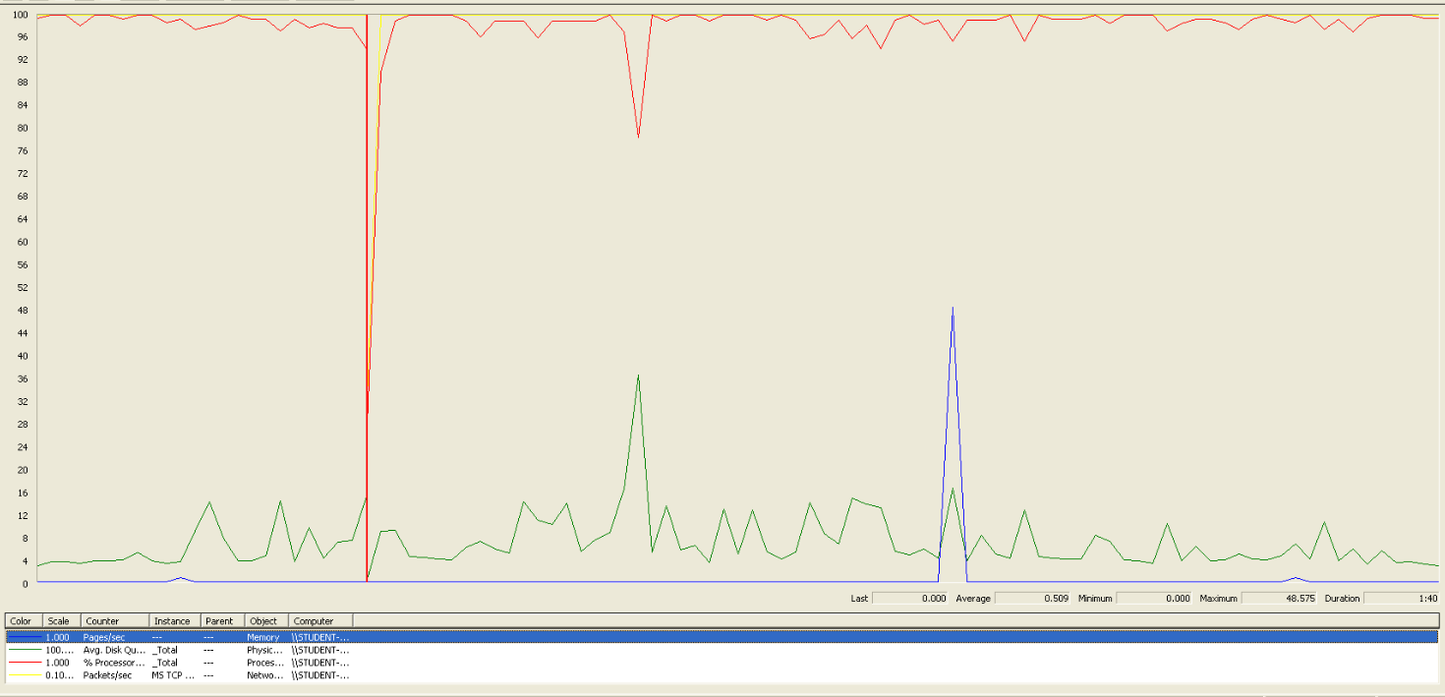

We can clearly see that the bottleneck is the CPU.

## Conclusion

The test was performed using:

CPU: i5 7300HQ (2 cores in the virtual machine)

RAM: 2 GB (virtual machine)

For this use case we can say that the maximum of concurrent users is about 200.

# Offer

## Create/Edit

Sequence:

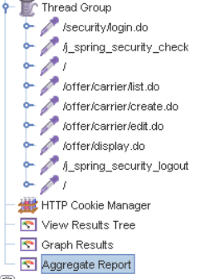

Aggregate Report:

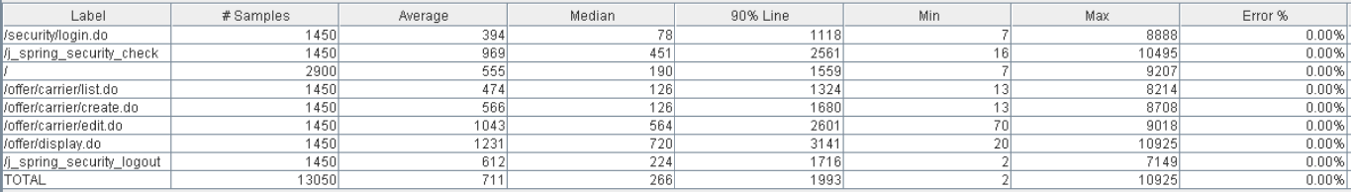 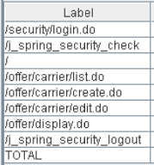 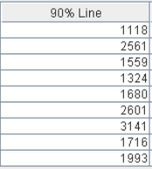 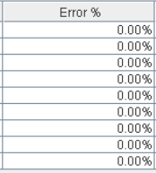

Thread properties:

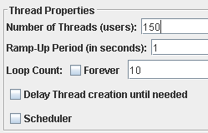

Graph Results:

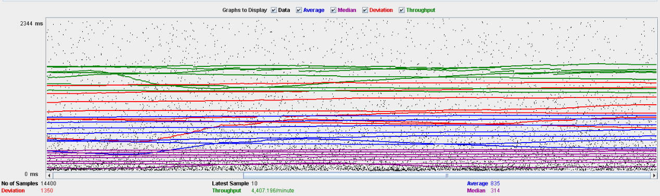

Performance Results:

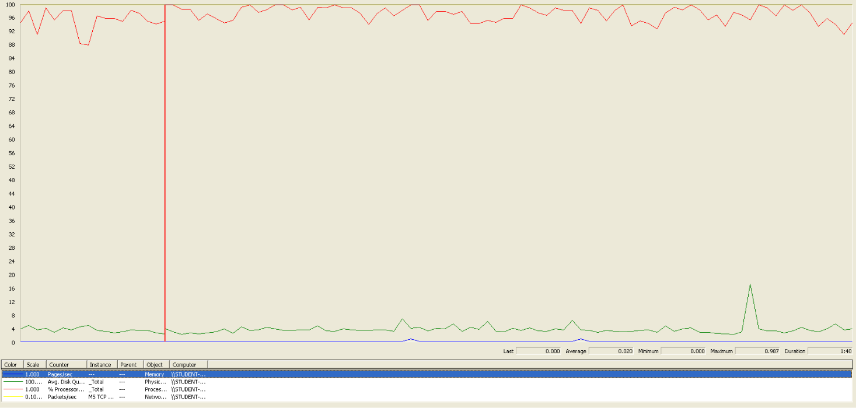

We can clearly see that the bottleneck is the CPU.

## Delete

Sequence:

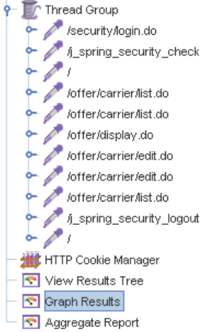

Aggregate Report:

 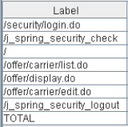 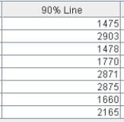 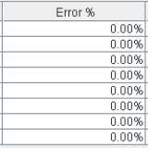

Thread properties:

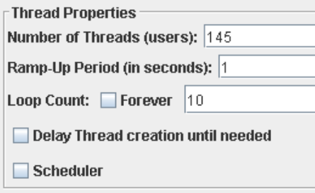

Graph Results:

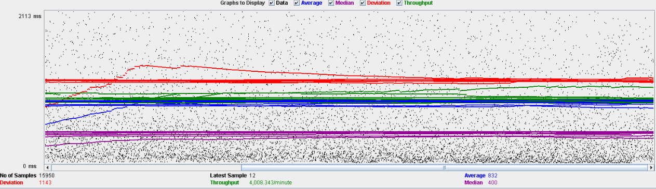

Performance Results:

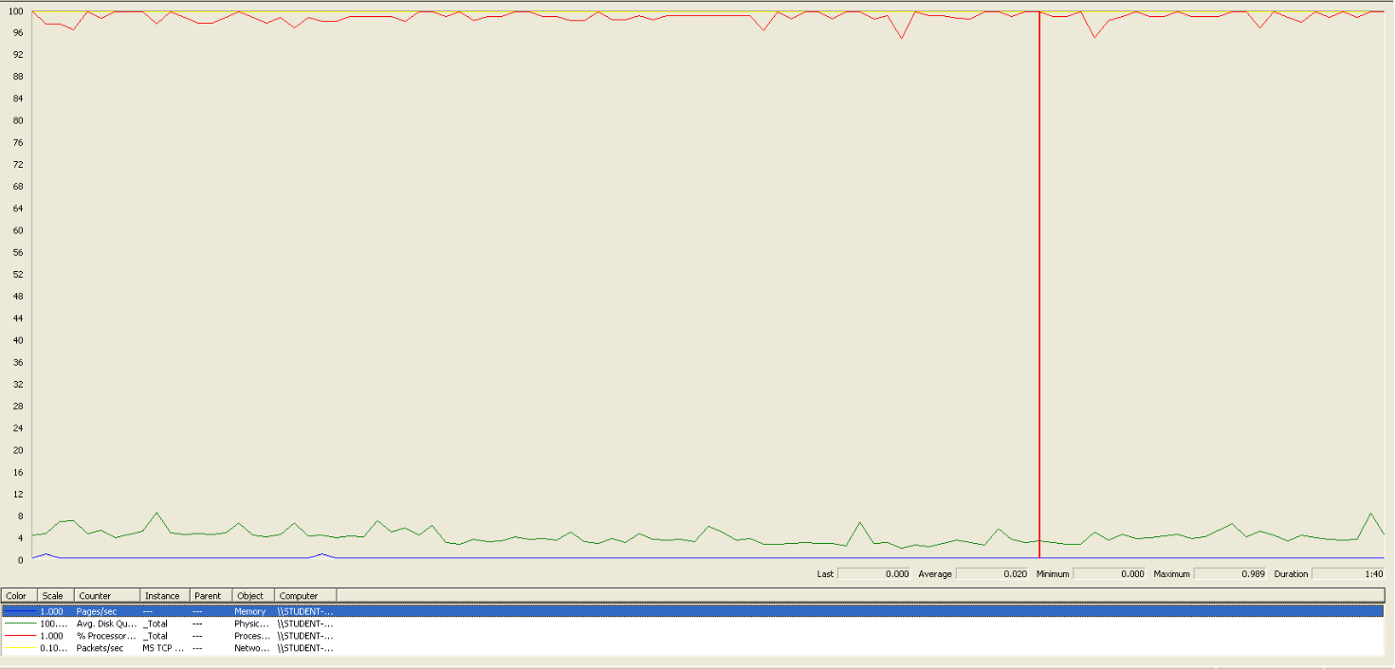

We can clearly see, another time, that the bottleneck is the CPU.

## Conclusion

The test was performed using:

CPU: i5 7300HQ (2 cores in the virtual machine)

RAM: 2 GB (virtual machine)

For this use case we can say that the maximum of concurrent users is about 145, delimited by the delete.

# TODO DE AQUI PABAJO SE BORRA

# Position

## Create

Sequence:

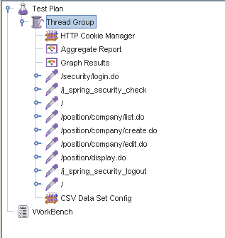

Aggregate Report:

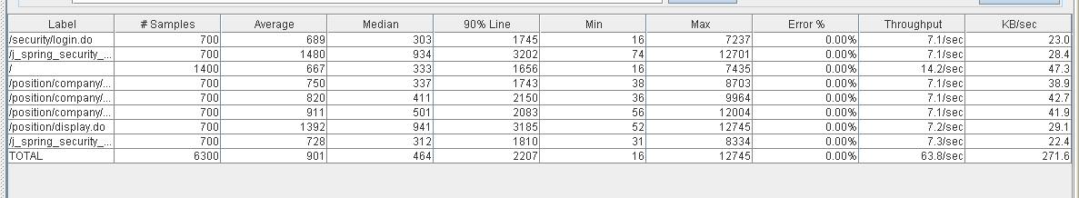

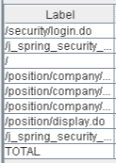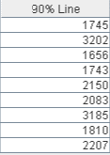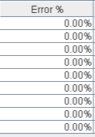

Thread properties:

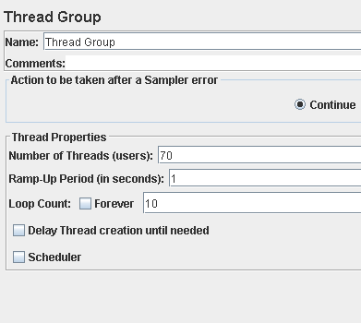

Graph Results:

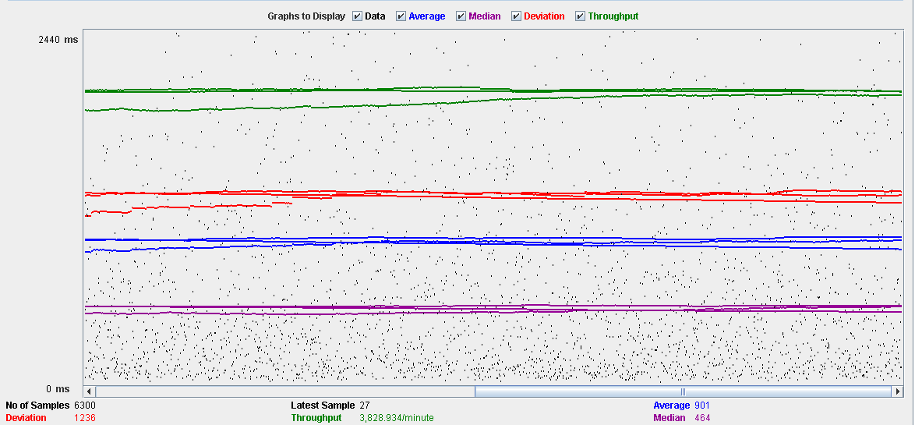

Performance Results:

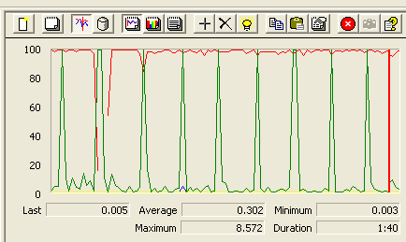

The CPU was always at its limit while the disk usage showed many peaks.

## Edit

Sequence:

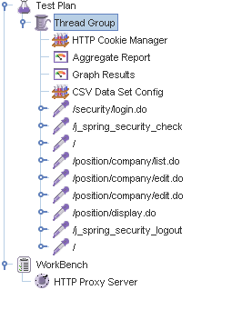

Aggregate Report:

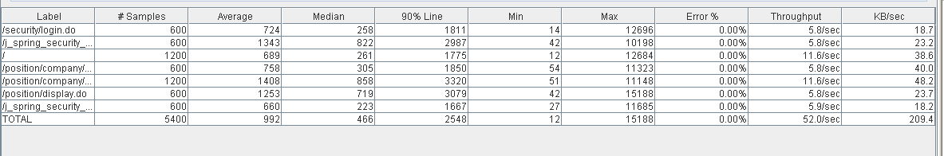

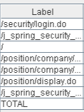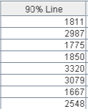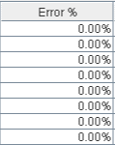

Thread properties:

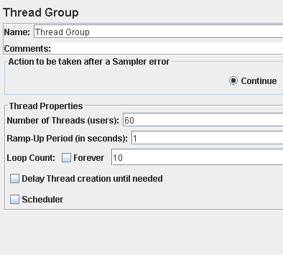

Graph Results:

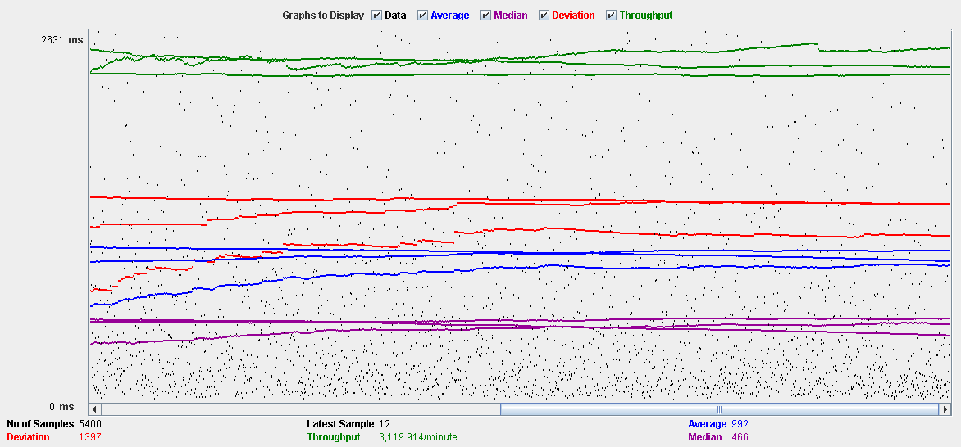

Performance Results:

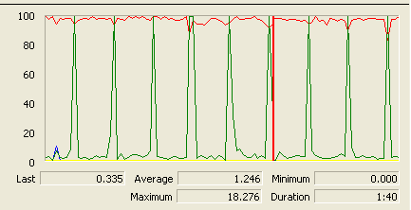

Again we can see that the CPU is always being used while the disk usage shows some periodic peaks.

## Delete

Sequence:

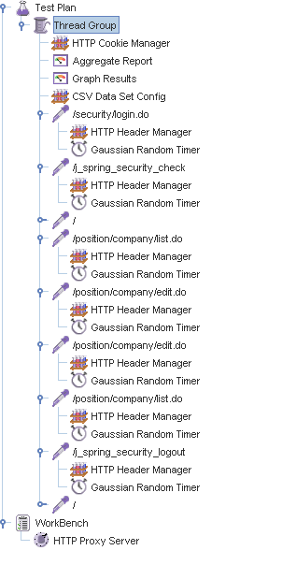

Aggregate Report:

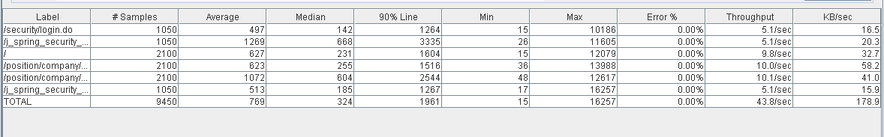

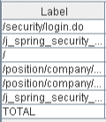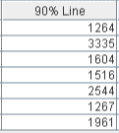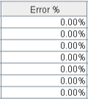

Thread properties:

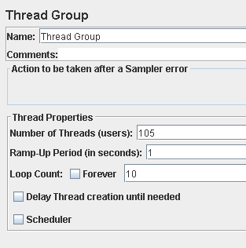.

Graph Results:

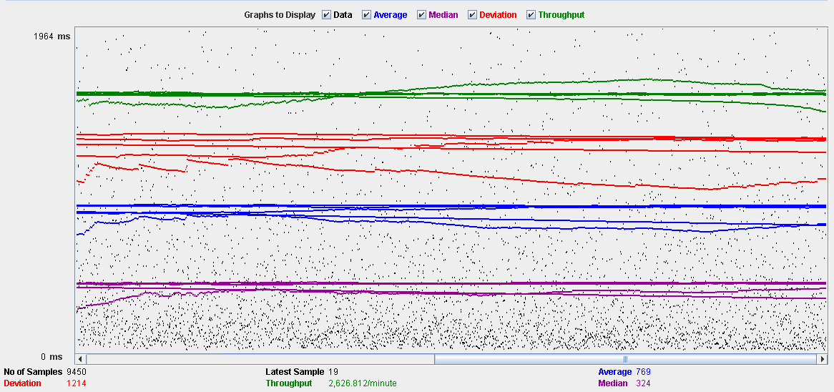

Performance Results:

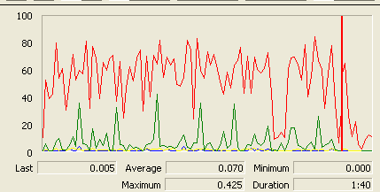

Again we can see that the CPU is always being used while the disk usage shows some peaks.

## Conclusion

The test was performed using:

CPU: 5 2500k (2 cores in the virtual machine)

RAM: 2 GB (virtual machine)

For this use case we can say that the limitation occurs during the edit process, being the maximum of concurrent users 60 because the time of respond starts to be very high at that point.

# Mess

## Search by tags, list by that tag and display a mess

Sequence:

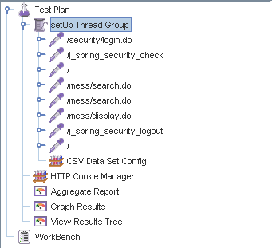

Aggregate Report:

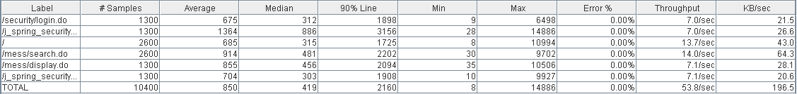

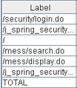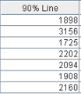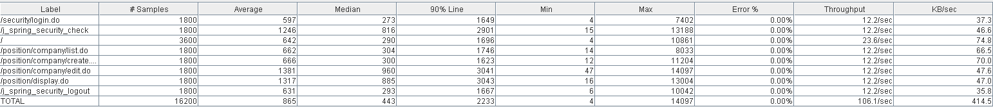

Thread properties:

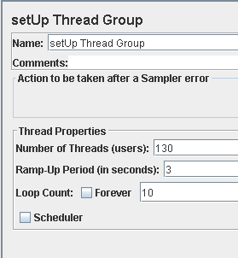

Graph Results:

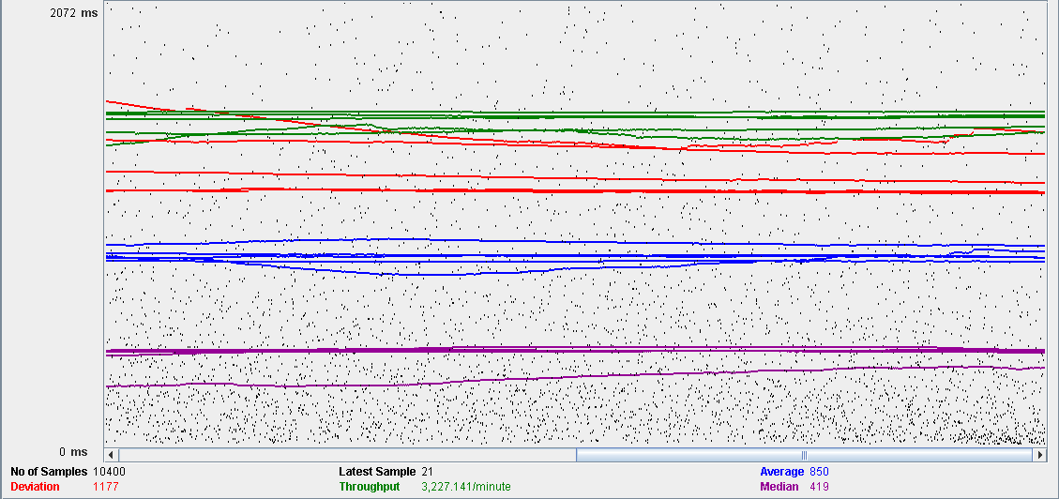

Performance Results:

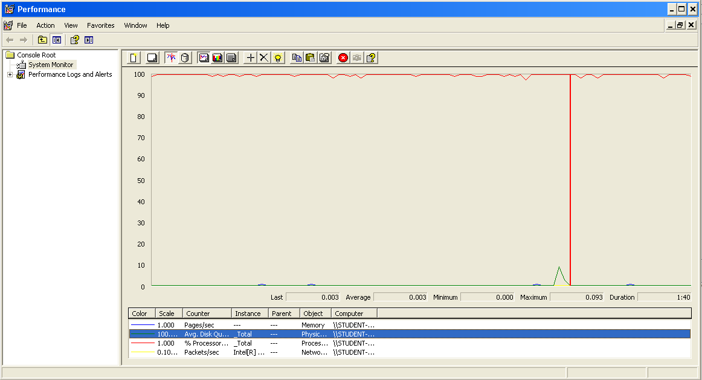

The CPU was always at its limit while the disk usage showed many peaks.

## Send a message

Sequence:

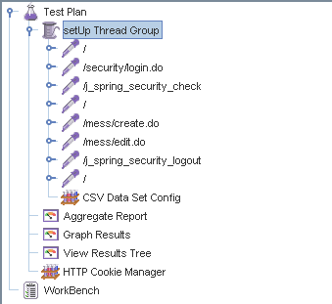

Aggregate Report:



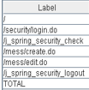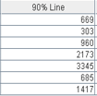

Thread properties:

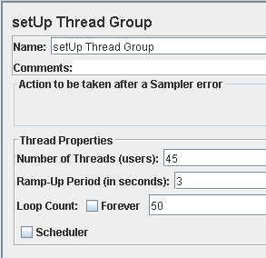

Graph Results:

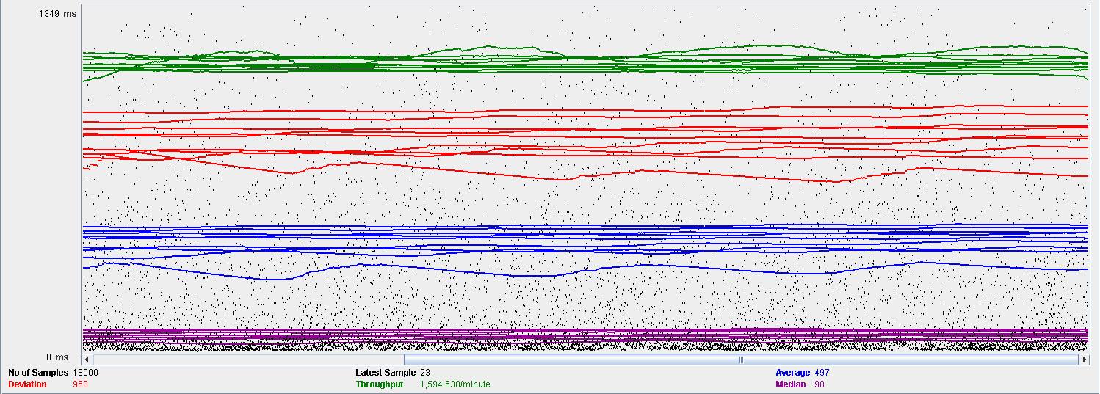

Performance Results:

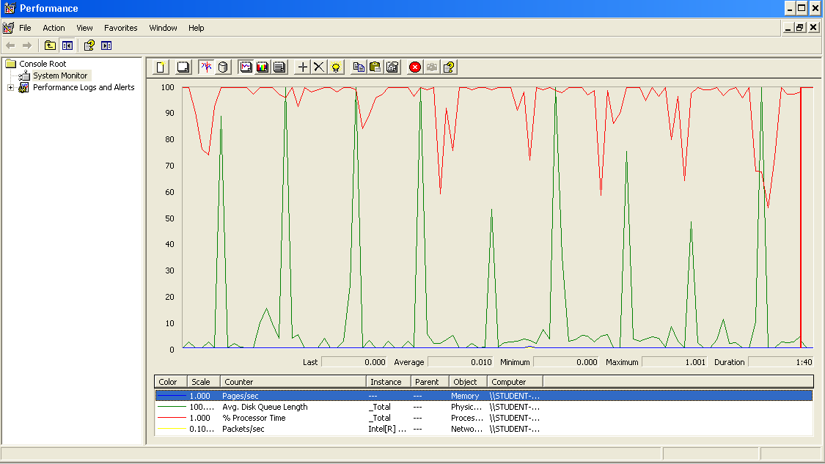

Again we can see that the CPU is always being used while the disk usage shows some periodic peaks.

## Delete a message

Sequence:

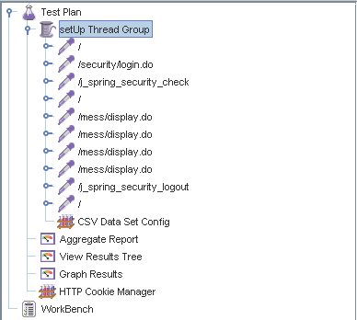

Aggregate Report:

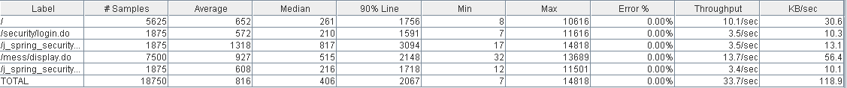

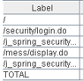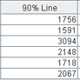

Thread properties:

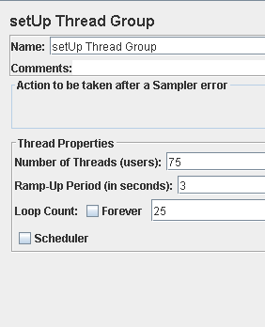

Graph Results:

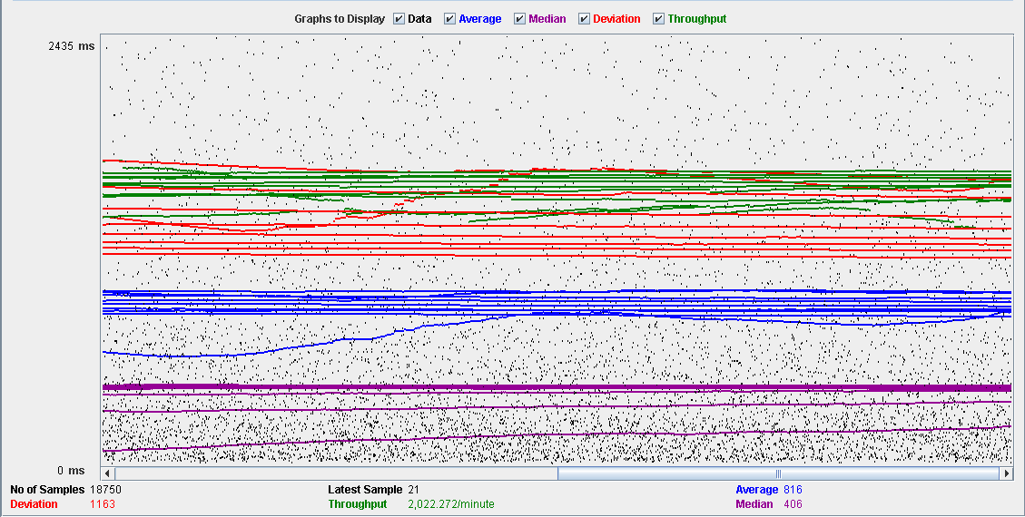

Performance Results:

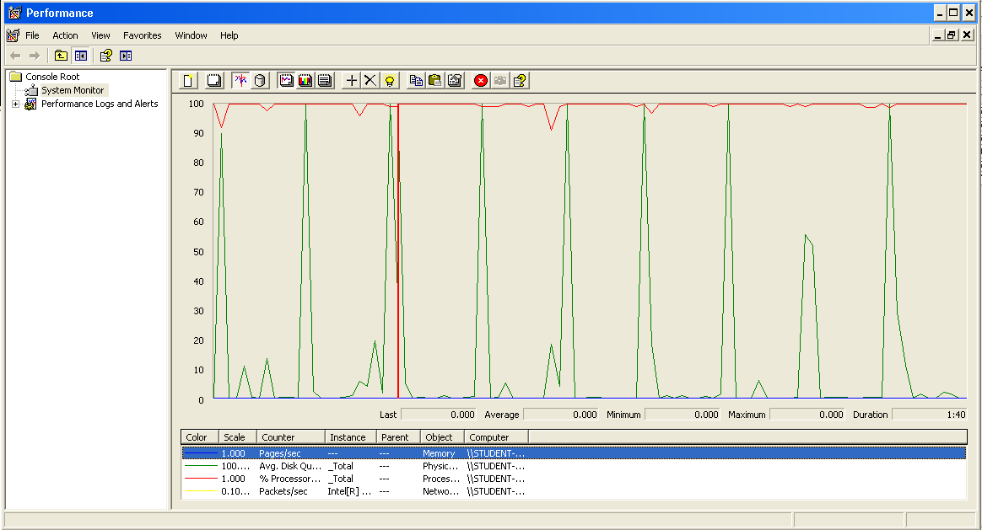

Again we can see that the CPU is always being used while the disk usage shows some periodic peaks.

## Send a broadcast mess

Sequence:

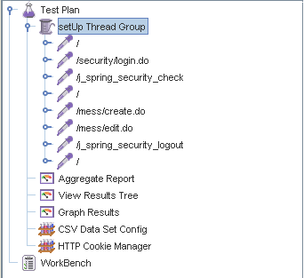

Aggregate Report:

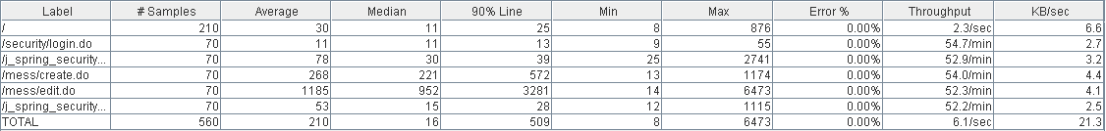

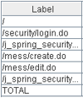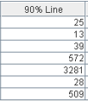

Thread properties:

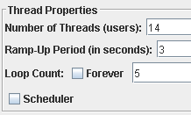

Graph Results:

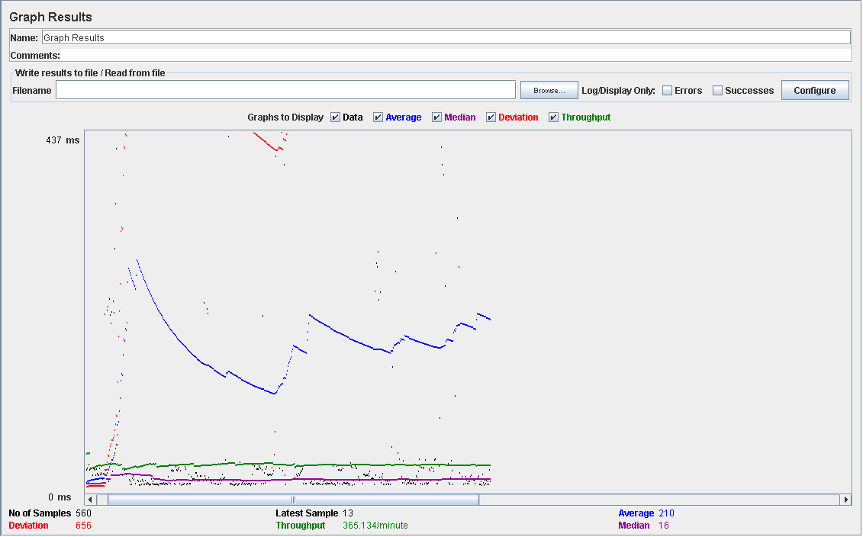

Performance Results:

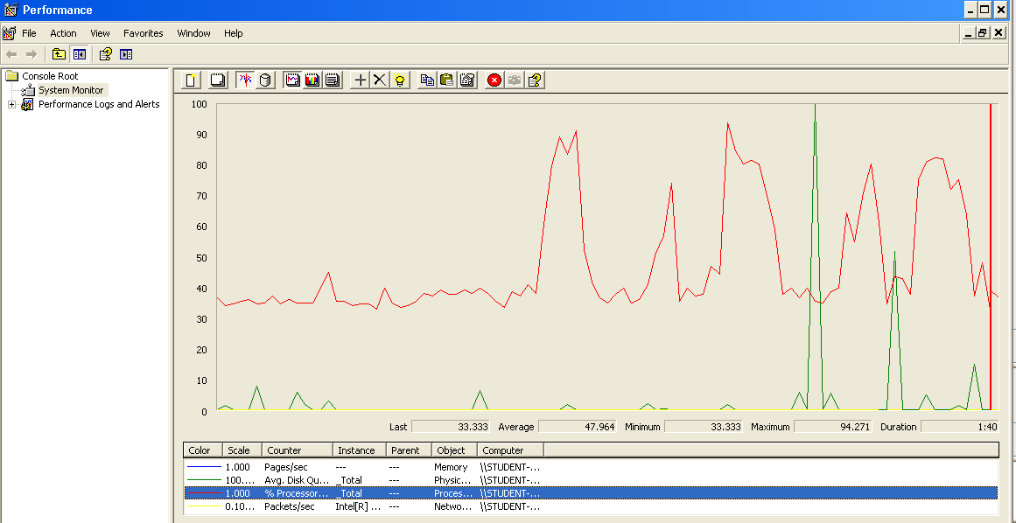

Again we can see that the CPU is always being used while the disk usage shows some peaks.

## Conclusion

The test was performed using:

CPU: i7 7700HQ (2 cores in the virtual machine)

RAM: 2 GB (virtual machine)

For this use case we can say that the limitation occurs during the creation process, being the maximum of concurrent users 14.

# Dashboard

## Display the dashboard and set the spammers

Sequence:

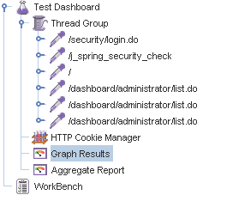

Aggregate Report:

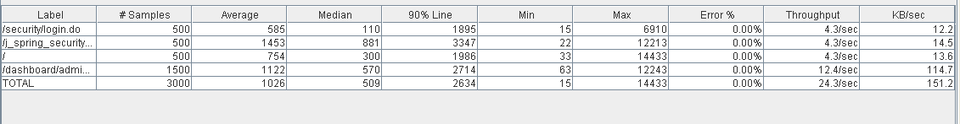

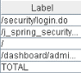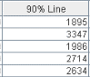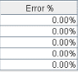

Thread properties:

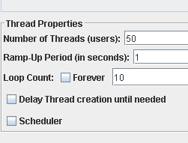

Graph Results:

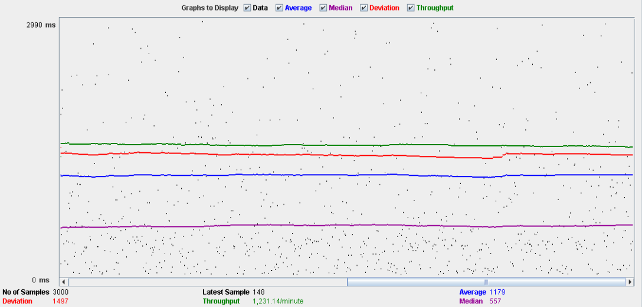

Performance Results:

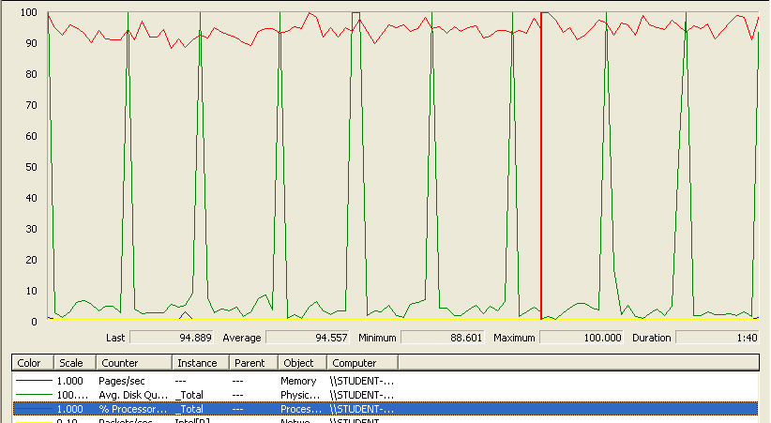

The CPU was always at its limit while the disk usage showed many peaks.

## Conclusion

The test was performed using:

CPU: i5 2500K (2 cores in the virtual machine)

RAM: 2 GB (virtual machine)

For this use case we can say that the limitation occurs around 50 users when the time of respond begins to be very high.

# Configuration

## Display the configuration and edit it

Sequence:

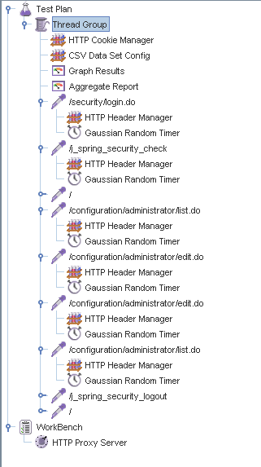

Aggregate Report:

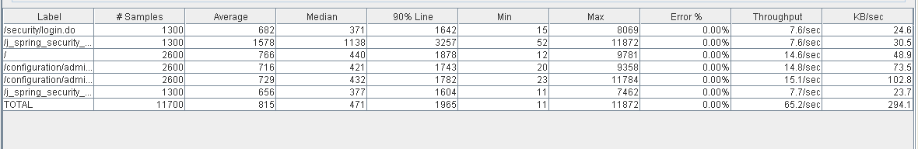

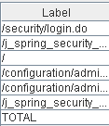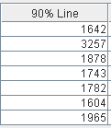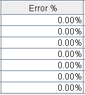

Thread properties:

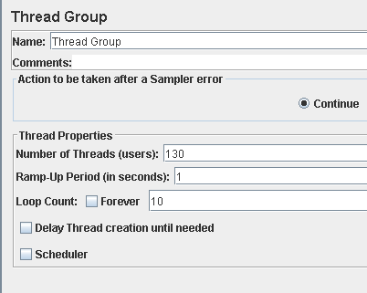

Graph Results:

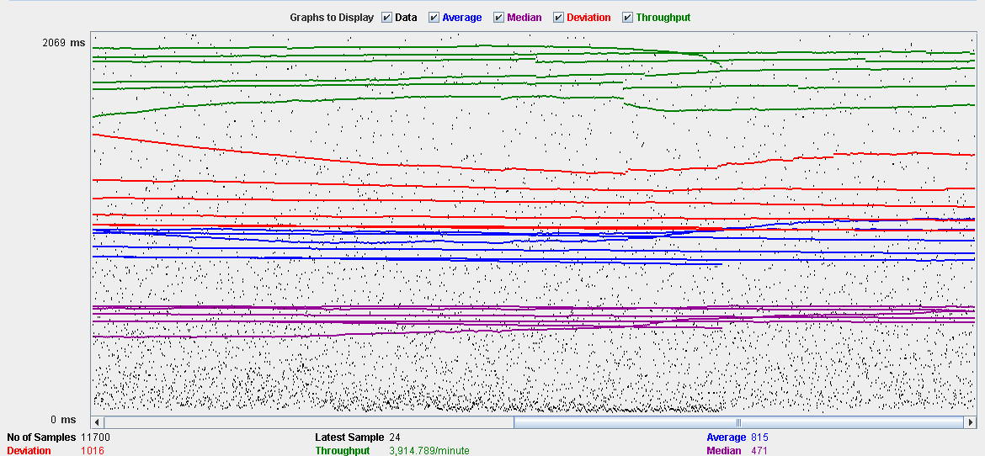

Performance Results:

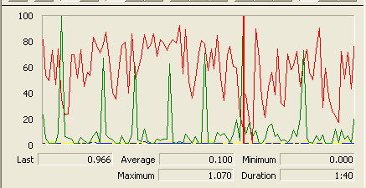

The CPU was always at its limit while the disk usage showed many peaks.

## Conclusion

The test was performed using:

CPU: i5 2500K (2 cores in the virtual machine)

RAM: 2 GB (virtual machine)

For this use case we can say that the limitation occurs around 130 users when the time of respond begins to be very high.

# Problem

## Create

Sequence:

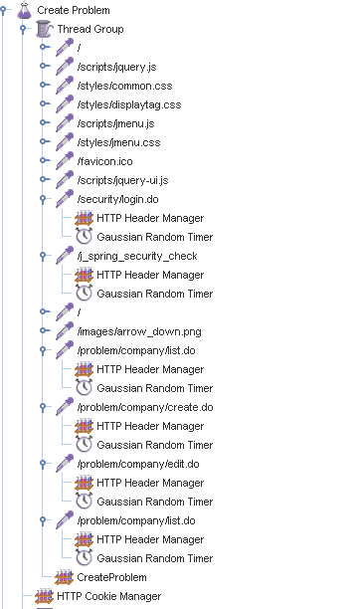

Aggregate Report:

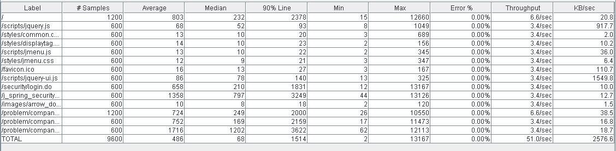

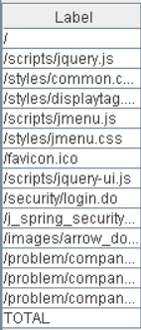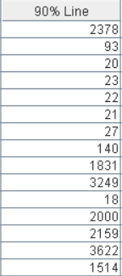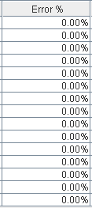

Thread properties:

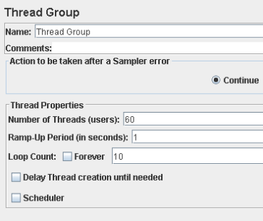

Graph Results:

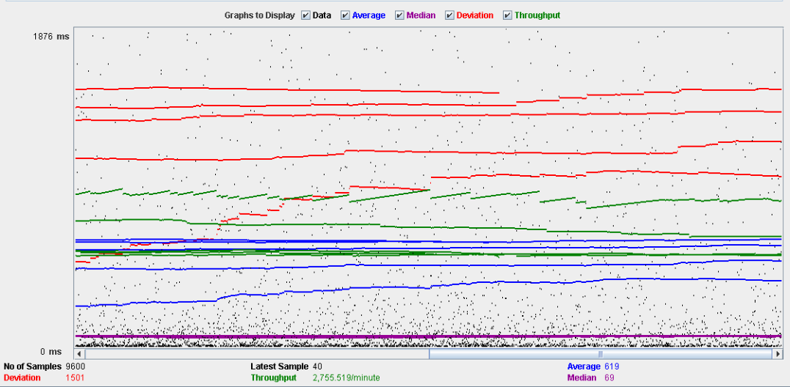

Performance Results:

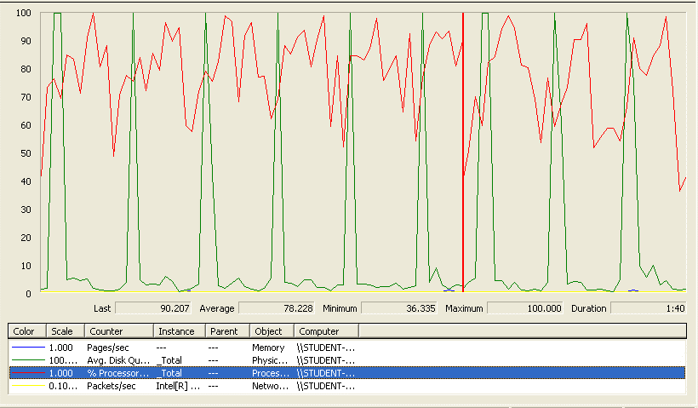

The CPU was always at its limit while the disk usage showed many peaks.

## Edit

Sequence:

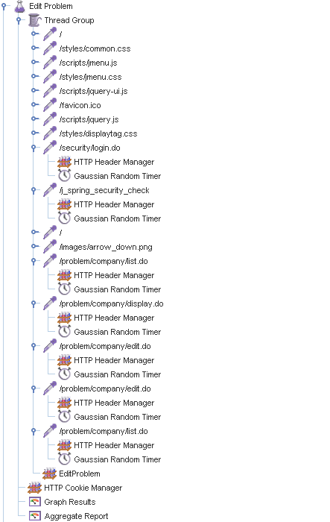

Aggregate Report:

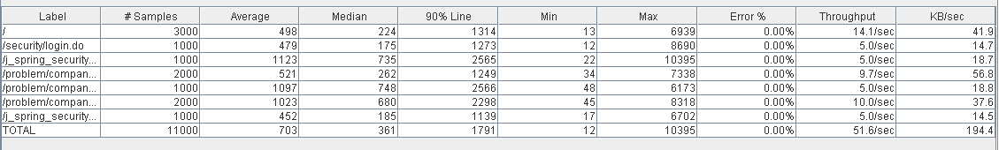

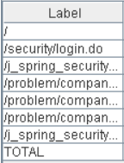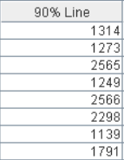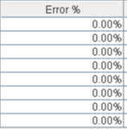

Thread properties:

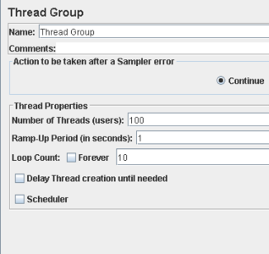

Graph Results:

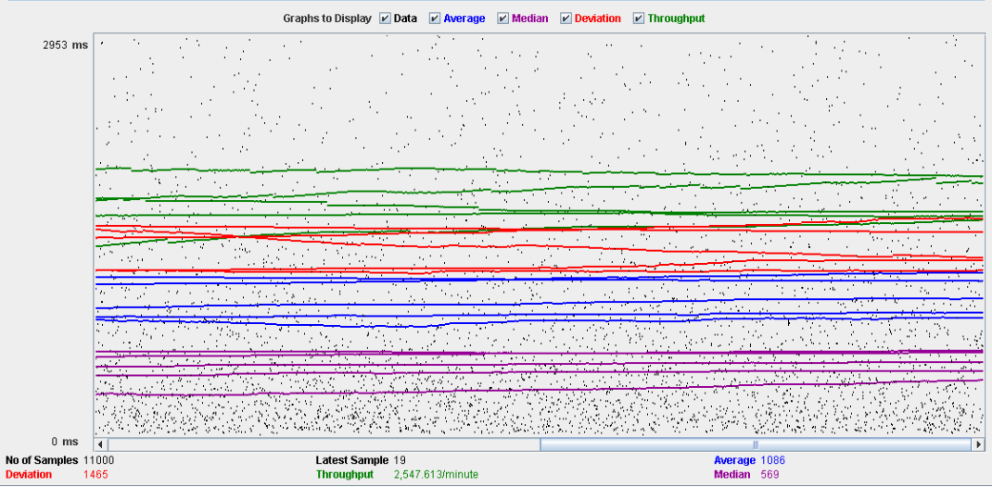

Performance Results:

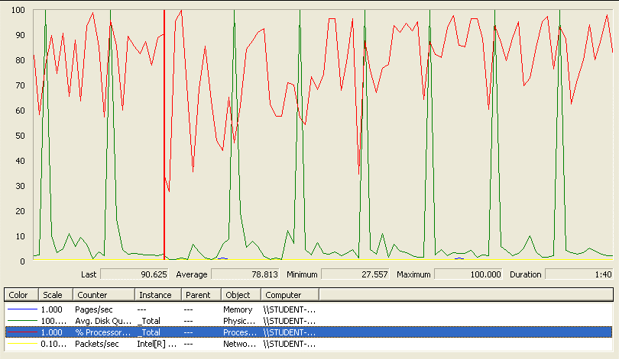

Again we can see that the CPU is always being used while the disk usage shows some periodic peaks.

## Delete

Sequence:

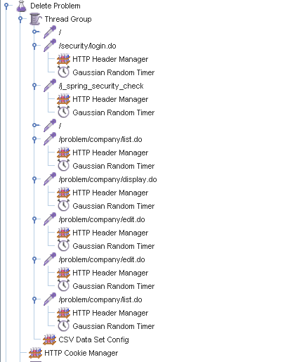

Aggregate Report:

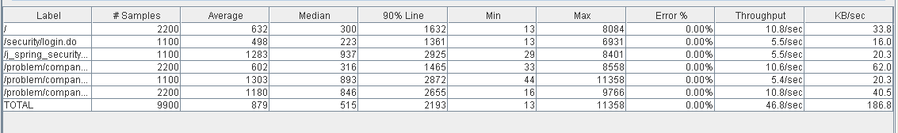

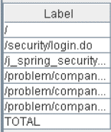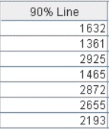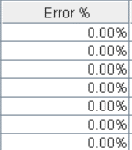

Thread properties:

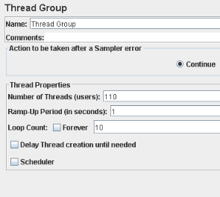

Graph Results:

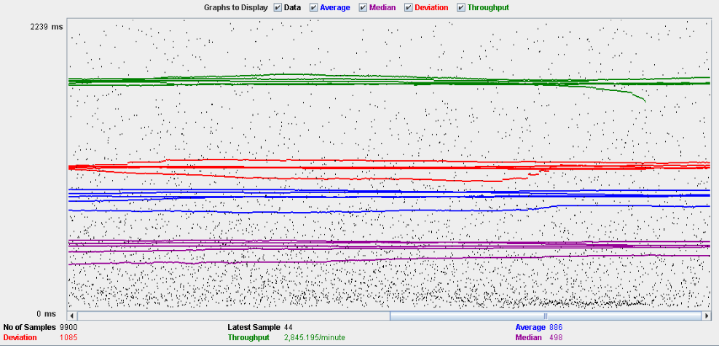

Performance Results:

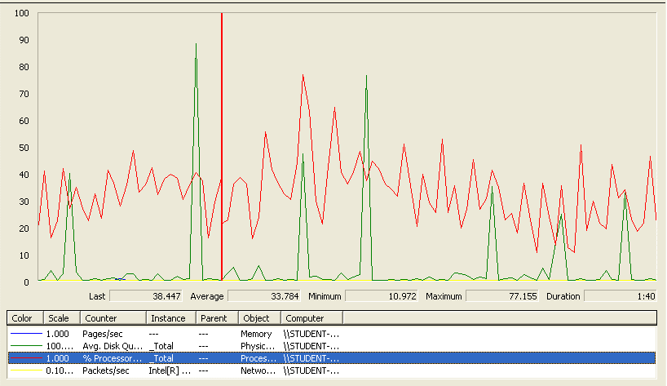

Again we can see that the CPU is always being used while the disk usage shows some periodic peaks.

## Conclusion

The test was performed using:

CPU: i5 2500k (2 cores in the virtual machine)

RAM: 2 GB (virtual machine)

For this use case we can say that the limitation occurs during the create process, being the maximum of concurrent users 60 because the time of respond begins to be very high.

# Finder

## Search and clear

Sequence:

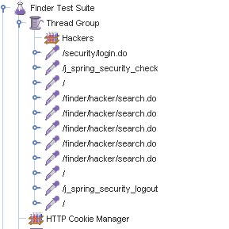

Aggregate Report:



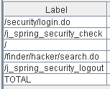 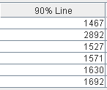 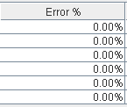

Thread properties:

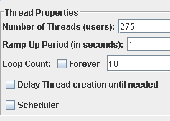

Graph Results:

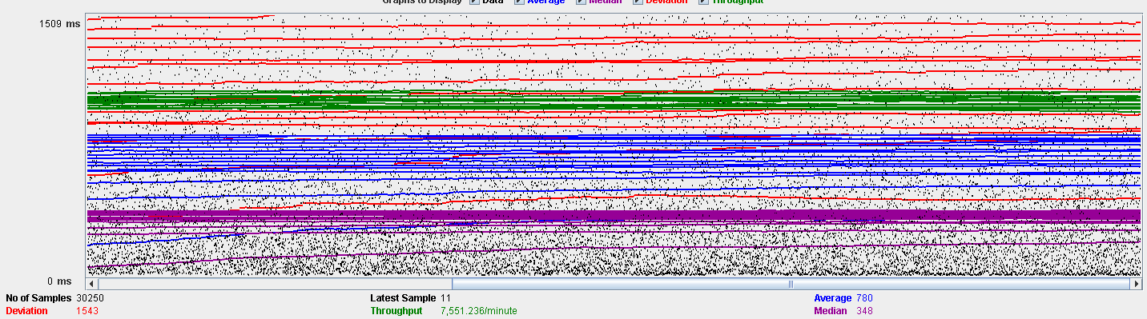

Performance Results:

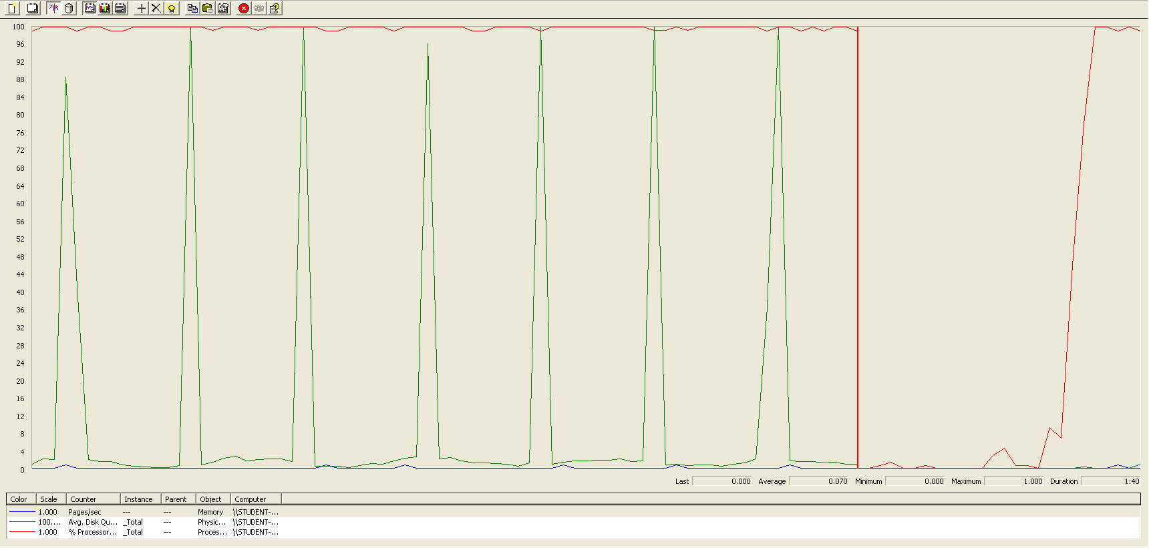

The CPU was always at its limit while the disk usage showed many peaks.

## Conclusion

The test was performed using:

CPU: i7 7300hq (2 cores in the virtual machine)

RAM: 2 GB (virtual machine)

For this use case we can say that the limitation is with a maximum of 275 concurrent users.

# Curricula

## Create a curriculum

Sequence:

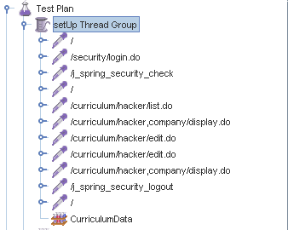

Aggregate Report:

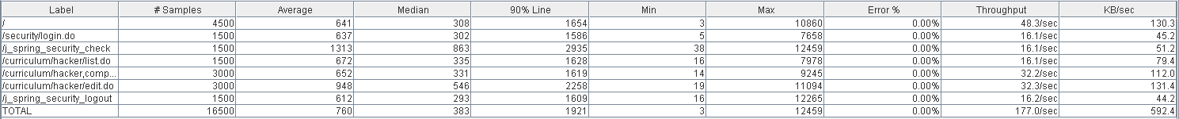



Thread properties:



Graph Results:

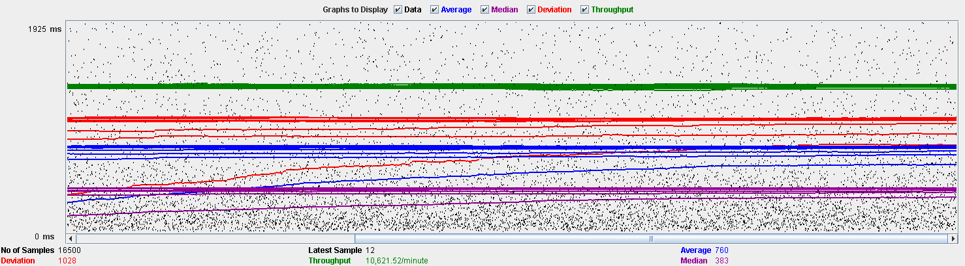

Performance Results:



The CPU was always at its limit while the disk usage showed many peaks.

## Delete a curriculum

Sequence:

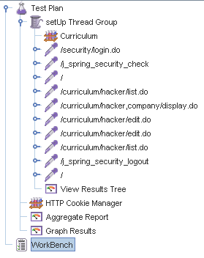

Aggregate Report:

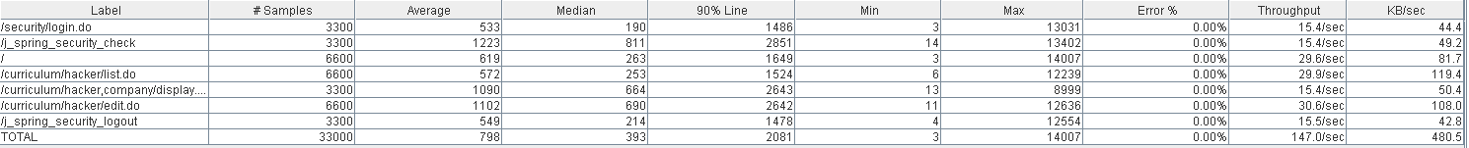



Thread properties:

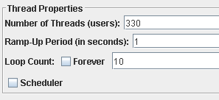

Graph Results:

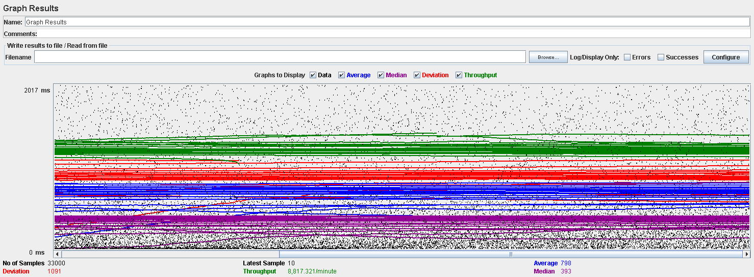

Performance Results:

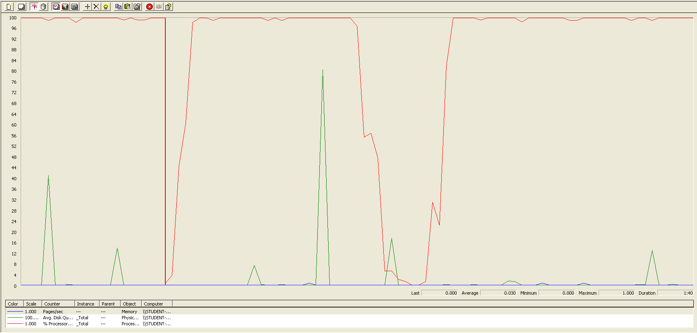

Again we can see that the CPU is always being used while the disk usage shows some little peaks.

# Datas (Personal, Education, Position and Miscellaneous data)

## Create all datas

Sequence:

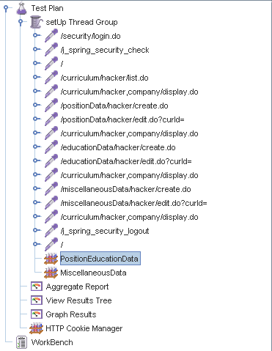

Aggregate Report:

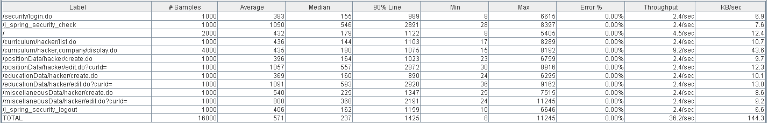

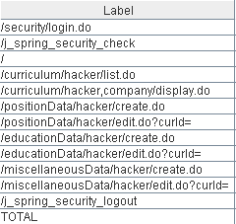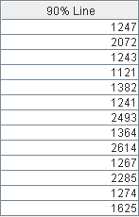

Thread properties:

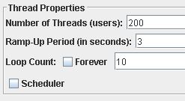

Graph Results:

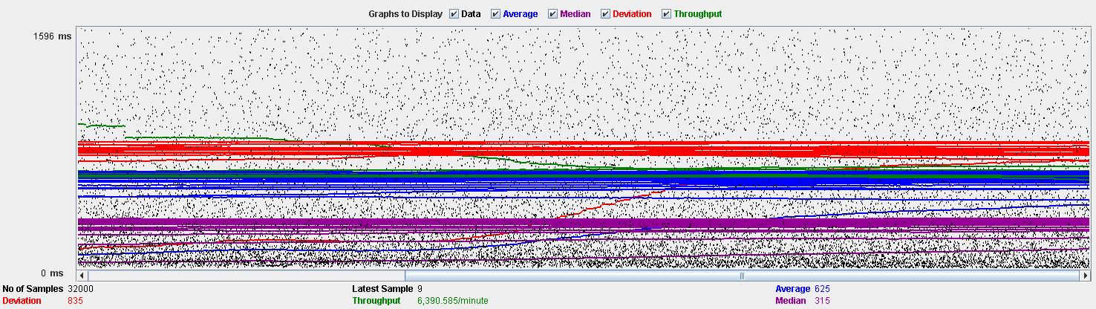

Performance Results:

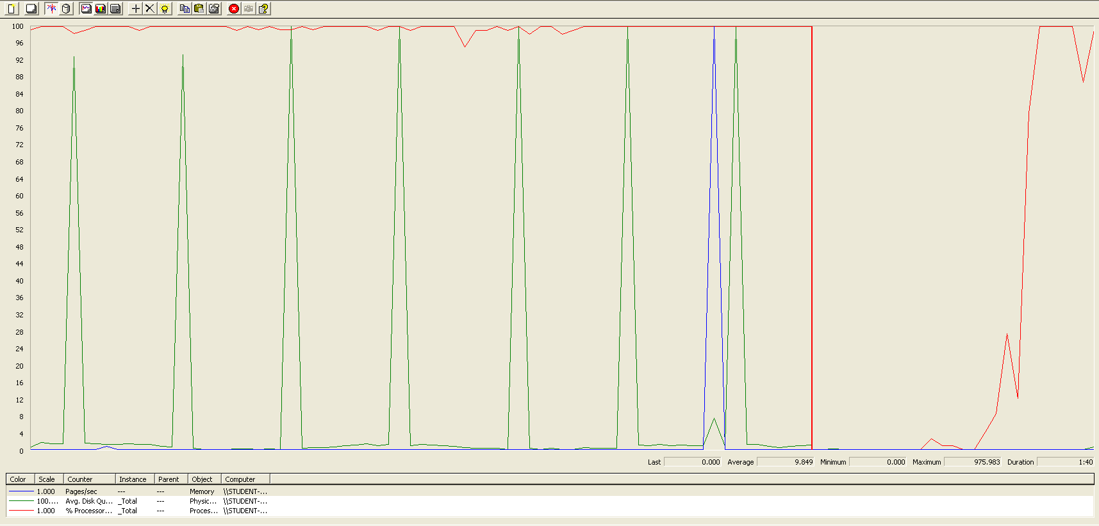

Again we can see that the CPU is always being used while the disk usage shows some periodic peaks.

## Edit a position data

Sequence:

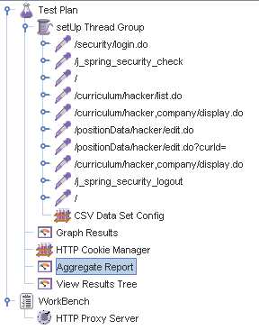

Aggregate Report:

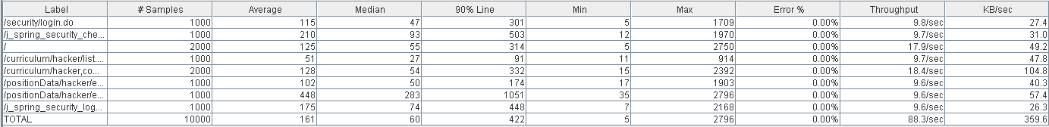

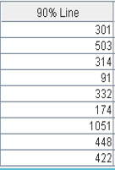

Thread properties:

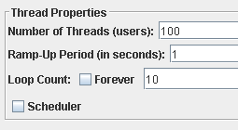

Graph Results:

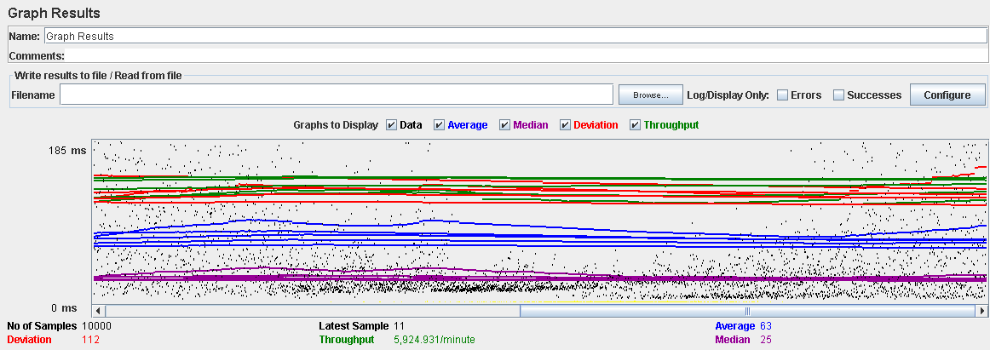

Performance Results:

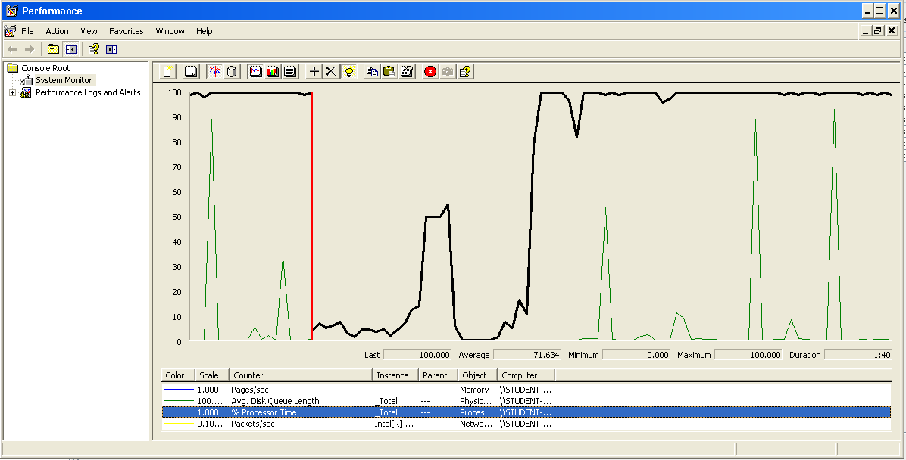

Again we can see that the CPU is always being used while the disk usage shows some peaks.

## Edit a education data

Sequence:

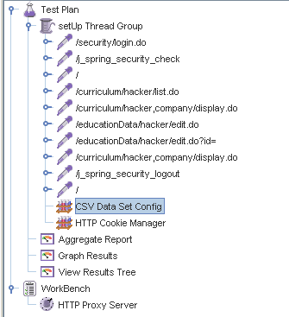

Aggregate Report:

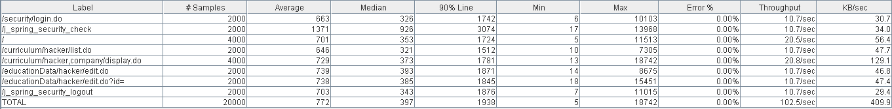

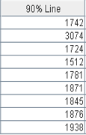

Thread properties:

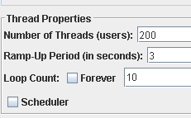

Graph Results:

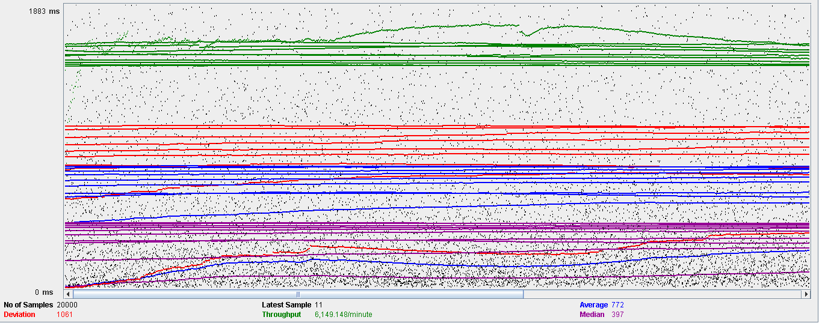

Performance Results:

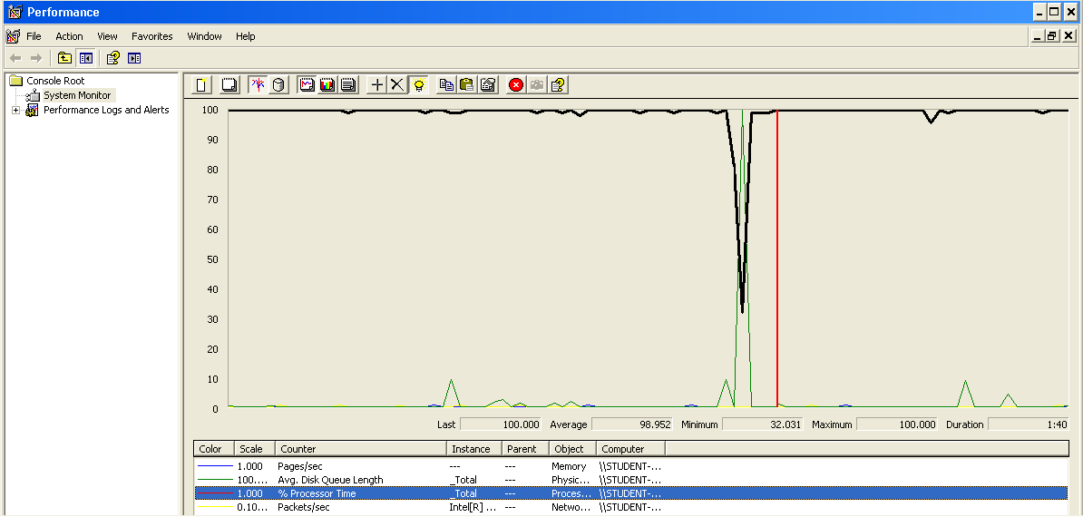

Again we can see that the CPU is always being used while the disk usage shows some peaks.

## Edit a miscellaneous data

Sequence:

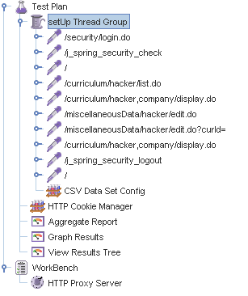

Aggregate Report:

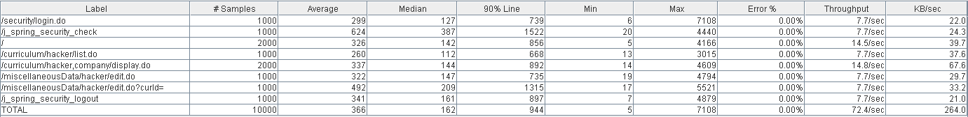

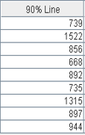

Thread properties:

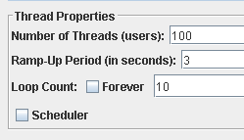

Graph Results:

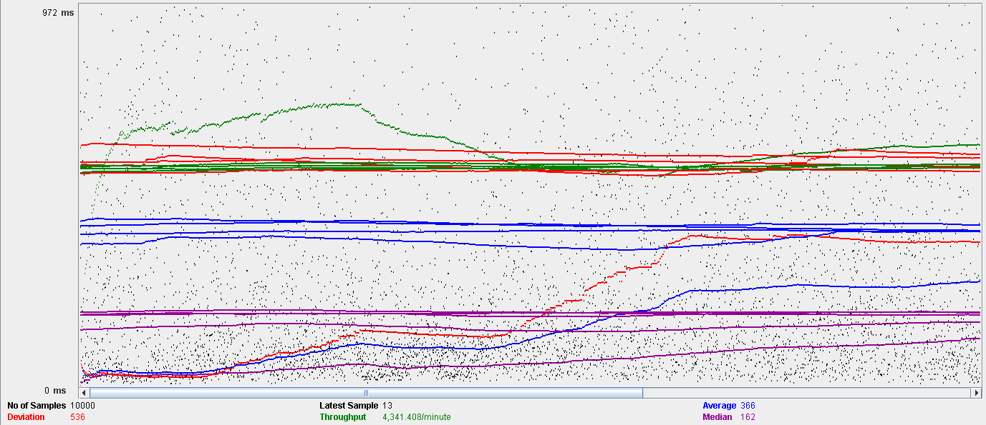

Performance Results:

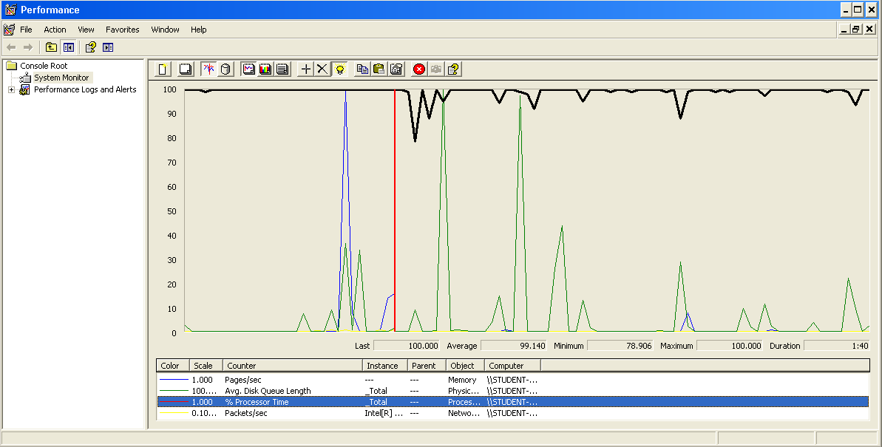

Again we can see that the CPU is always being used while the disk usage shows some peaks.

## Delete a position data

Sequence:

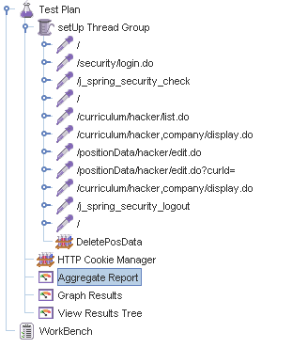

Aggregate Report:

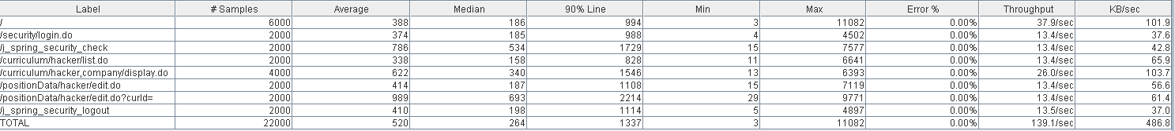

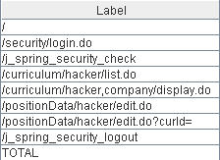 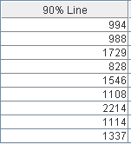

Thread properties:

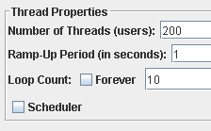

Graph Results:

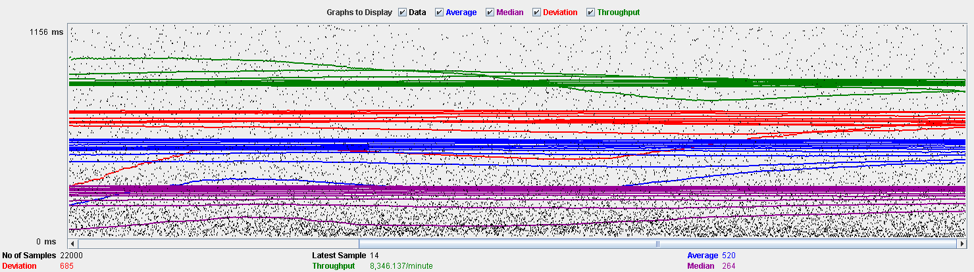

Performance Results:

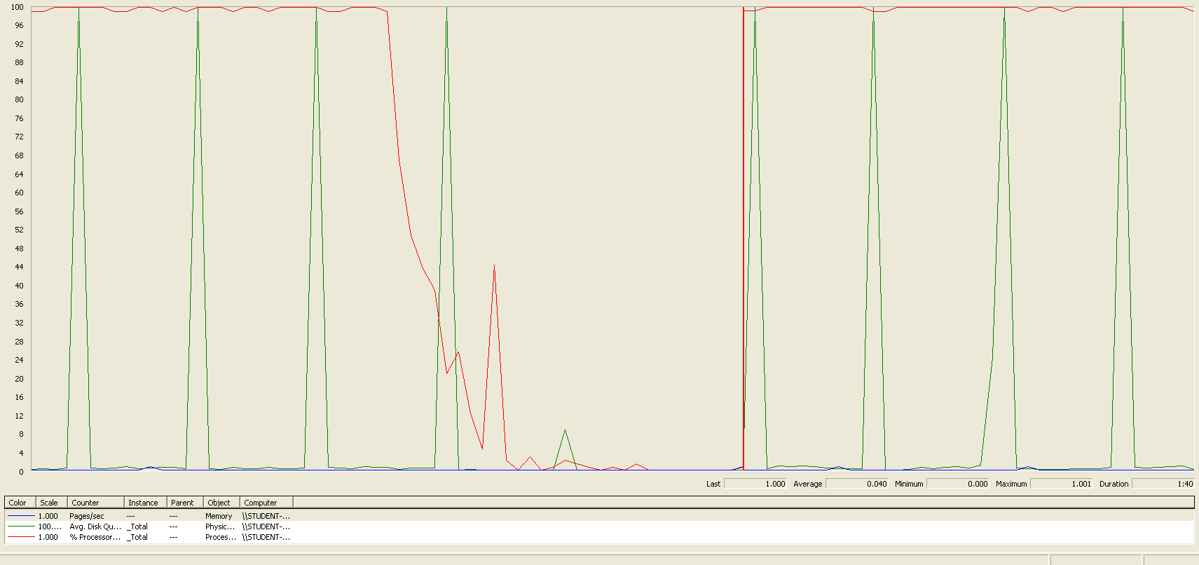

Again we can see that the CPU is always being used while the disk usage shows some peaks.

## Delete a education data

Sequence:

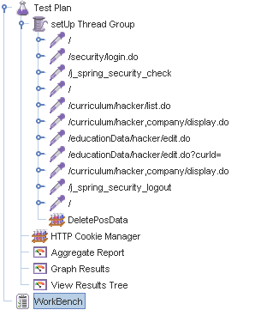

Aggregate Report:

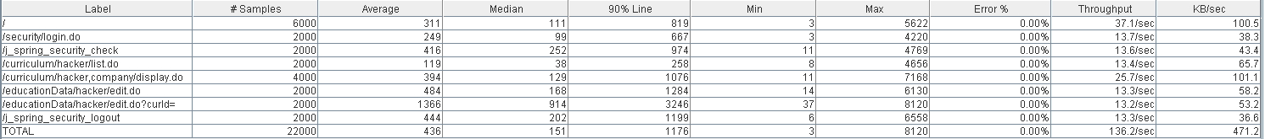

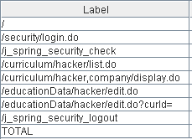 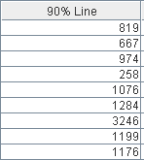

Thread properties:



Graph Results:

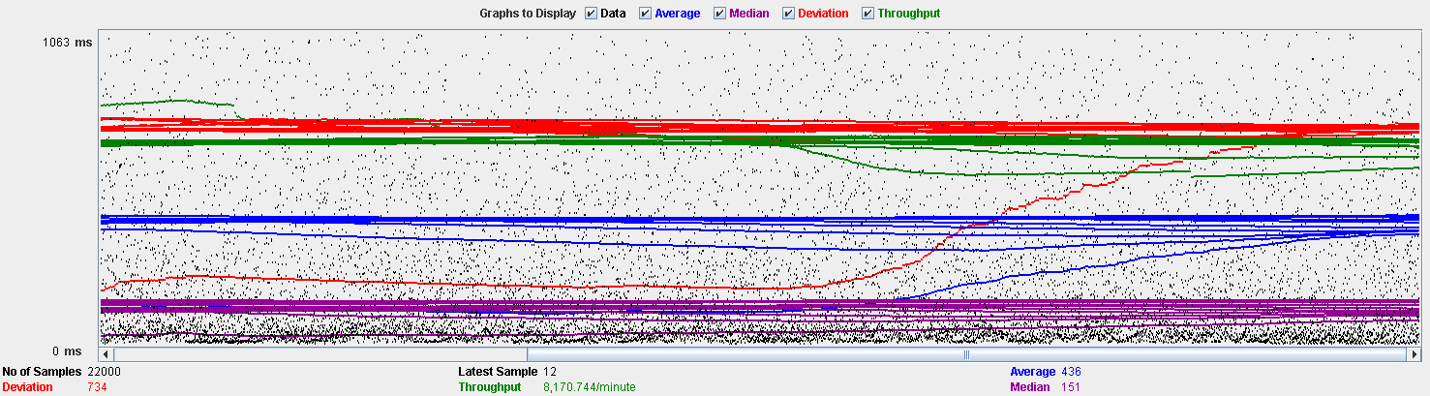

Performance Results:

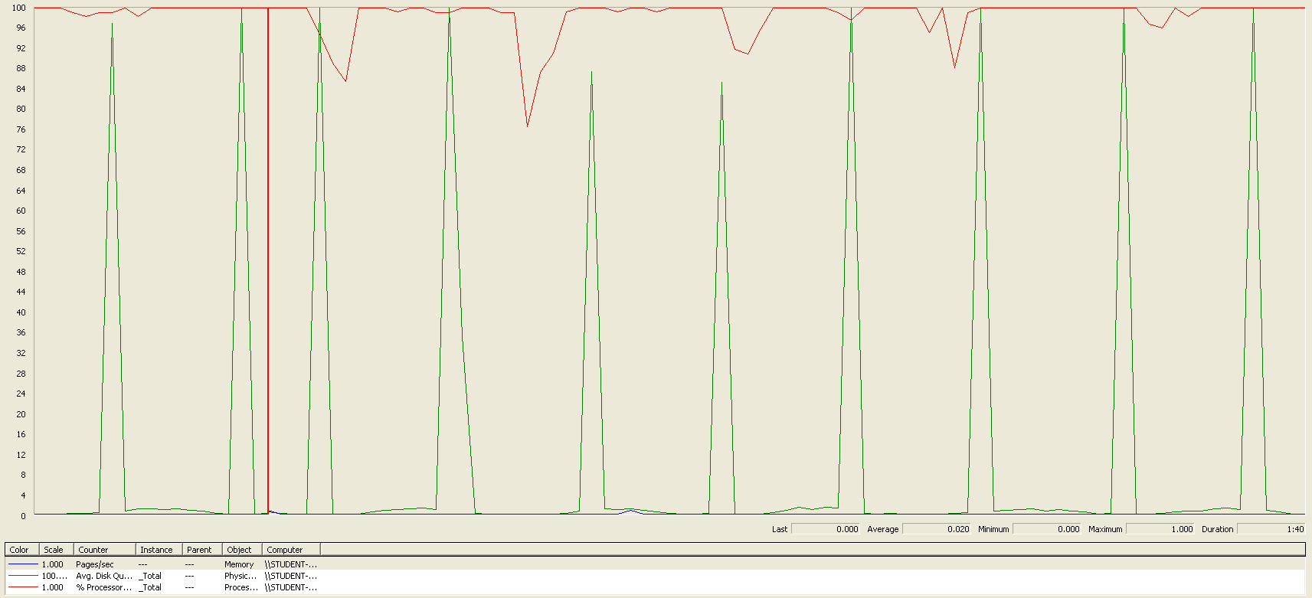

Again we can see that the CPU is always being used while the disk usage shows some peaks.

## Delete a miscellaneous data

Sequence:

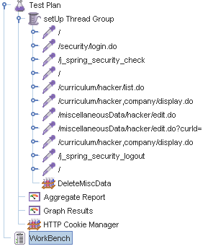

Aggregate Report:

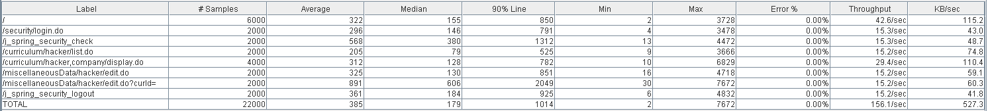

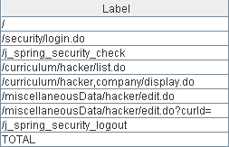 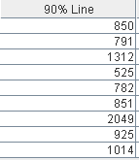

Thread properties:



Graph Results:

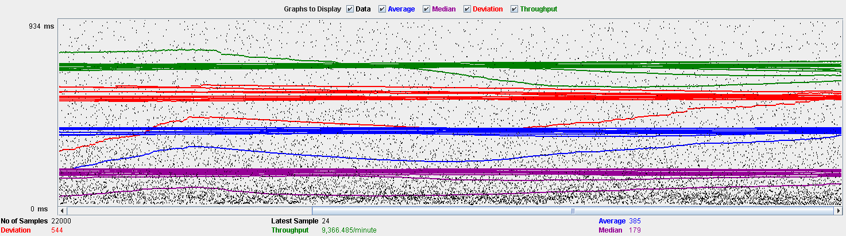

Performance Results:

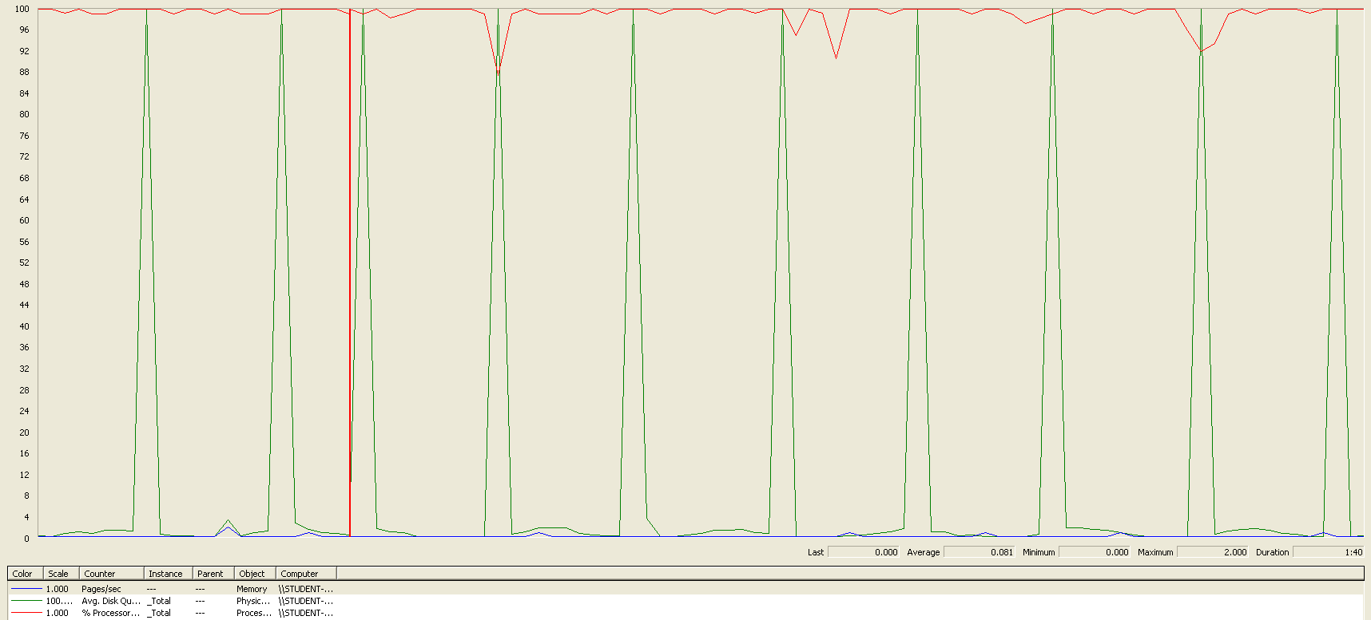

Again we can see that the CPU is always being used while the disk usage shows some peaks.

## Conclusion

The test was performed using:

CPU: i7 6700hq (2 cores in the virtual machine)

RAM: 4 GB (virtual machine)

For this use case we can say that the limitation occurs during the creation process, being the maximum of concurrent users 180.

# Social profile

## Create

Sequence:

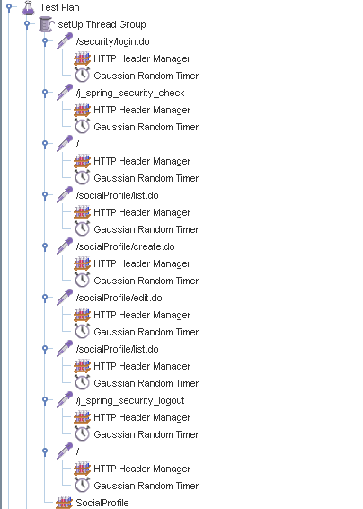

Aggregate Report:

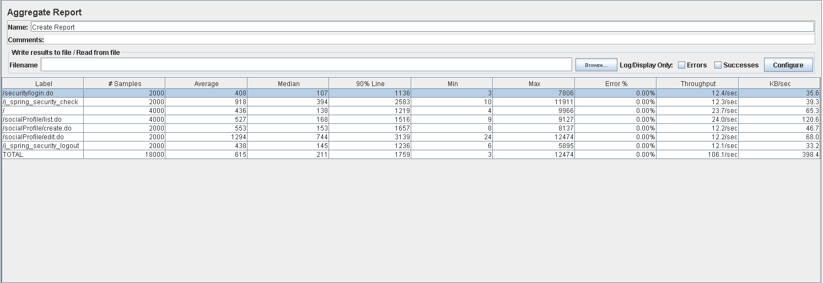



Thread properties:

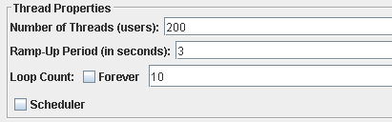

Graph Results:

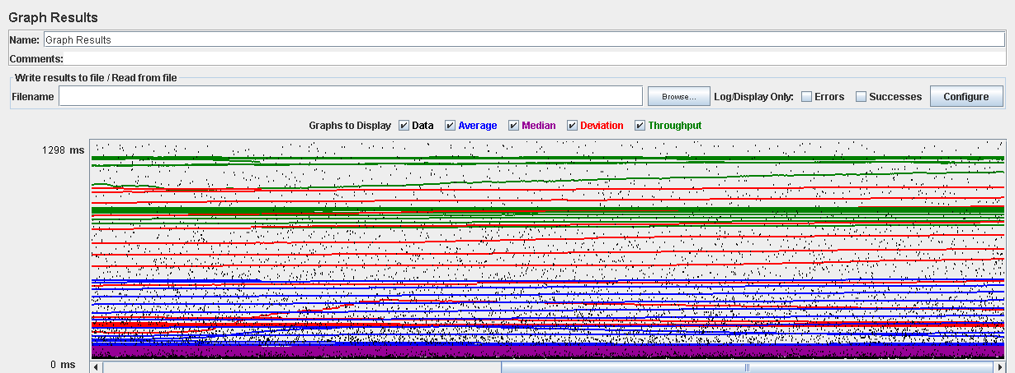

Performance Results:

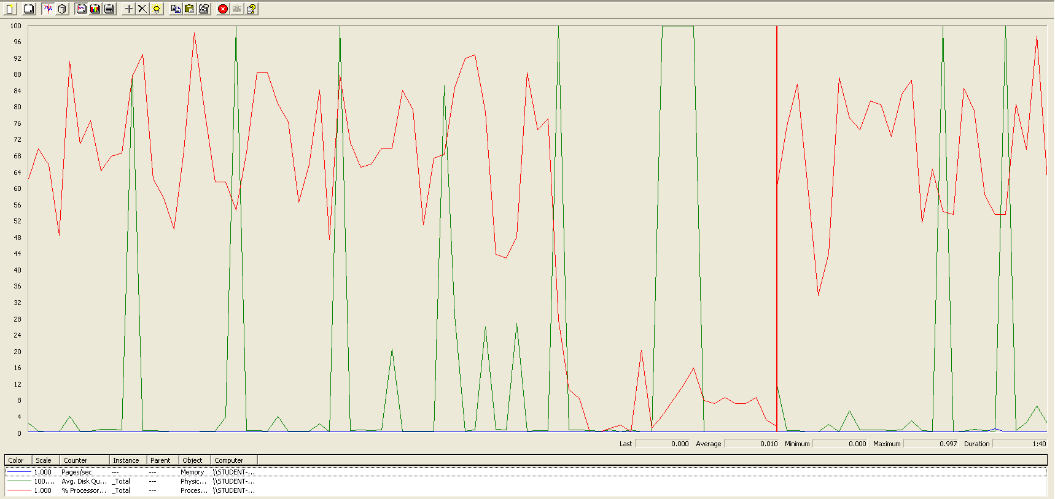

The CPU was always at its limit while the disk usage showed many peaks.

## Edit

Sequence:

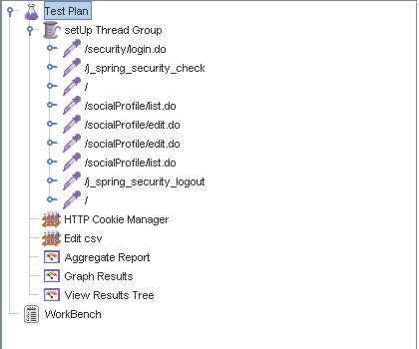

Aggregate Report:

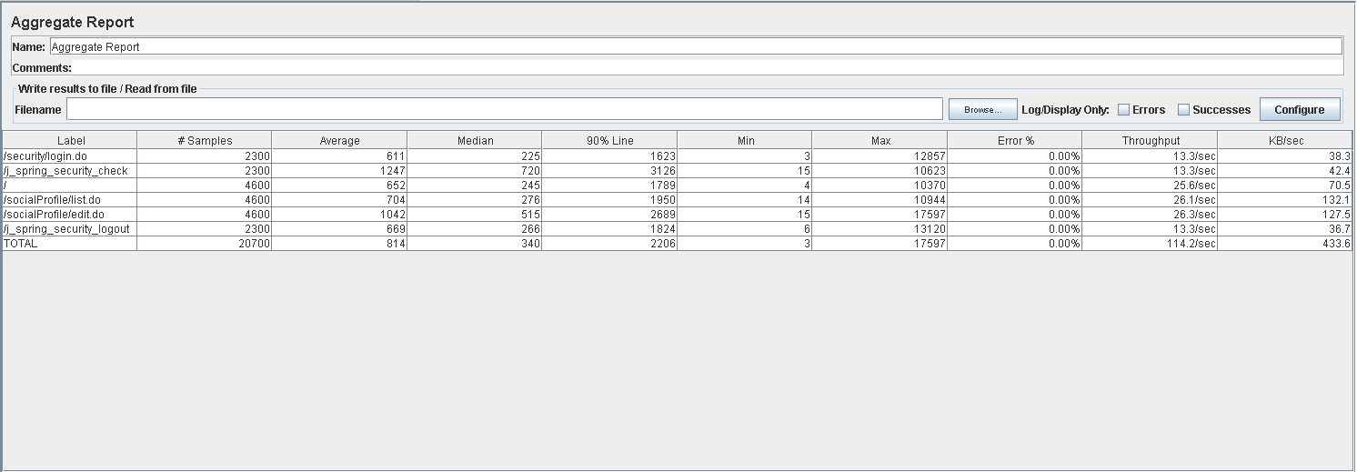

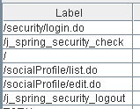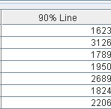

Thread properties:

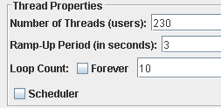

Graph Results:

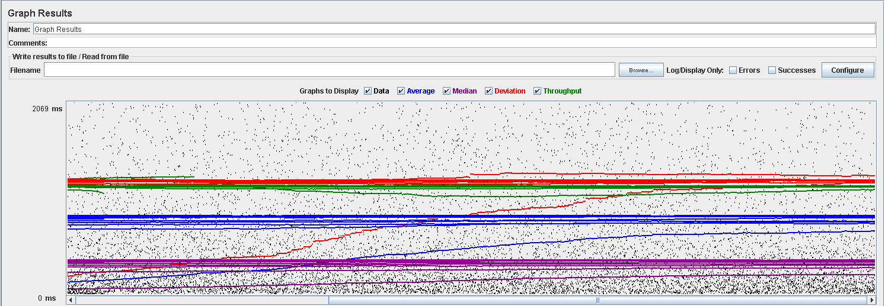

Performance Results:

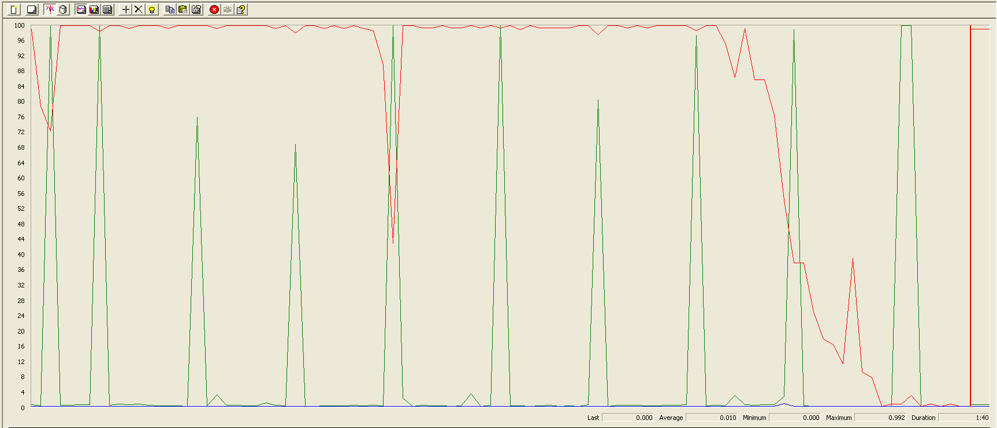

Again we can see that the CPU is always being used while the disk usage shows different peaks at times.

## 

## Delete

Sequence:

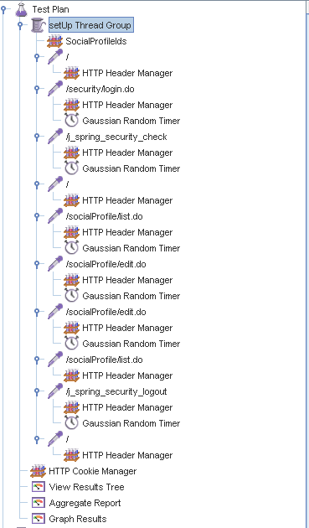

Aggregate Report:

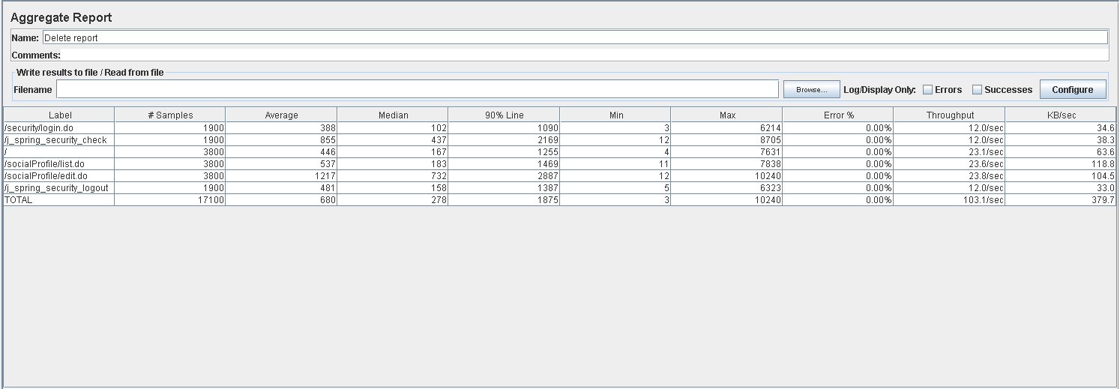

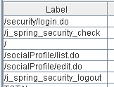

Thread properties:

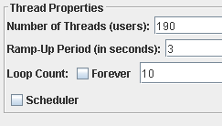

Graph Results:

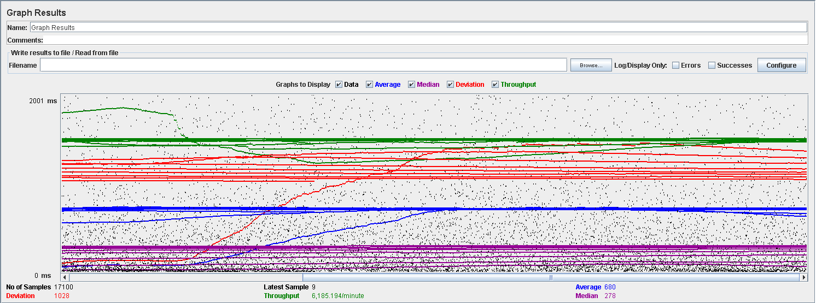

Performance Results:



Again we can see that the CPU is always being used while the disk usage shows some periodic peaks.

## Conclusion

The test was performed using:

CPU: i7 7700hq (2 cores in the virtual machine)

RAM: 4 GB (virtual machine)

For this use case we can say that the limitation occurs during the creation process, being the maximum of concurrent users 190.

# Actor

## Create

Sequence:

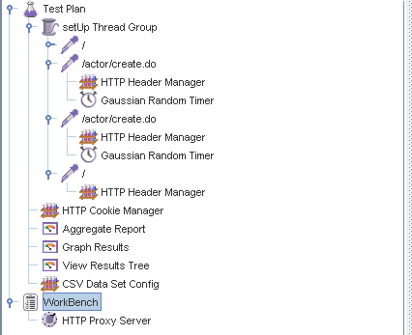

Aggregate Report:



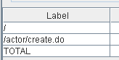 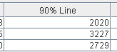 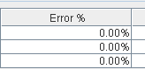

Thread properties:



Graph Results:

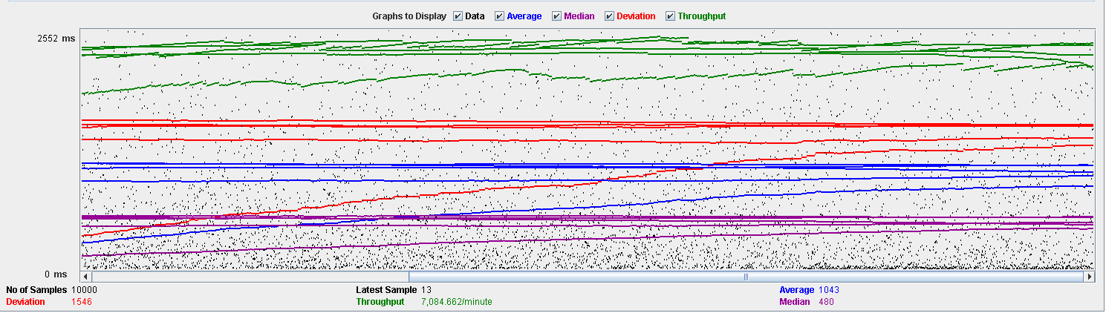

Performance Results:

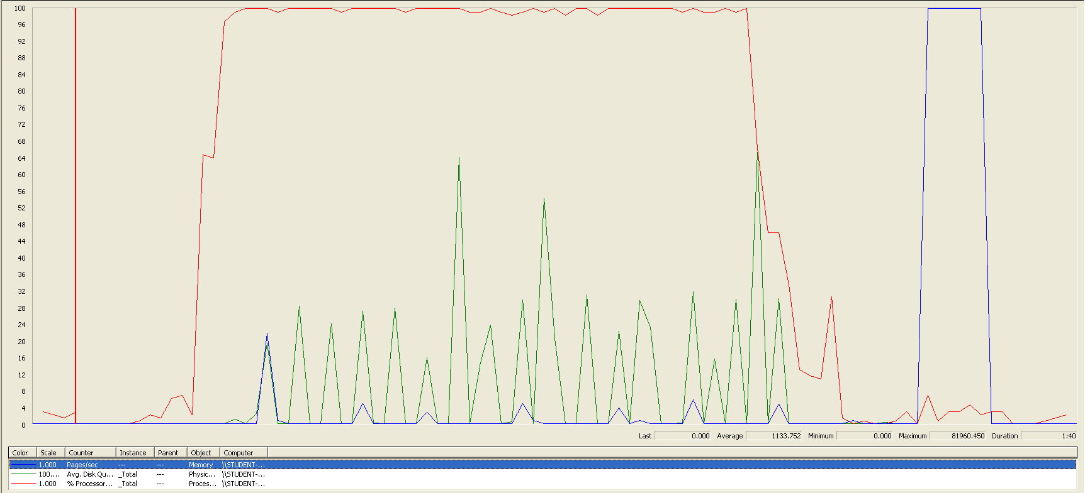

The CPU was always at its limit while the disk usage has a lot of peaks.

## Edit

Sequence:

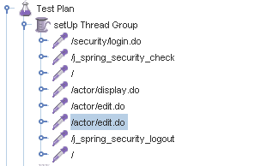

Aggregate Report:





Thread properties:

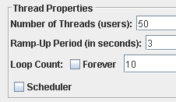

Graph Results:

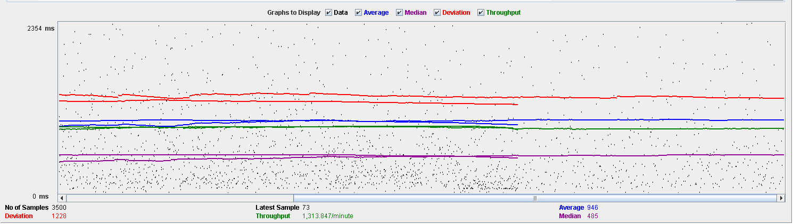

Performance Results:

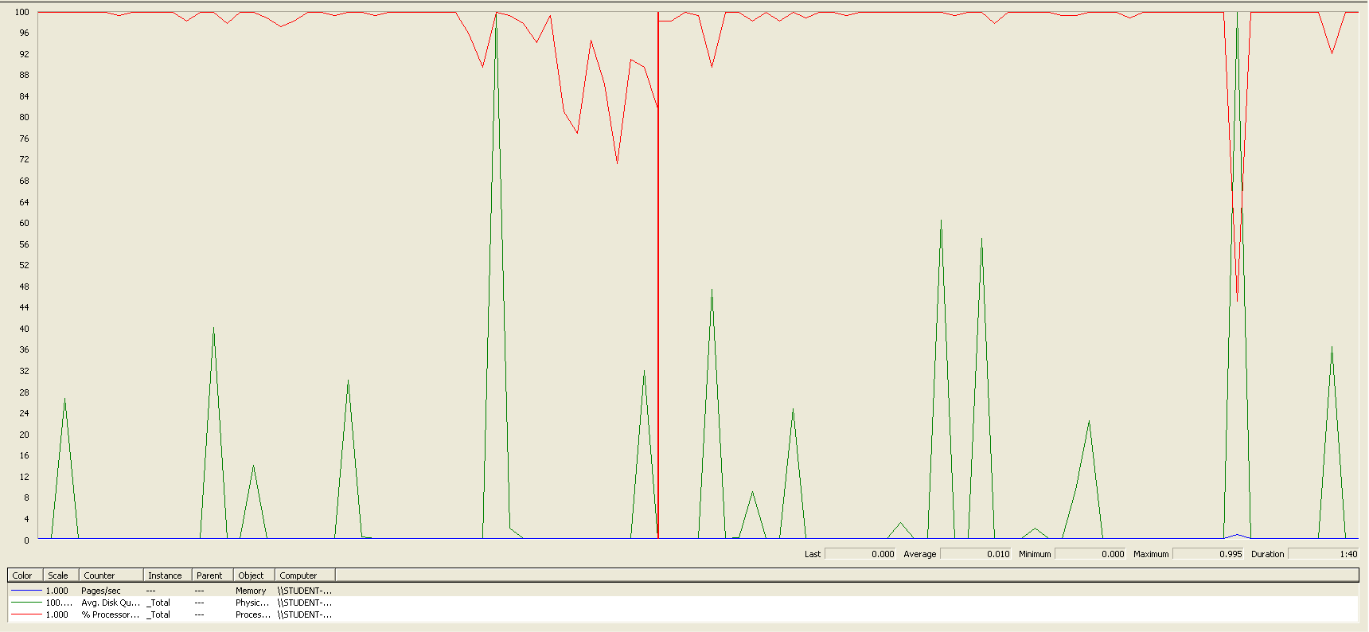

Again we can see that the CPU is always being used while the disk usage has some peaks at times.

## Delete

Sequence:



Aggregate Report:



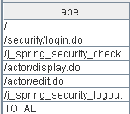

Thread properties:

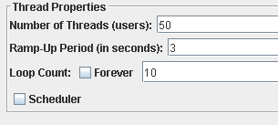

Graph Results:

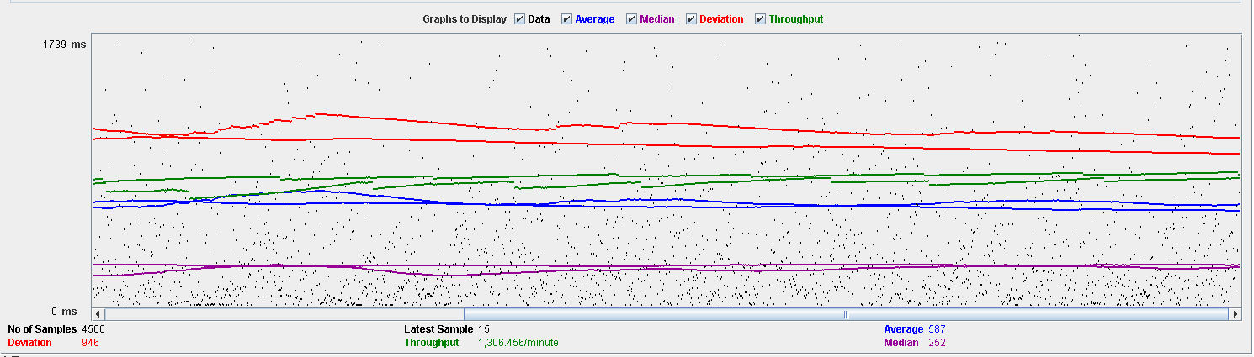

Performance Results:

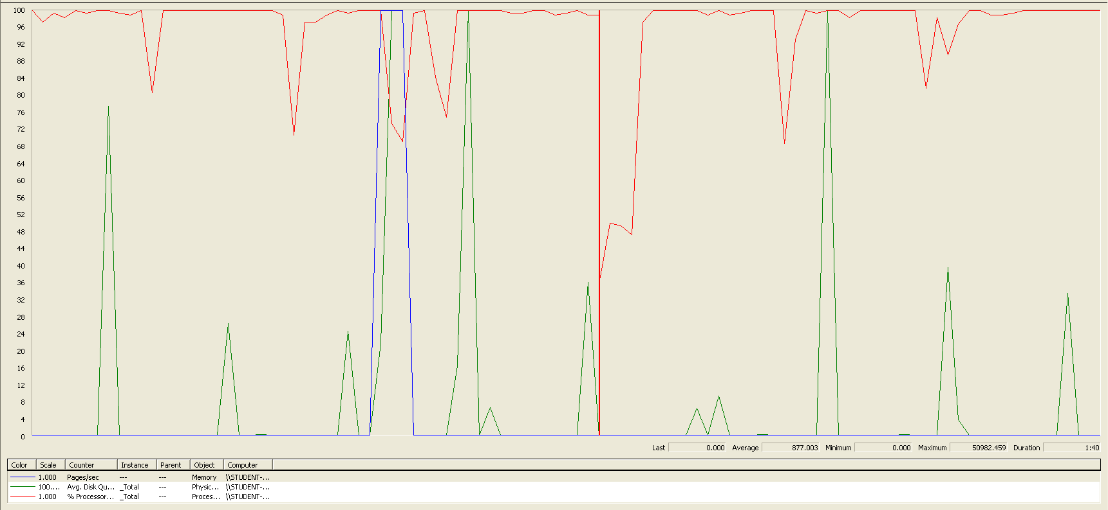

Again we can see that the CPU is always being used while the disk usage has different peaks.

## Conclusion

The test was performed using:

CPU: i7 7700hq (2 cores in the virtual machine)

RAM: 4 GB (virtual machine)

For this use case we can say that the limitation occurs during the creation process, being the maximum of concurrent users is 50.

# Application

## Create

Sequence:

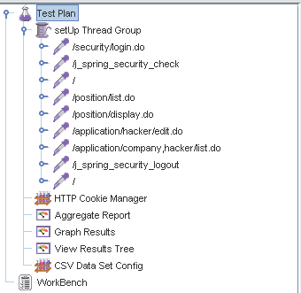

Aggregate Report:

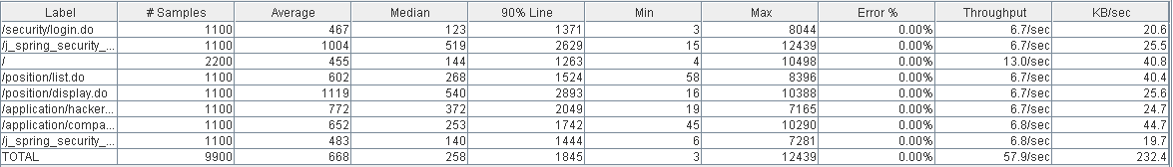

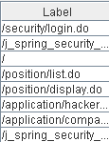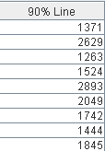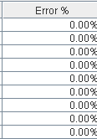

Thread properties:

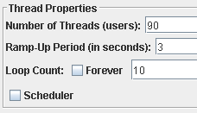

Graph Results:

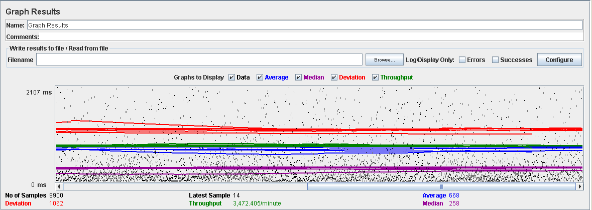

Performance Results:

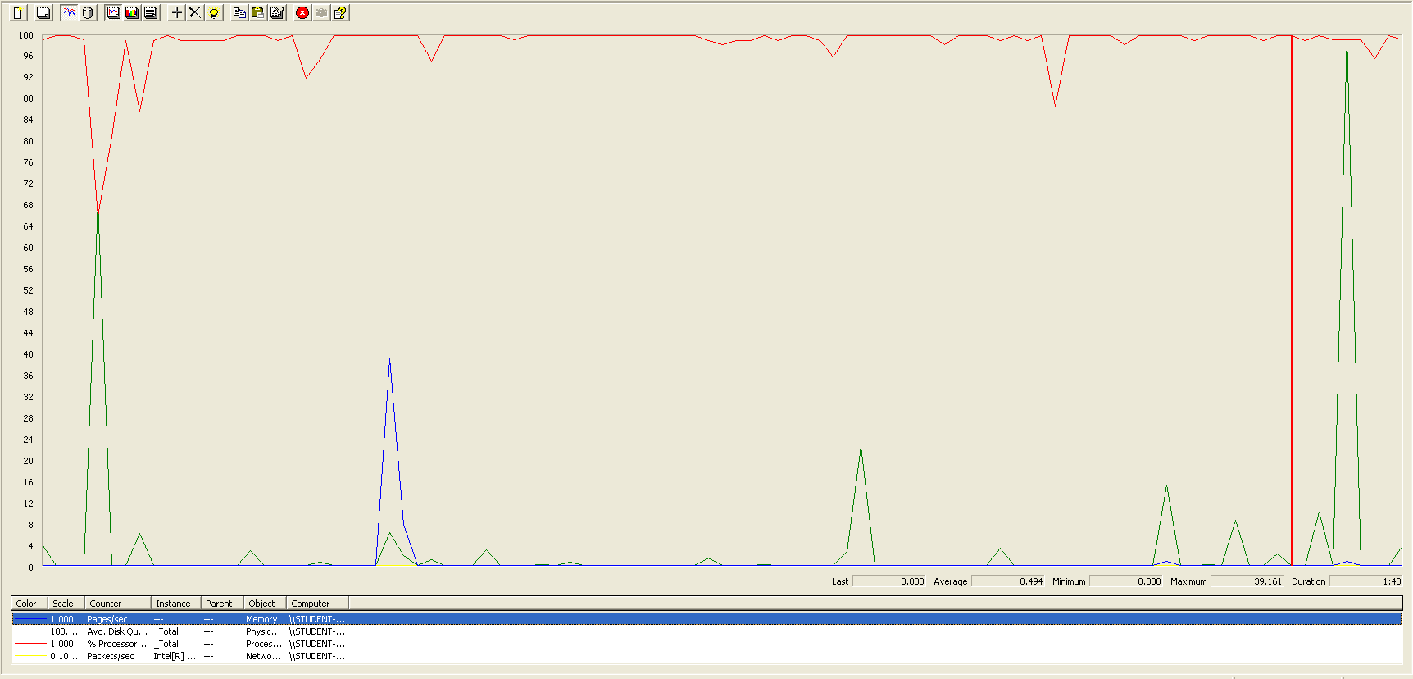

The CPU was always at its limit while the disk usage has some peaks.

## Edit

Sequence:

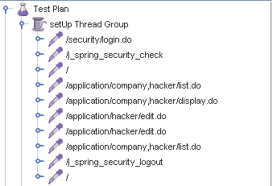

Aggregate Report:

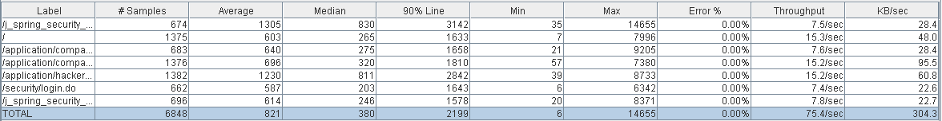

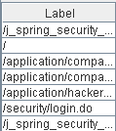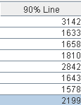

Thread properties:

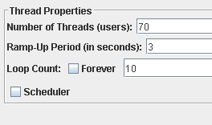

Graph Results:

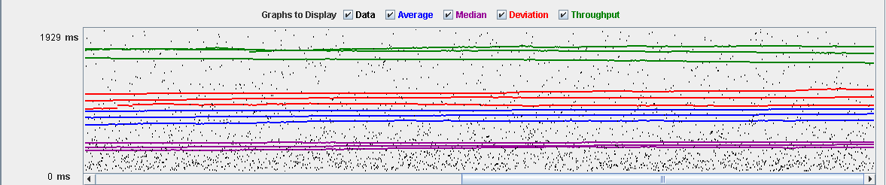

Performance Results:

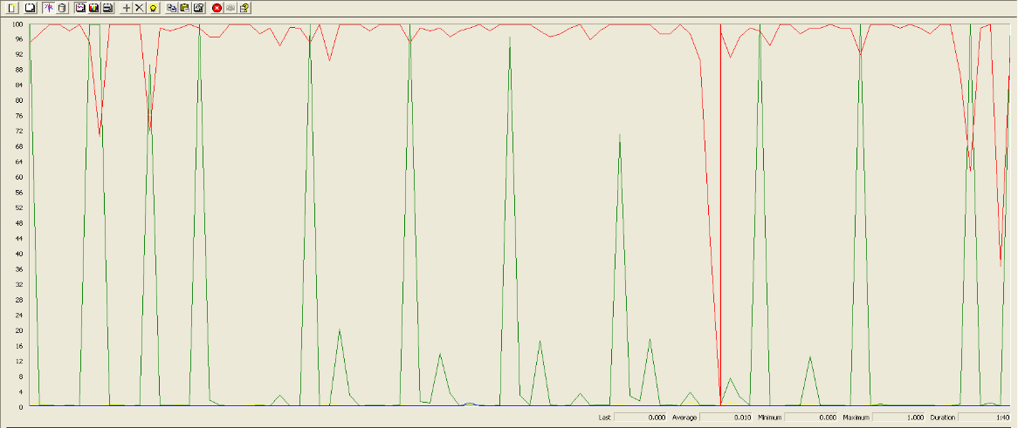

Again we can see that the CPU is always being used while the disk usage has low peaks at times.

## Delete

Sequence:

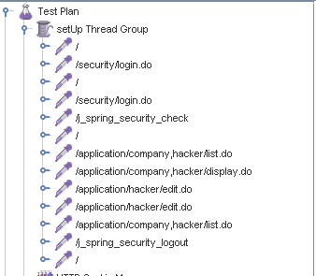

Aggregate Report:

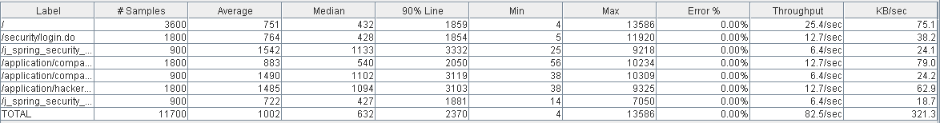

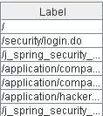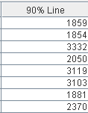

Thread properties:

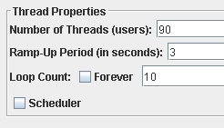

Graph Results:

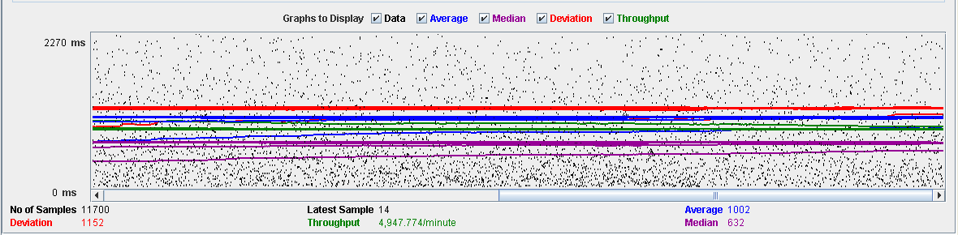

Performance Results:

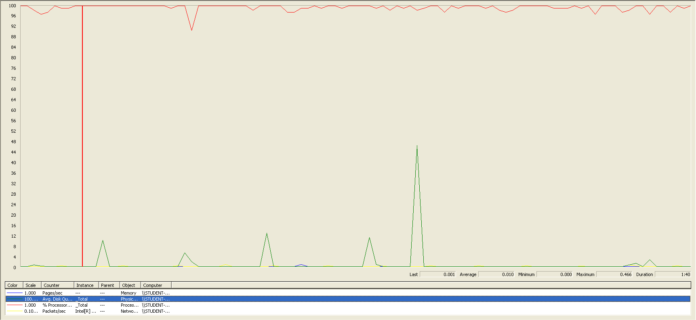

Again we can see that the CPU is always being used while the disk usage has different peaks.

## Conclusion

The test was performed using:

CPU: i7 7700hq (2 cores in the virtual machine)

RAM: 4 GB (virtual machine)

For this use case we can say that the limitation occurs during the creation process, being the maximum of concurrent users 70.

# Audit

## Assign

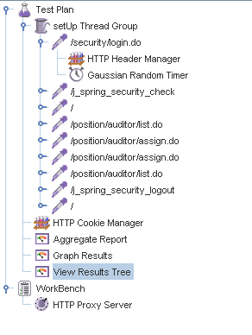

Aggregate Report:

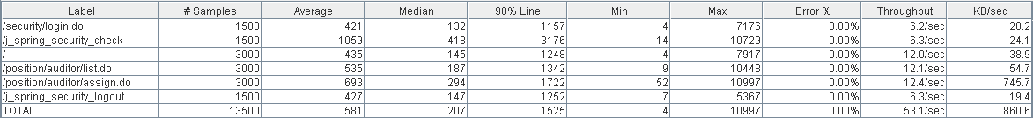



Thread properties:

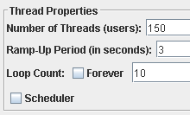

Graph Results:

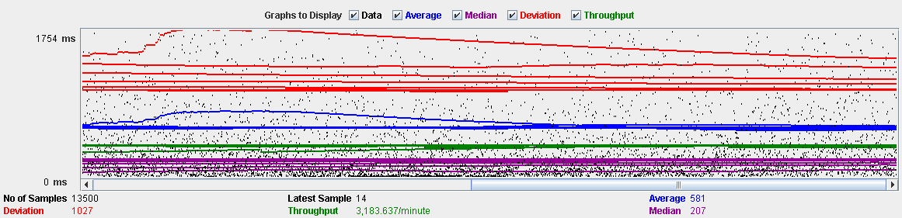

Performance Results:

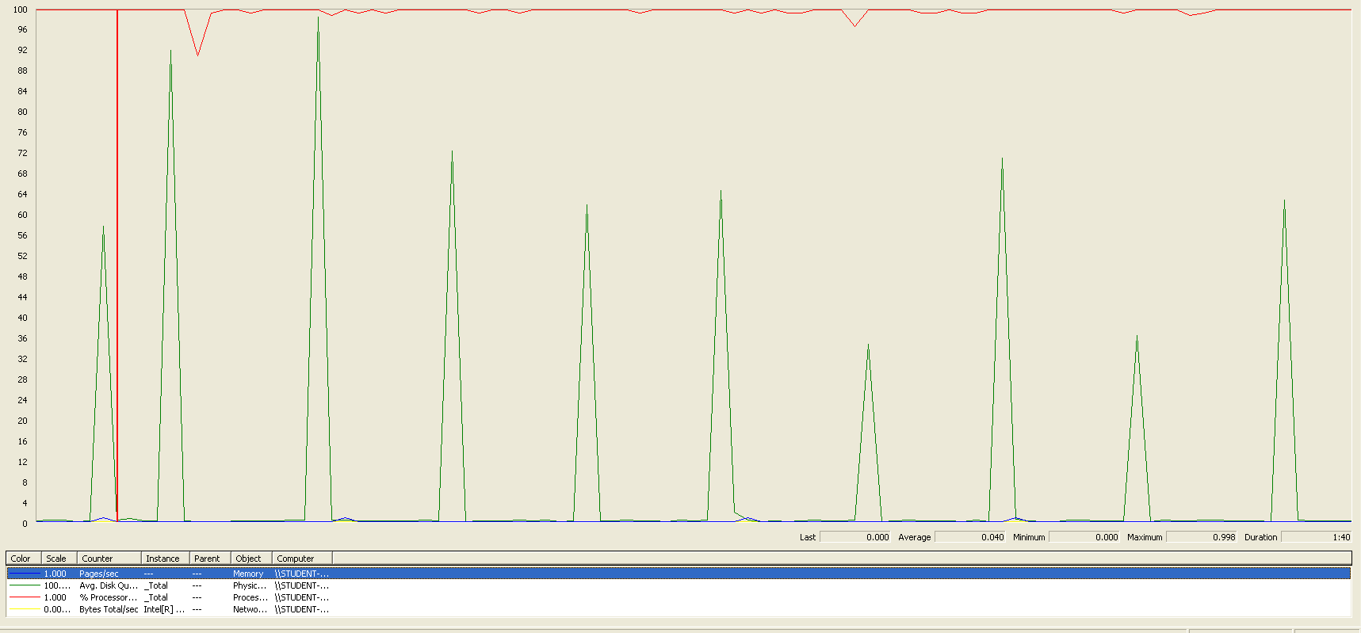

The CPU was always at its limit while the disk usage showed many peaks.

## Create

Sequence:

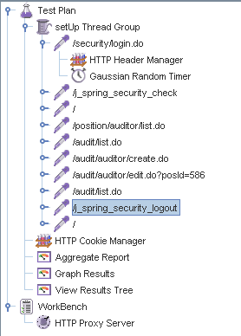

Aggregate Report:

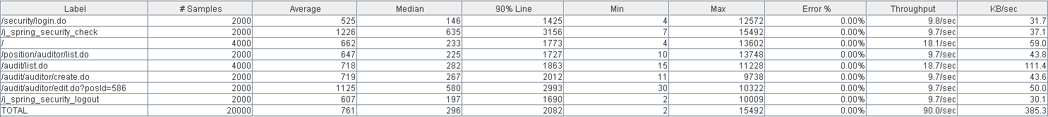



Thread properties:

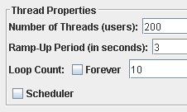

Graph Results:



Performance Results:

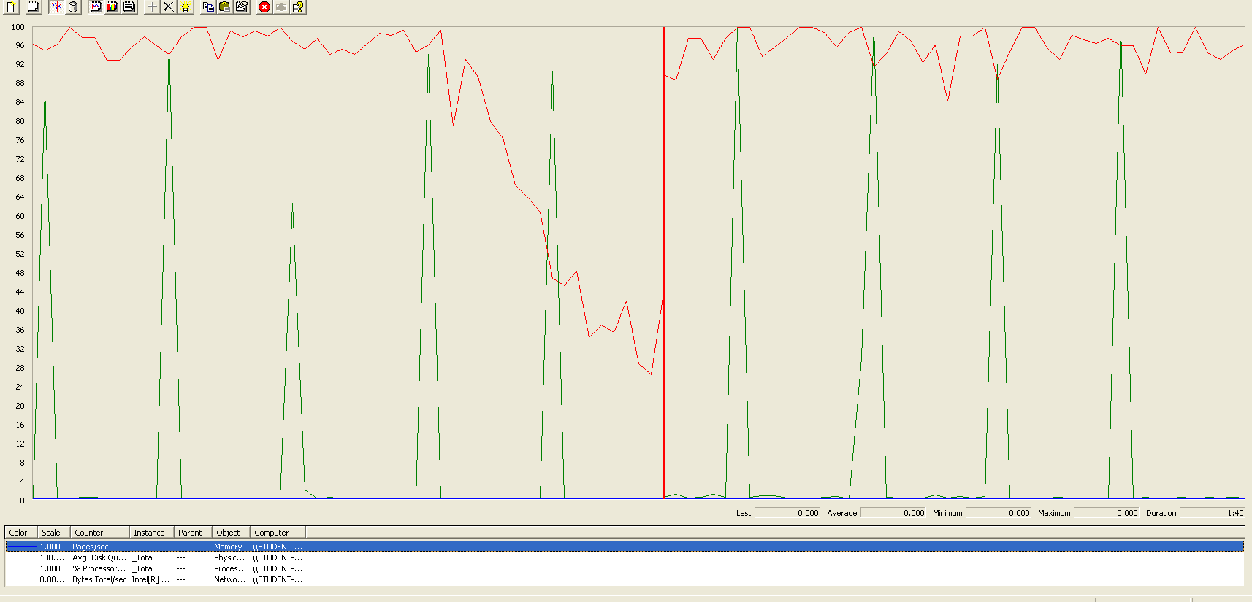

The CPU was always at its limit in various points of the execution while the disk usage showed many peaks.

## Edit

Sequence:

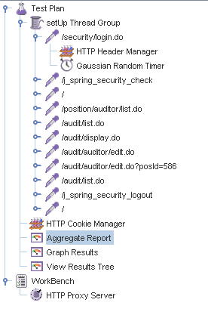

Aggregate Report:

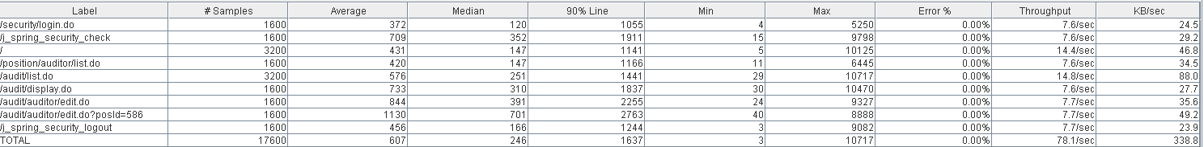



Thread properties:

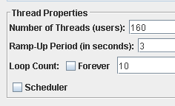

Graph Results:

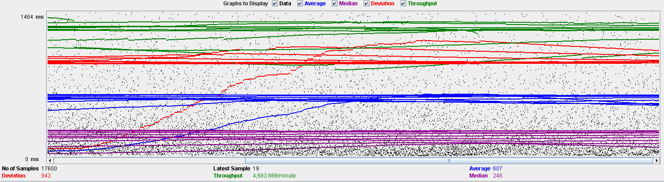

Performance Results:

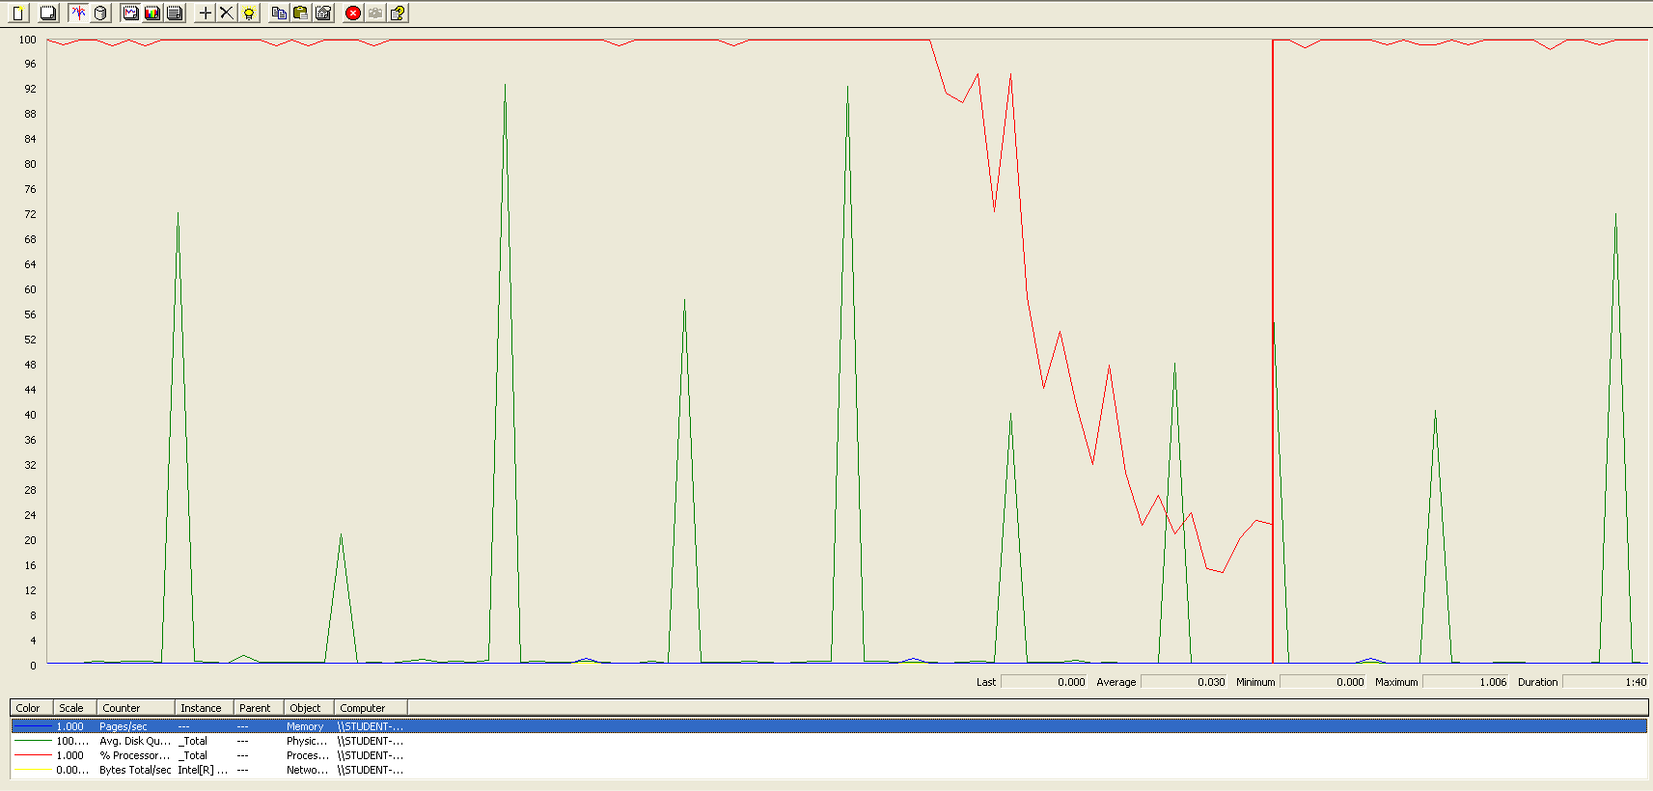

The CPU was always at its limit while the disk usage showed many peaks.

## Delete

Sequence:



Aggregate Report:

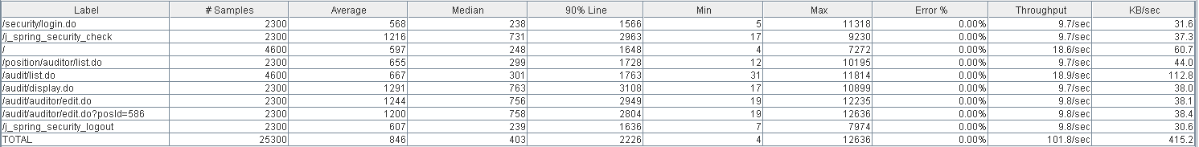



Thread properties:

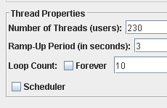

Graph Results:

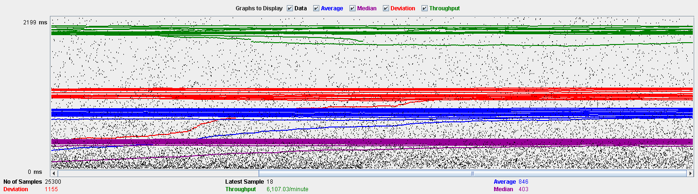

Performance Results:

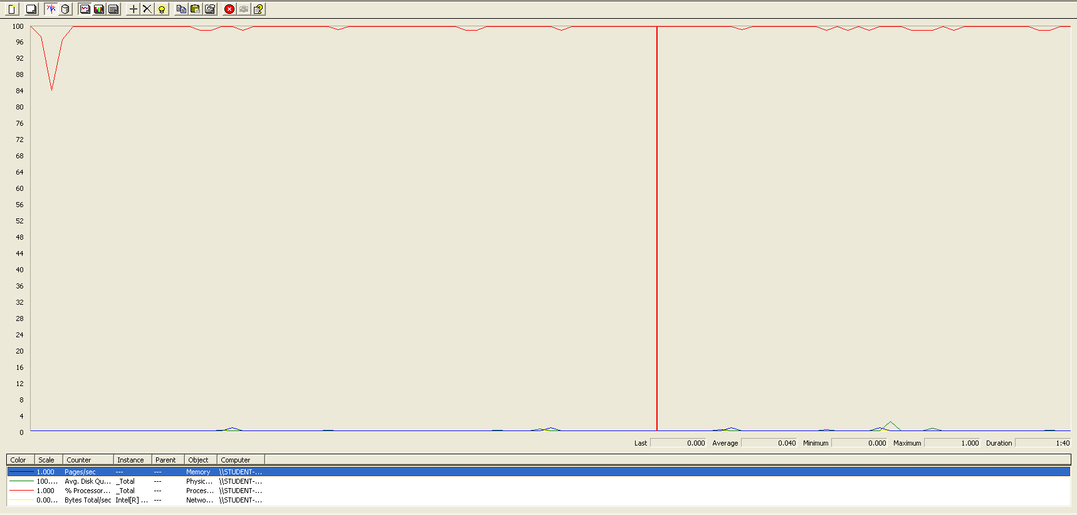

The CPU was always at its limit.

## Conclusion

The test was performed using:

CPU: i7 6700hq (2 cores in the virtual machine)

RAM: 4 GB (virtual machine)

For this use case we can say that the limitation occurs during the assign process, being the maximum of concurrent users 150.

# Sponsorship

## Create

Sequence:

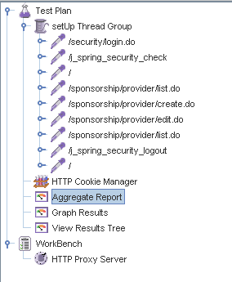

Aggregate Report:

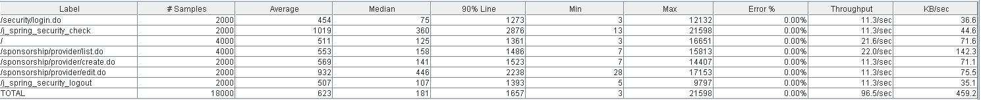



Thread properties:

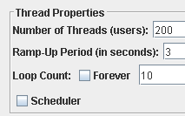

Graph Results:

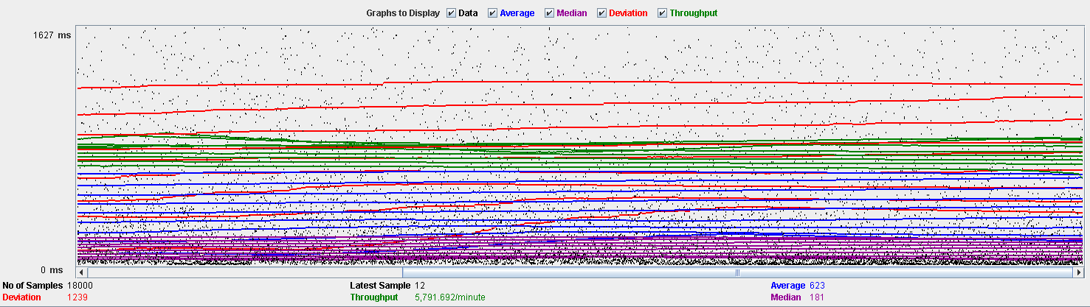

Performance Results:

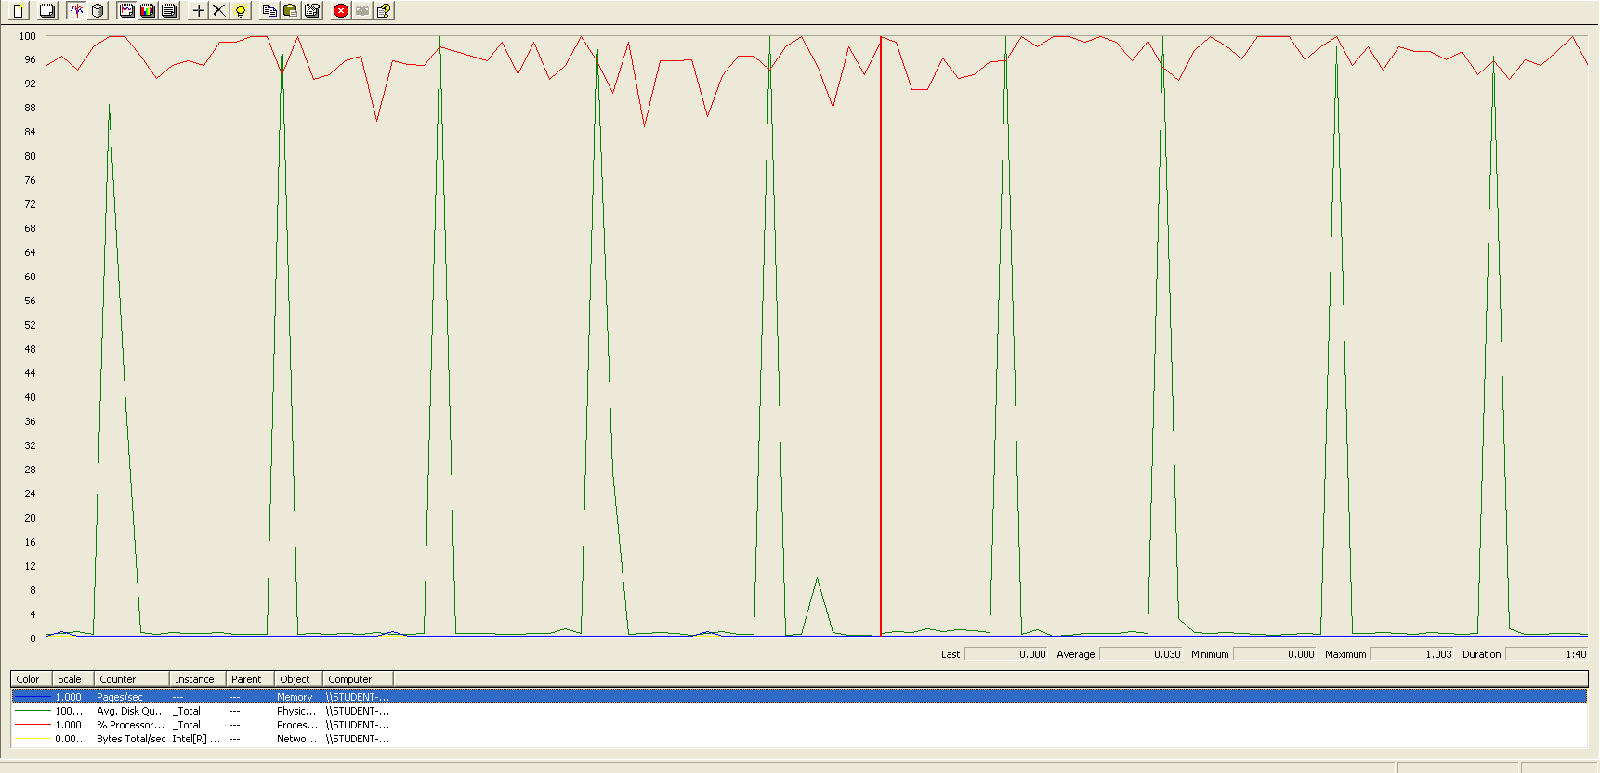

The CPU was always at its limit while the disk usage showed many peaks.

## Edit

Sequence:

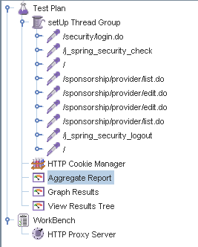

Aggregate Report:





Thread properties:

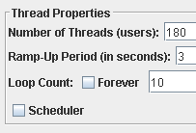

Graph Results:

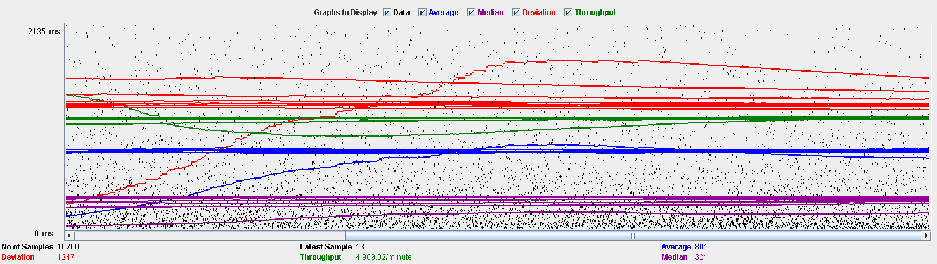

Performance Results:

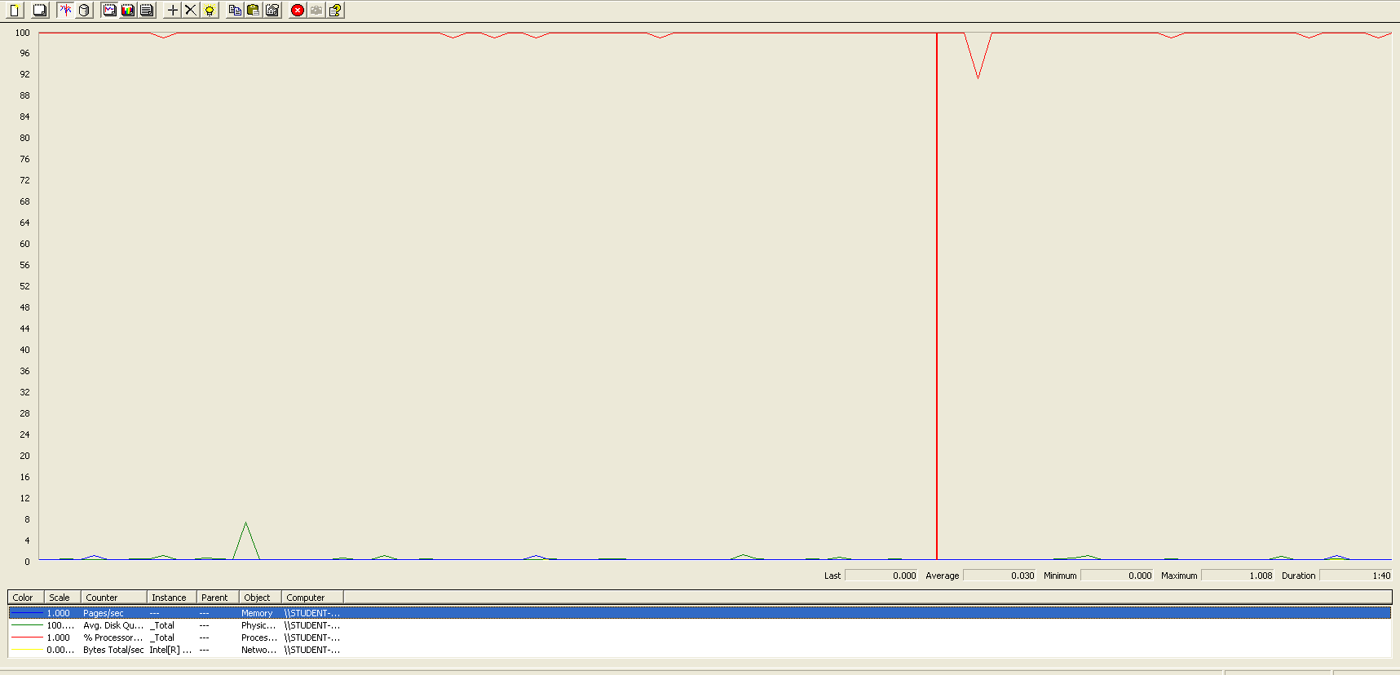

The CPU was always at its limit.

## Delete

Sequence:

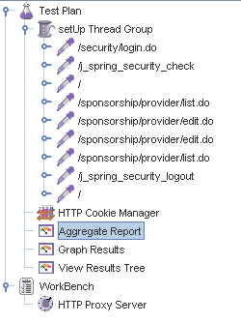

Aggregate Report:





Thread properties:

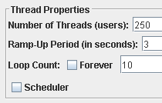

Graph Results:

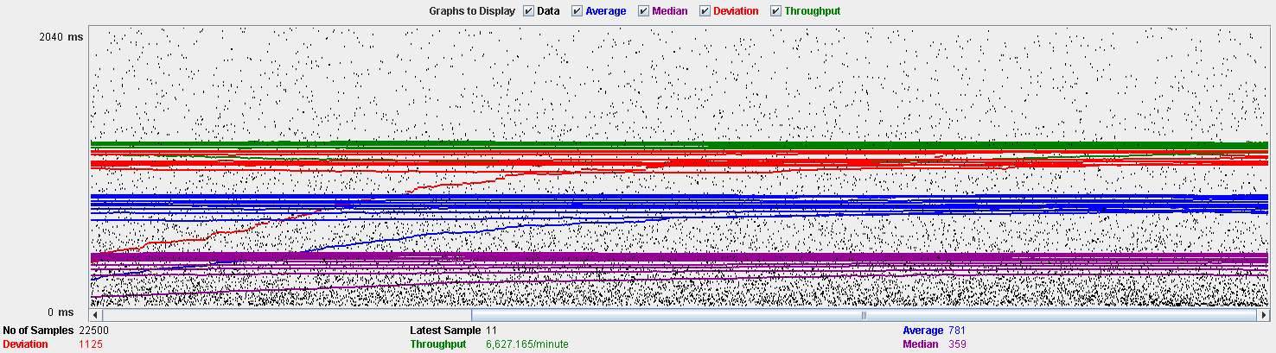

Performance Results:

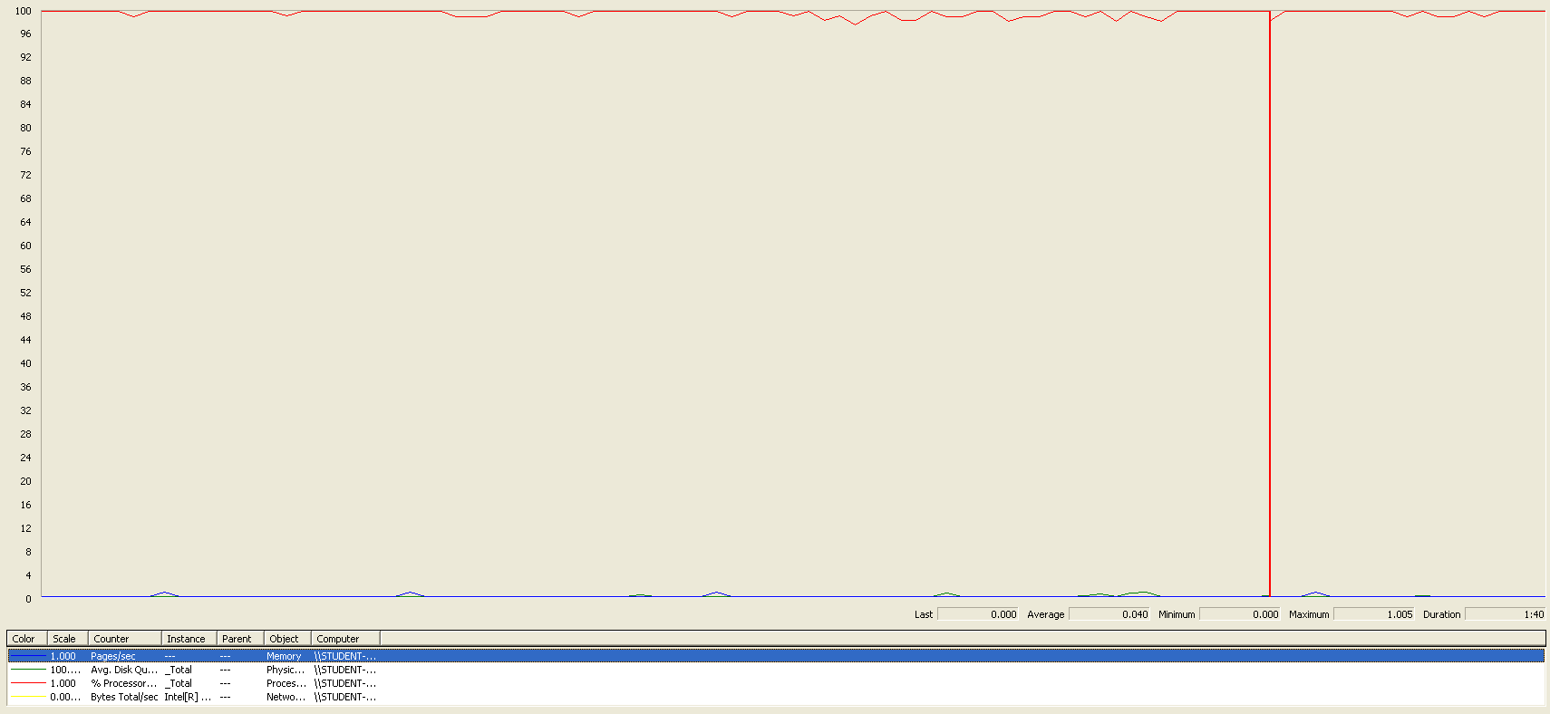

The CPU was always at its limit.

## Conclusion

The test was performed using:

CPU: i7 6700hq (2 cores in the virtual machine)

RAM: 4 GB (virtual machine)

For this use case we can say that the limitation occurs during the edit process, being the maximum of concurrent users 180.

# Item

## Create

Sequence:

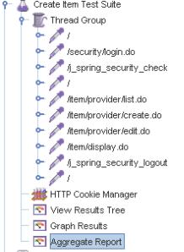

Aggregate Report:

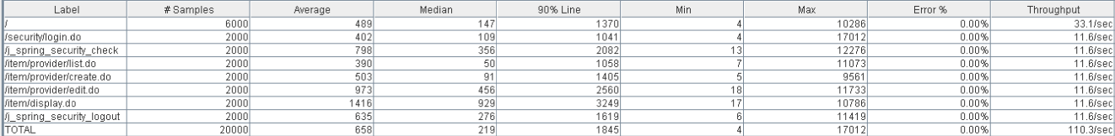

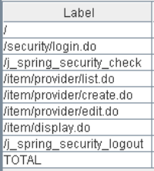 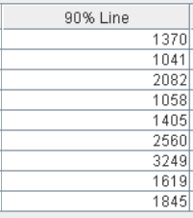 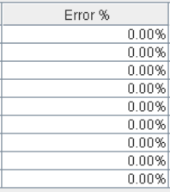

Thread properties:



Graph Results:

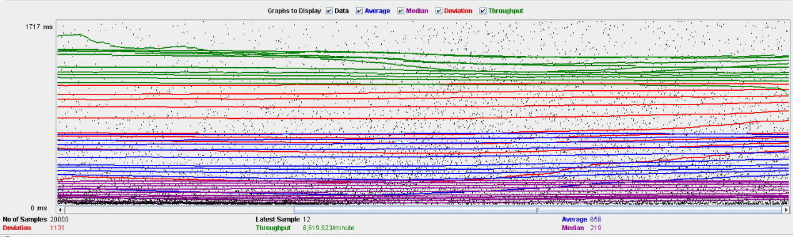

Performance Results:

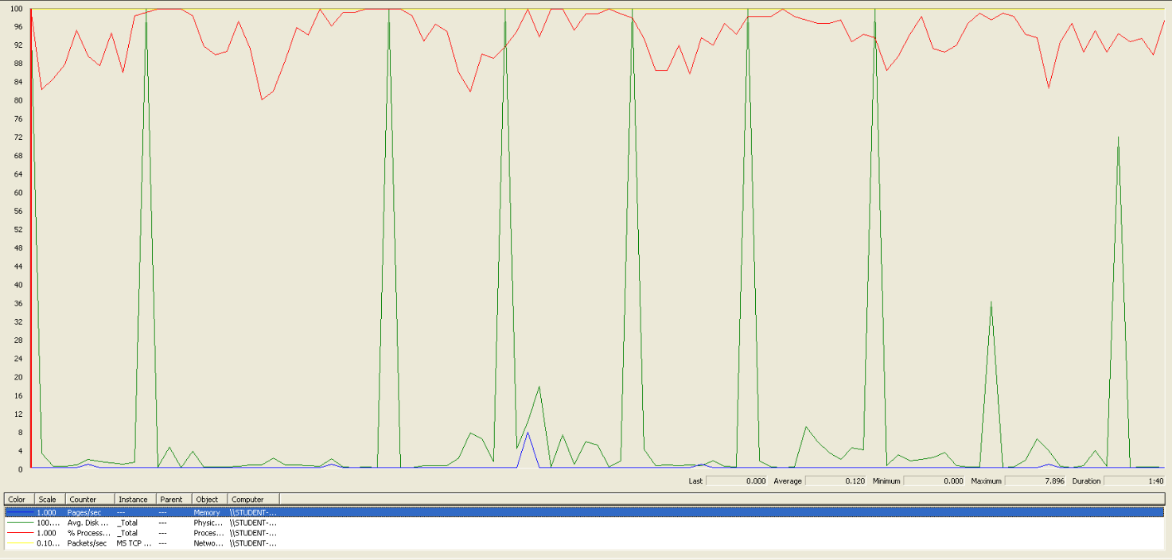

The CPU was always at its limit while the disk usage has some peaks.

## Edit

Sequence:

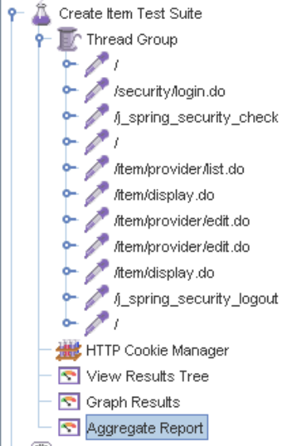

Aggregate Report:

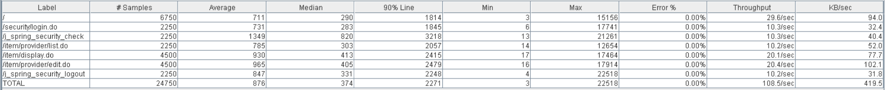

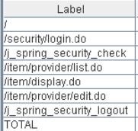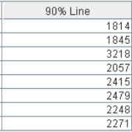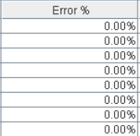

Thread properties:



Graph Results:

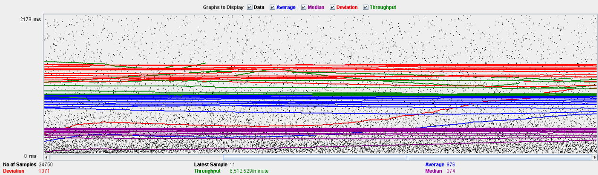

Performance Results:

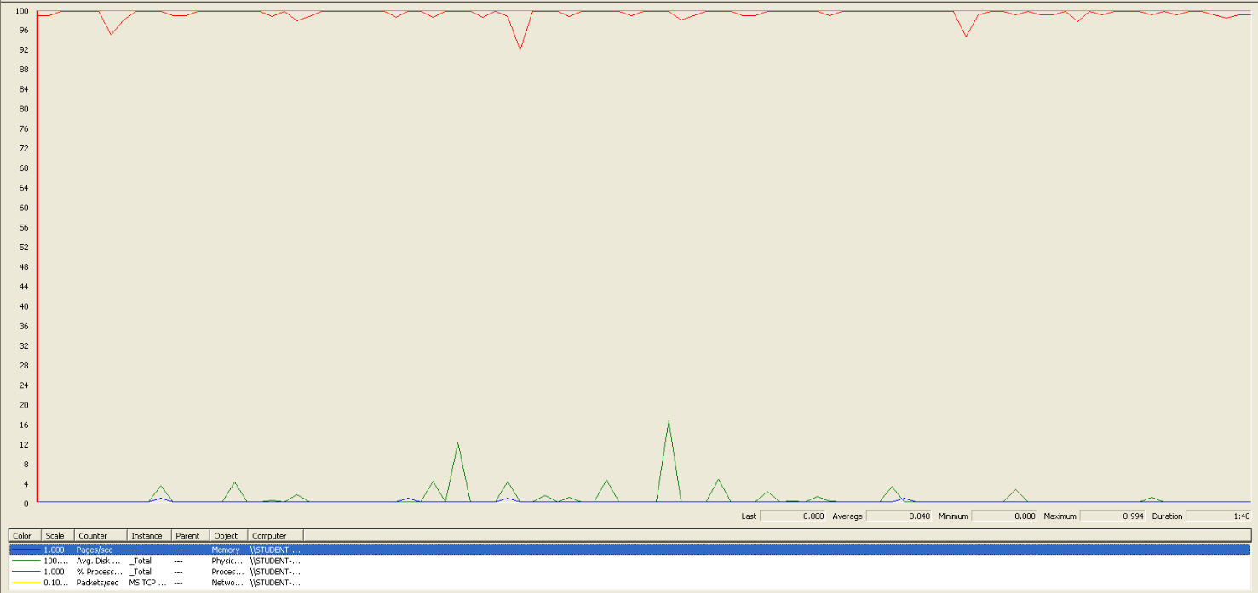

Again we can see that the CPU is always being used, is the problem in this use case.

## Delete

Sequence:

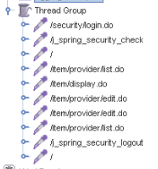

Aggregate Report:

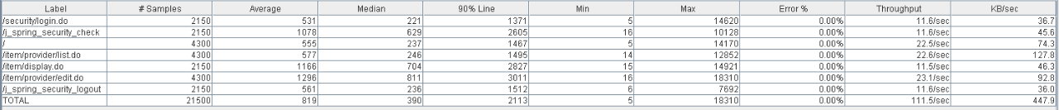

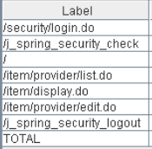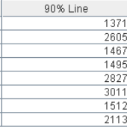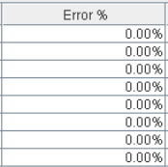

Thread properties:



Graph Results:

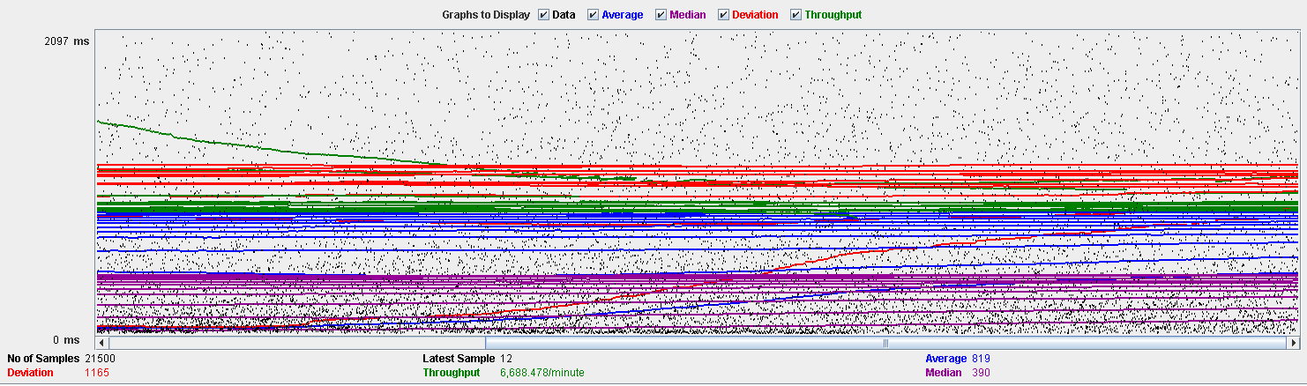

Performance Results:

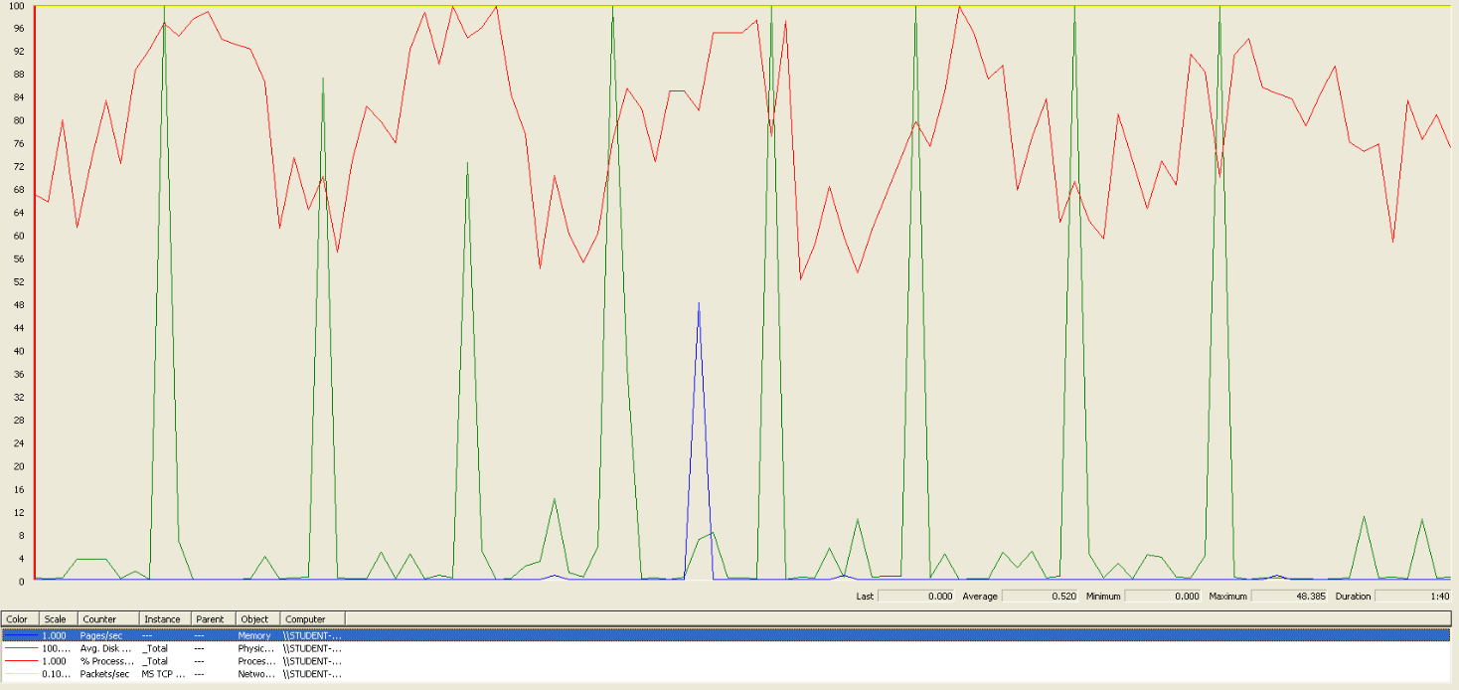

Again we can see that the CPU is always being used while the disk usage has different peaks.

## Conclusion

The test was performed using:

CPU: i5 7300hq (2 cores in the virtual machine)

RAM: 2 GB (virtual machine)

For this use case we can say that the limitation occurs during the creation process, being the maximum of concurrent users 190.

# Conclusion of the performance

As we can see in the tests above, the limitations of our system are in the message system, specially in the method of broadcasting a message (14 concurrent users). We think that this may be a bit unrealistic, because in a real environment won’t be many administrators sending multiple notifications. Due that, we consider that the limit of concurrent users for our system is 45 (sending a message).